Meeting Minutes

Meeting Minutes
The Meeting Minutes is available in the Workspace section. It is enabled to customers based on their request. Using the Meeting Minutes, you can record the details of the meetings held by your company. 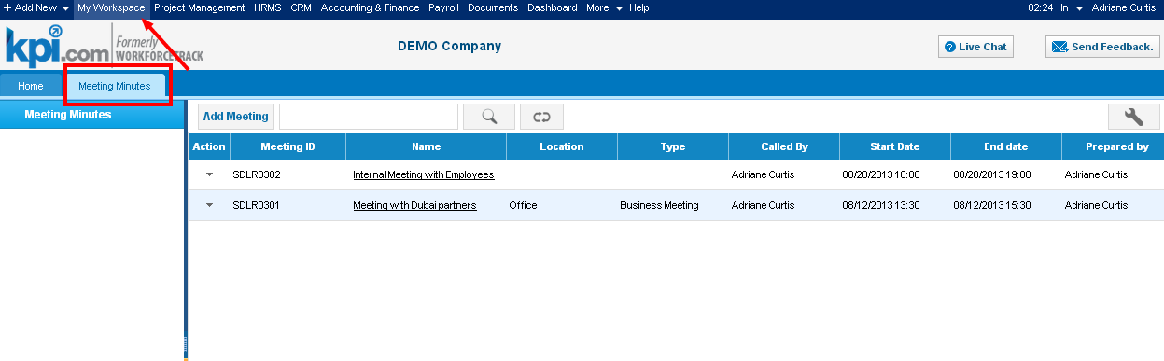Meetings Minutes can be added using following steps Humans >> Meeting Minutes 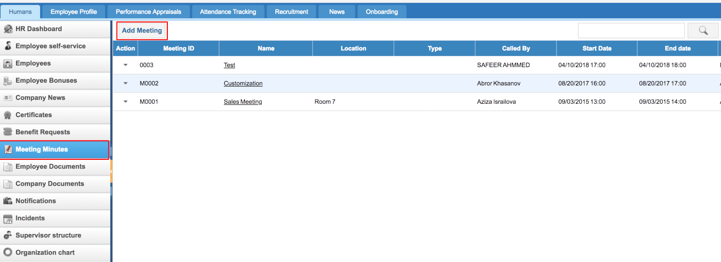 Add Meeting Minutes To add a meeting, click on the "Add Meeting" button on top of the page and fill in the form. 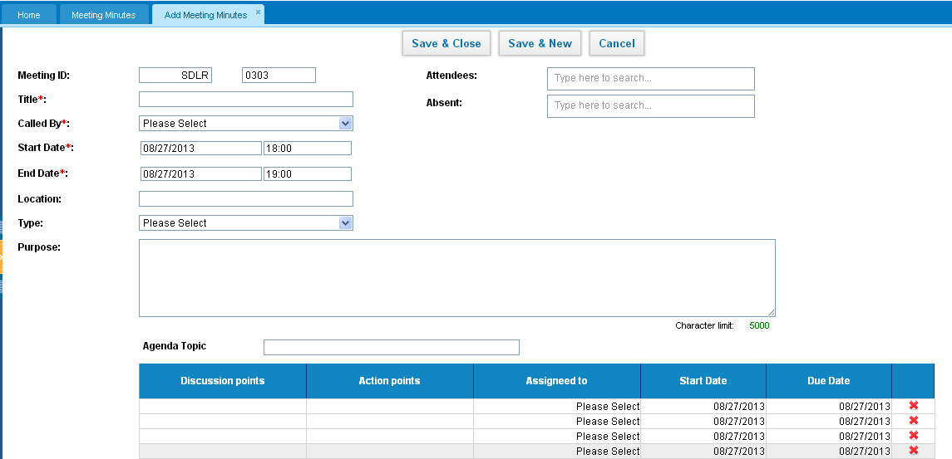You can specify employees who attended the meeting and those who were absent. You can also create several agendas by clicking "Add New Agenda" link. Copy Meeting details You can create a meeting by copying some details from another meeting. To do that, click on the actions dropdown and choose "Copy to New". 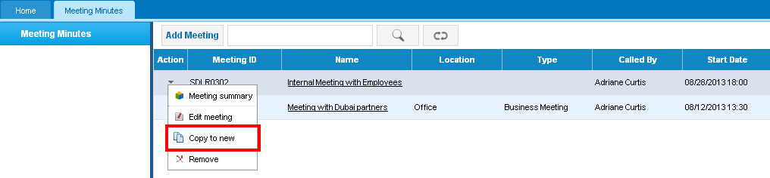 Upload Files Uploading files is available in the left side of the Meeting Minutes form or the Meeting summary page. Edit Meeting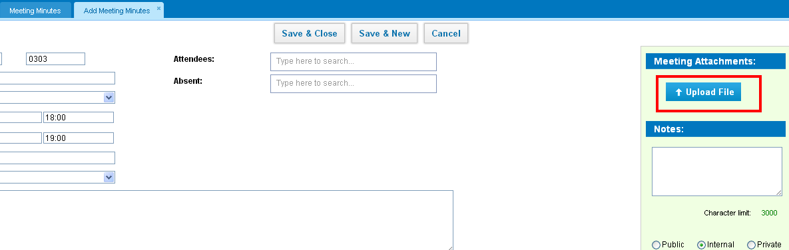 To edit a meeting, click on the actions dropdown and choose "Edit Meeting". The Edit option is available to the Administrator and the person who created it. Delete Meeting To delete a meeting, click on the actions dropdown and choose "Remove".

My Workspace Widgets
kpi.com Workspace is a very practical module that enables you to observe your workflow in an uncomplicated format and perform several functions on this page. it is easy to find Workspace from the right side. 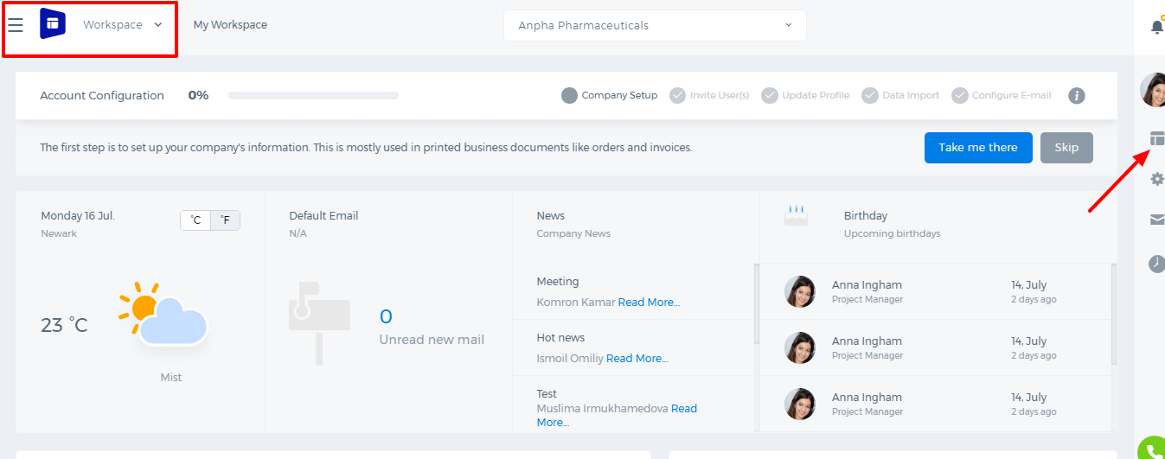To set up a company information, you have to press the blue button "Take me there" from the right side. With this button, you can input information about your company. 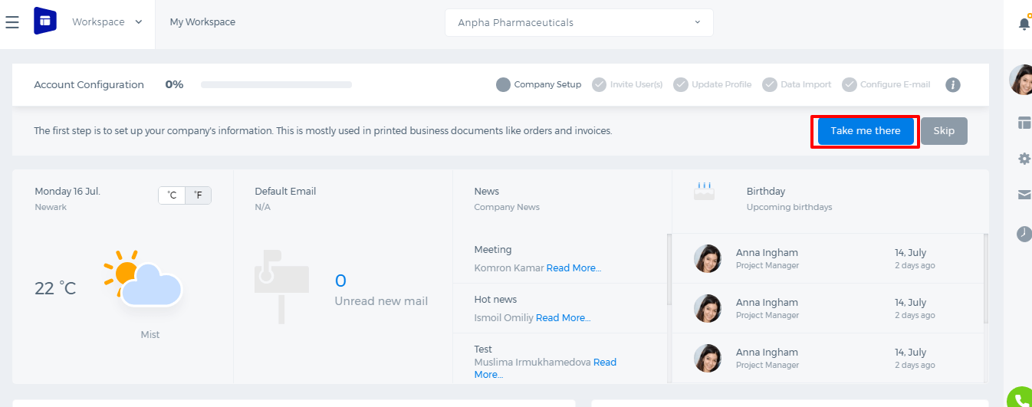 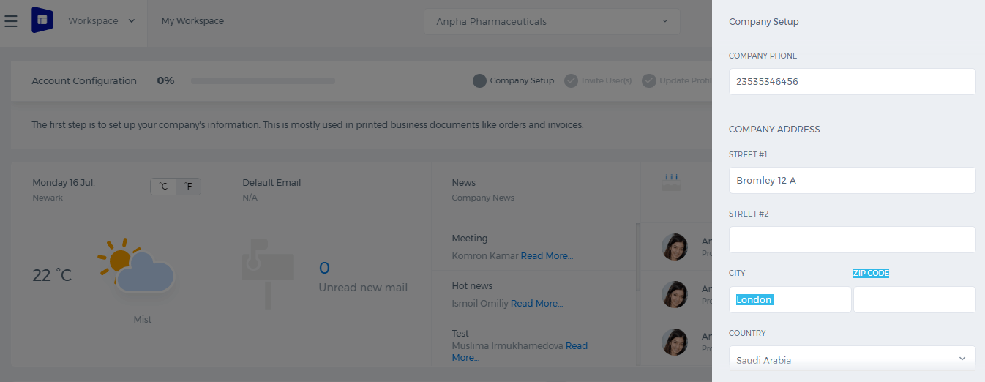 Widgets Available in My Workspace You are able to navigate the following features: CALENDAR – it forwards you to the business calendar page where you can add events, tasks and appoint meetings, views all projects, tasks, issues, etc within the specified time period (daily, weekly or monthly). You can also sync your Google Calendar with the system. Sync Google Calendar with kpi.com Firstly, you need to link up your kpi.com account to your Google account. Please follow the steps below:
- Sign into your Gmail account on the same browser that you opened kpi.com Calendar tool.
- Click on Configure with Google function in the Calendar section. Select your Google account for configuring in the page that opens. Click Continue after selecting the account.
- Select the Grant access button to confirm the access. To deny the access, click on Deny access.
- By clicking on the Synchronize with Google button, you can transfer all events from Google Calendar to kpi.com Calendar or choose a specific period to transfer.
Once you have completed the above steps, you have linked up your kpi.com account with your Google account. CONTACTS – this feature shows the list of all your contacts as CRM, client, supplier, employee and private contacts. 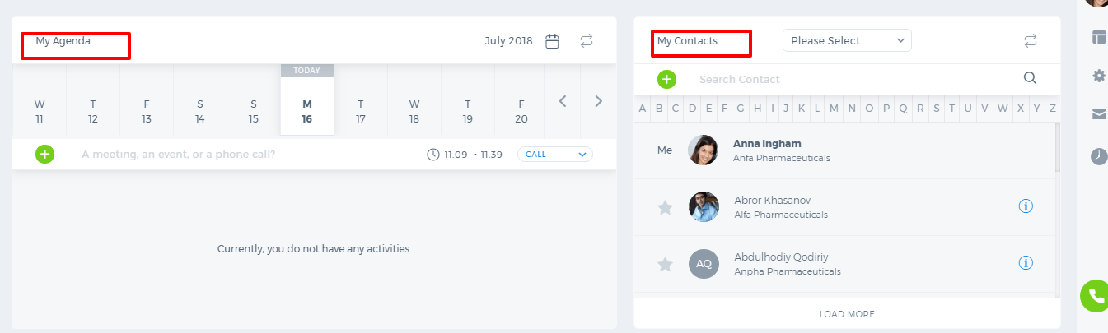 Add Contact on My Workspace Go to the My Workspace section and find the Contacts feature in the first pane. Click Add a Contactfunction right there and provide information in fields such as owner name, contact’s full name, job title, e-mail address, etc. Once the form is completed, click Save & Close. NOTES – this is a very convenient feature for you to leave task or project related notes for your employees. Add Sticky Note A sticky note can be added using the Notes feature that is found in the first pane of My Workspace. Once you have opened the Notes page, you will see the button called Sticky in the list where you can add your own sticky notes. NEWS – you can see the news of the company and add news by your own using this feature. Delete Company News Find the News function in the first pane that forwards you to the list of news. There, you will find the Removefunction in Actions dropdown with that you can delete the news. UPDATES – Once you open this feature, you will see the list of all updates and filter them using the Filter function. LEAVE REAQUEST – this function allows you to add a Leave Request directly from your Workspace panel without going into the HRMS section. Finally, in the next pane, you will see the Help Desk where you can find tips and instructions on how to use the system tools. The last subsection illustrates the Weather News widget. You can also choose any country and see the weather results. The main pane contains overall information obtained from different modules as Project Management, CRM, Accounting & Finance and HRMS. AGENDA LIST VIEW Agenda is a list of upcoming events and tasks related to your projects, company, or employees. You can set important reminders about meetings, interviews and conferences. Edit Tasks/Events in Agenda To edit the tasks/events in Agenda, click on one of the tasks and find the Edit function in the first pane on your screen. MY UPDATES and MY PEERS’ UPDATES 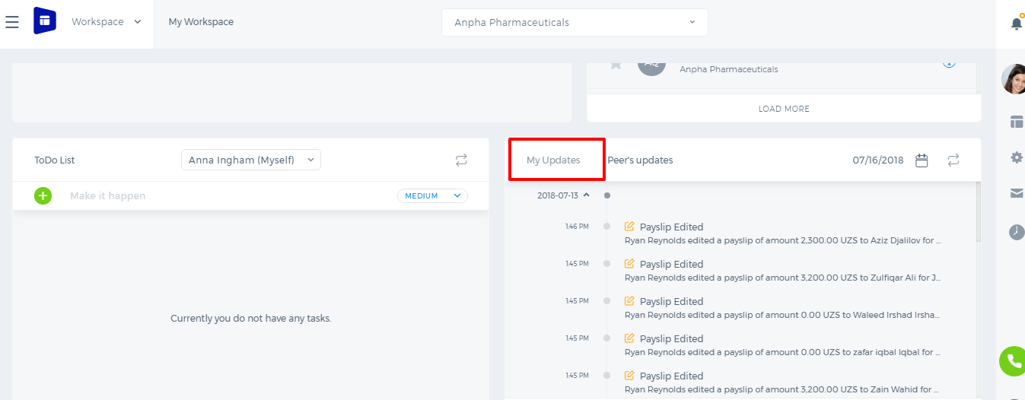 Updates are the recent activities done by you and your peers through the kpi.com system. They include all tasks you have added, completed, requests you have sent for approval or tasks you have been assigned. COMPANY NEWS This panel will help you provide the latest information about the company updates. Once you or your colleagues have added any public news, this will appear in the Company News panel where you can view the news details and leave comments. PROJECT PROGRESS DASHBOARD With the help of the Project Progress Dashboard panel, you can view your current projects in detail. The progress statistic information will be viewed once you have filled in the project dashboard. PROJECT INVOLVEMENT Project Involvement is a convenient panel that reflects the percentage of your projects. The information is presented as a pie chart.

Billable tasks

Billable tasks
Task billable box is required to create a timesheet based invoice to the customers. When creating a timesheet based invoice on a project, the time entries of only the billable tasks will be considered. So, if you issue an invoice to your customers based on task worked hours, tick the Billable box when creating your tasks. 