Shortlists

Shortlists
In order to add a candidate to shortlist, click on Select Candidate button from Shortlists listing. 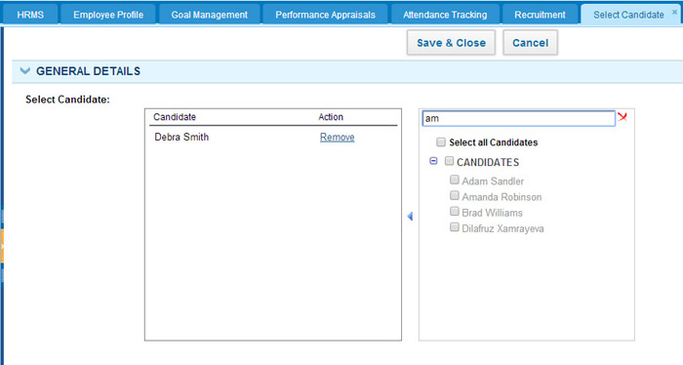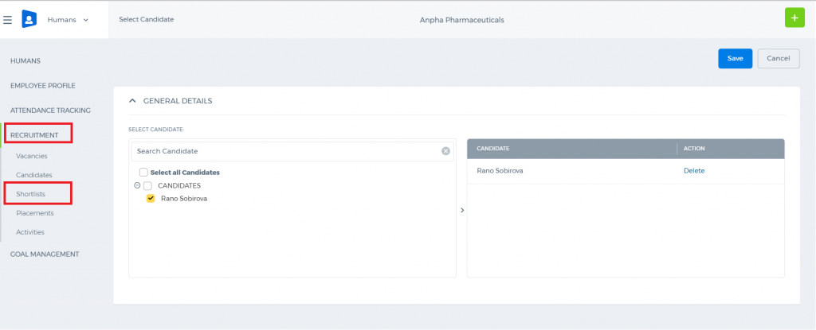 Search for candidate name on the right, tick it and click Save & Close (you can select more than one candidate). Once the candidate is added to shortlist, their status will change to “Shortlist”. You can also add the candidate to shortlist from Candidates listing. 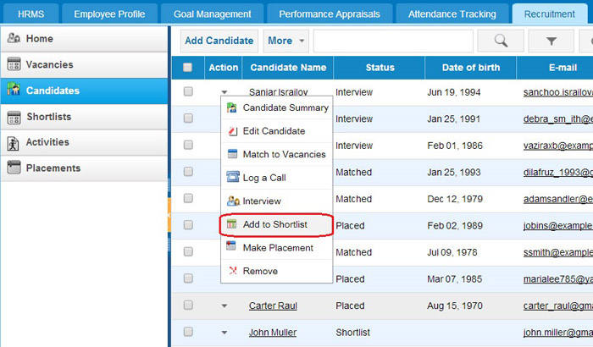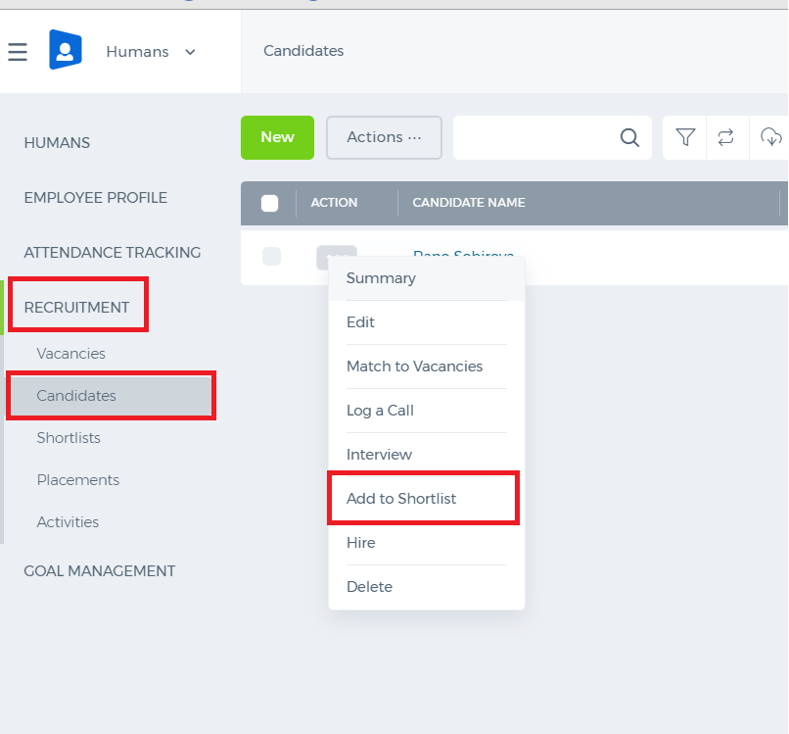 You need to find a required candidate, click Action and select “Add to Shortlist”.

Candidates

Candidates
Add/edit a candidate In order to add new candidate, press Add Candidate button in the Candidates listing. 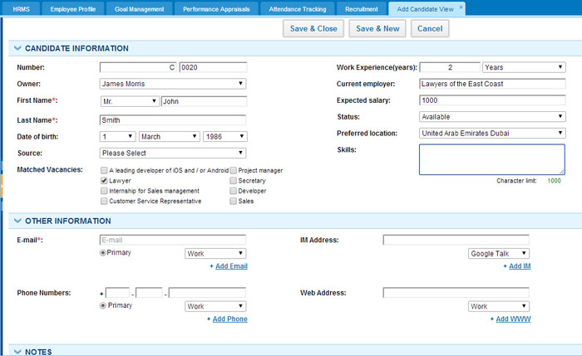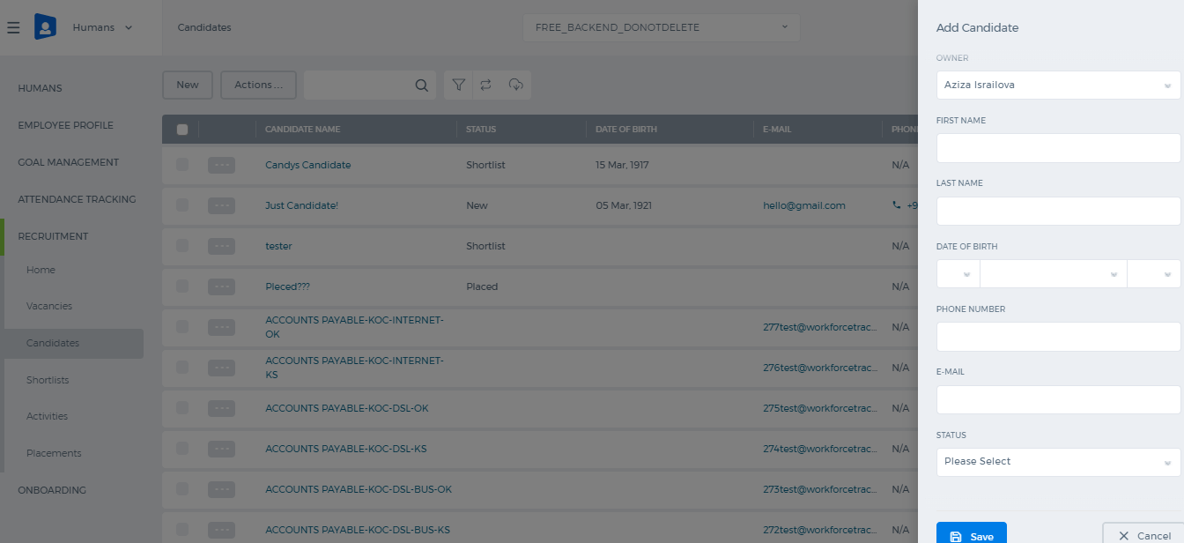 Fill in the following fields (fields with red asterisk are compulsory): Number–Unique number, assigned to this candidate (you can leave default one, or edit it) Owner–Employee, responsible for contacting this candidate First name – First name of the candidate Last name – Last name of the candidate Date of birth – Date of birth of the candidate Source – Choose the way this candidate was found Matched Vacancies – tick vacancies, for which this candidate might be suitable Work experience (years)–amount of previous work experience(can be specified in months or years) Current employer – Current employer of the candidate Expected salary – Salary, which this candidate is expecting to have Status – Current status of this candidate Preferred location – Choose location, where this candidate would prefer to work Skills – List of skills that this candidate possesses E-mail – One or more e-mail addresses of the candidate Phone Numbers–One or more phone numbers of the candidate IM Address – One or more Instant Messenger addresses of the candidate Web Address – One or more web addresses of this candidate You can fill in candidate’s address information, add some extra notes or attachments. Also, candidate can be linked to Project, Contact, Lead, Opportunity etc. Candidates Listing In order to perform different manipulation on candidates from this listing, you need to click on the Action menu. 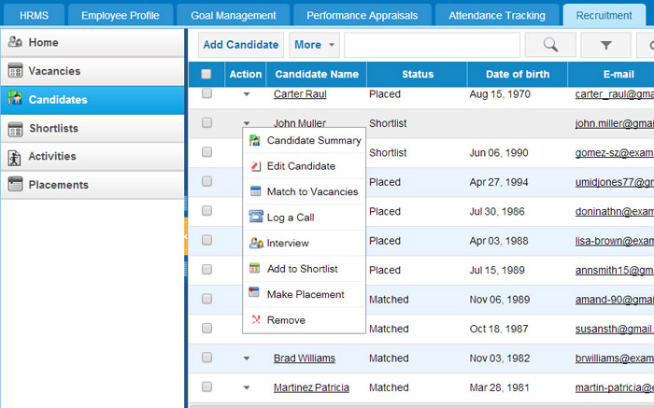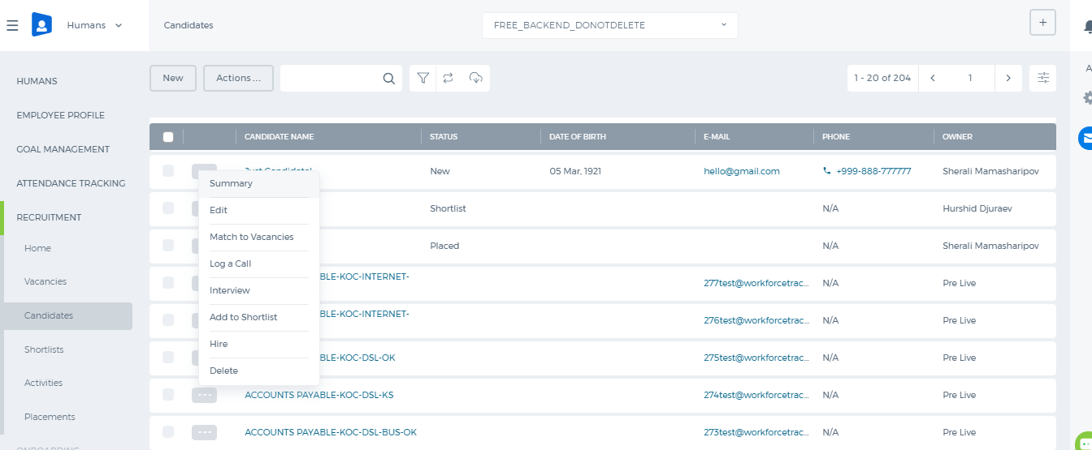 You can Match this candidate to active vacancies, log an Event (Call or Interview) for him/her or add him/her to Shortlist.

Vacancies

Vacancies
Add/edit a vacancy Before adding a vacancy, you need to have at least one Position. Positions can be added from HRMS – Positionslisting – Add new position. In order to add new vacancy, press Add Vacancy button in the Vacancies listing. 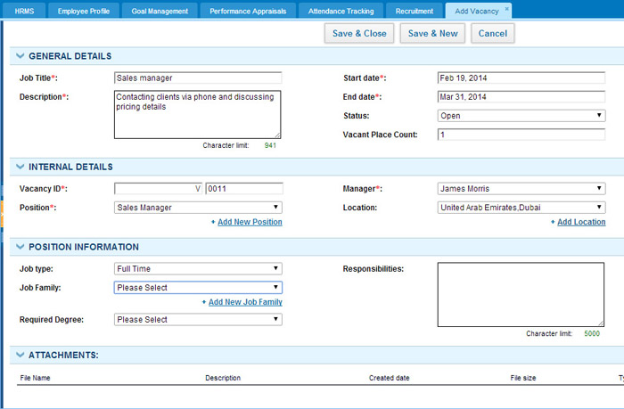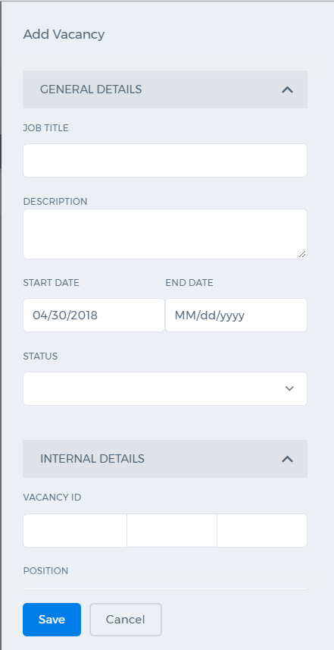 Fill in the following fields (fields with red asterisk are compulsory): Job Title–Vacancy name. Description–Short description of this vacancy. Start Date–Vacancy creation date. End Date–Vacancy end date. Status–Current status of this vacancy. Vacant Place Count–the number of places available. Vacancy ID–Unique number assigned to this vacancy (you can leave default one, or edit it). Position – Select appropriate position from the drop-down list or create a new one. Manager–Employee, responsible for managing candidates for this vacancy. Location–Choose location, where this vacancy is located (or add a new location). Job type–Part-time or full-time. Job family–Choose job family from the list (or add a new job family). Required Degree– Minimumeducational degree required to be qualified for this job. Responsibilities–Short description of responsibilities, which this job will include. Change Vacancy Status In order to change vacancy status, you can Edit this vacancy or change it directly from Vacancies listing 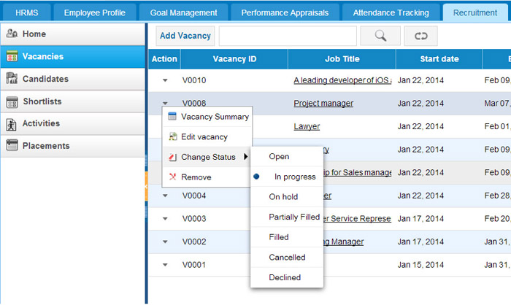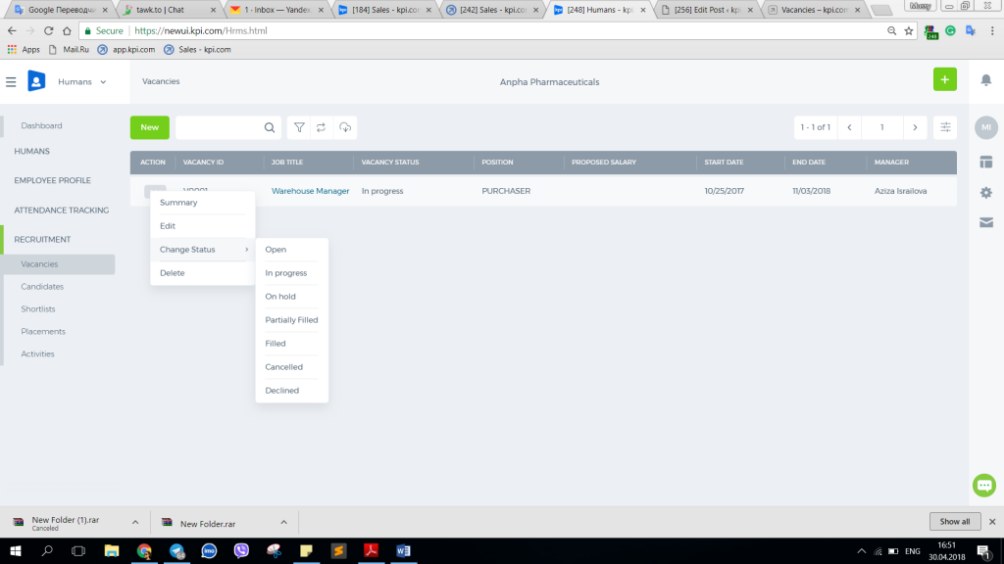

Recruitment home

Recruitment home
Recruitment is available under HRMS module and helps in the process of hiring new staff. 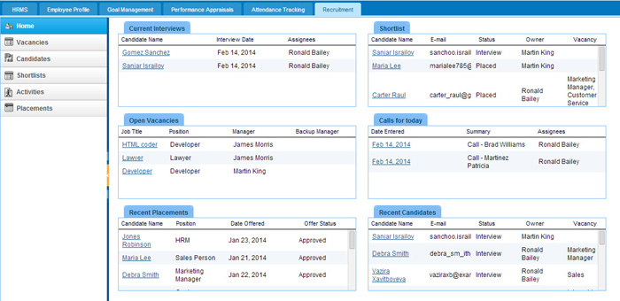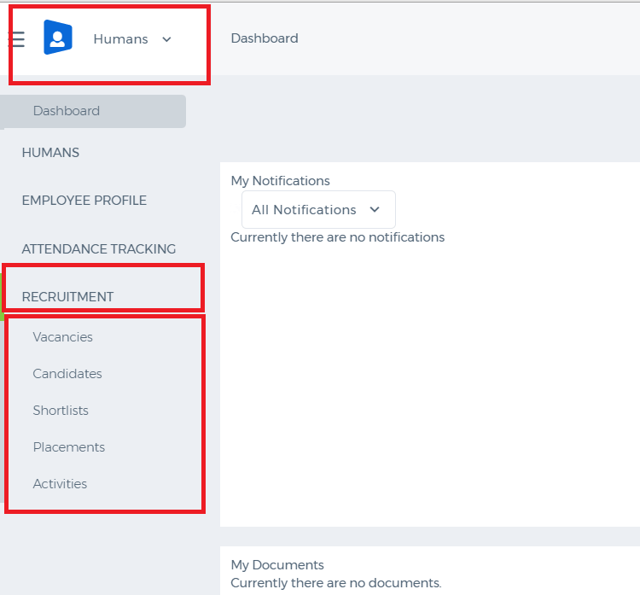

Remove Employee

Remove Employee
To remove an employee from the Employee List: 1. Go to Empoyees section of the Humans or Projects module or Settings>>Users and Privileges. 2. Find the employee from the list 3. Click the Actions drop-down 4. Choose Delete You will be asked to be sure whether to delete the selected employee or not. Click OK and the employee will be removed from the system. If the employee is a project manager in certain projects, you will be asked to change the manager. Remove function completely deletes all employee-related data from the system, whereas Terminate Employment keeps them in the system. 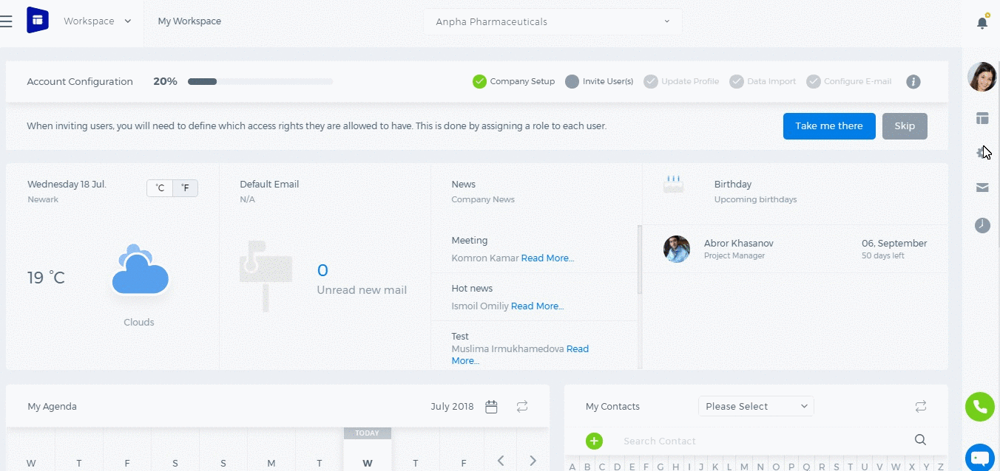

Terminate/Resign Employment

Terminate/Resign Employment
The termination of employment does not delete any personal or job-related data of the employee, i.e. project leave request, invoices, expense reports, time sheets, etc. Termination disables the access of the employee and gives you a chance to add a new user (frees up the user limit). To terminate employment, perform the following steps: 1. Go to either Humans, Projects or Settings>>Users and Privileges and then Employees. 2. Find the employee in the list 3. Click the Action drop-down 4. Choose Terminate Employment. In the new User Interface, the option is called "Resign". A pop-up window will appear to confirm the termination/resignation of employment. As soon as you confirm, the employee will be terminated/resigned. 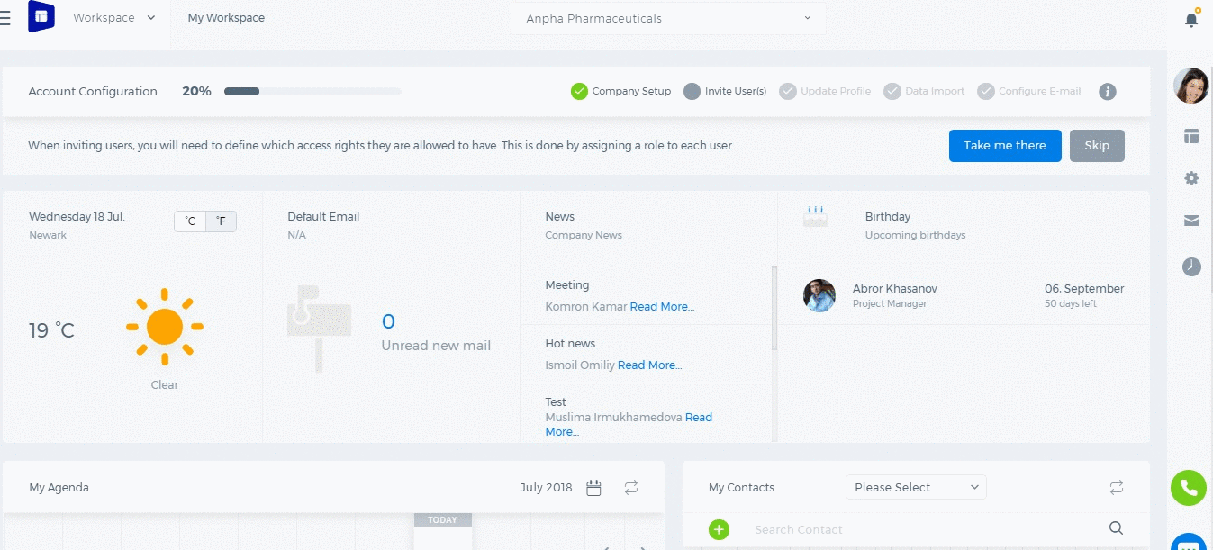

Deactivate Employee

Deactivate Employee
There are several options to control employees access and update it if necessary. You can either deactivate, resign or remove employees. Deactivate option disables the access of an employee to the application. However, this is temporary deactivation since the admin and HR manager can activate the employee's access any time. Deactivation doesn't give another chance to add a new employee. To deactivate an employee, perform the following steps: 1. Click Employees on the left-sidebar 2. Find the employee and click the Action drop-down 3. From the Action drop-down select Deactivate. The deactivation function prevents the employee’s access to the account, but all information related to the employee will be kept in the system. 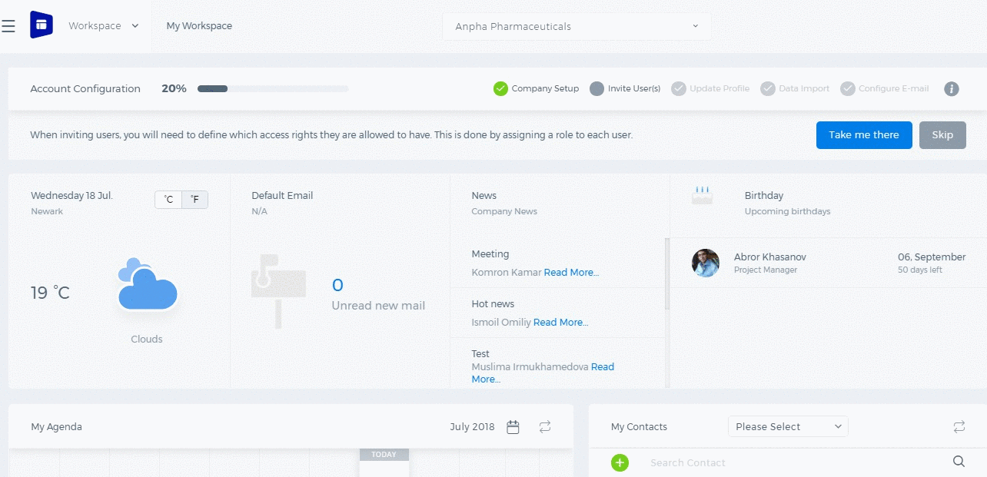

Employee Activation Process

Employee Activation Process
Once a new employee is added to the employees list, an activation link will be sent to the employee’s email address. To activate the account, the employee should follow the link and activate his/her account. 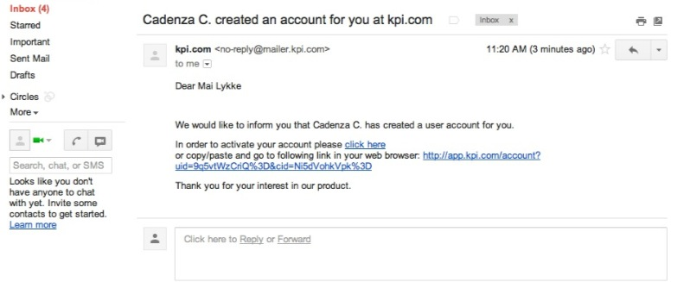Click the link to activate the account. It will redirect to the kpi.com welcome page. To access to an employee’s account, set the password. 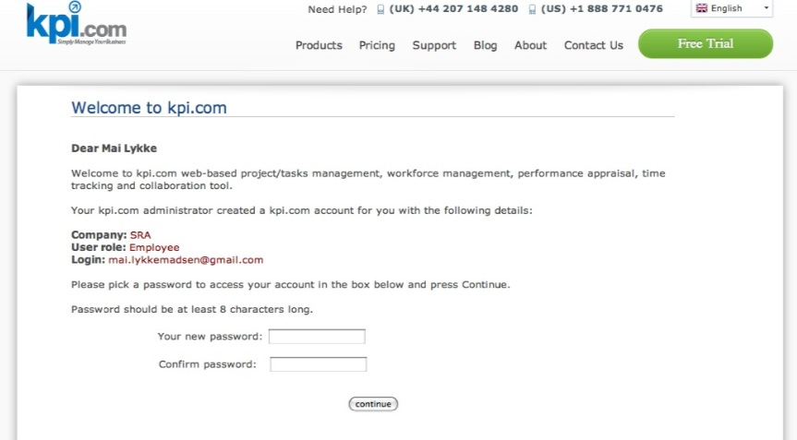 Double-check the correctness of an email address before sending the activation link. If no activation link is received, it is recommended to check the Spam folder of the mailbox.

Add New Employee

Add New Employee
The Employees section of the Humans/Projects or the Settings>>Users and Priviliges module stores the personal information of employees in the system. Only administrators, directors and HR managers are eligible to add a new employee to the system. To add a new employee, go to Humans or Projects or Settings>>Users and Privileges and then Employees section and click add. First Name – Employee’s first name Last Name – Employee’s last name E-mail – Employee’s email address (Since an activation link will be sent to an employee’s email address, it is recommended to provide a valid email address) Role – Employee’s position at the company To assign a role to the person, select the roles from the existing list. Following roles are available in the system by default:
- Employee
- Administrator
- Director
- Accountant
- HR Manager
- Sales Manager
- Customer Service Representative
- Sales Person
Then choose a department and a location if needed. No Access – If this box is checked, the employee will not receive an activation email and they will not have access to the system. You will just keep employee information in the application, however, you will be able to generate payruns for them. ESS User – Employee Self-Service User. If this box is checked, the user will have very limited access to the application and their user access level cannot be changed. In the new user interface, you need to add your employee first and then go to edit employee form and add more details. 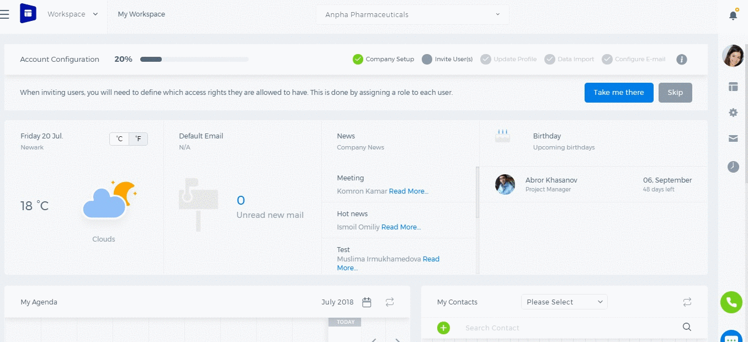

Resource Utilization

Resource Utilization
Resrouce Utilization is an additional feature which is activated on the request of our customers. Using the Resource Utilization, you can manage the resource allocation within projects and tasks. 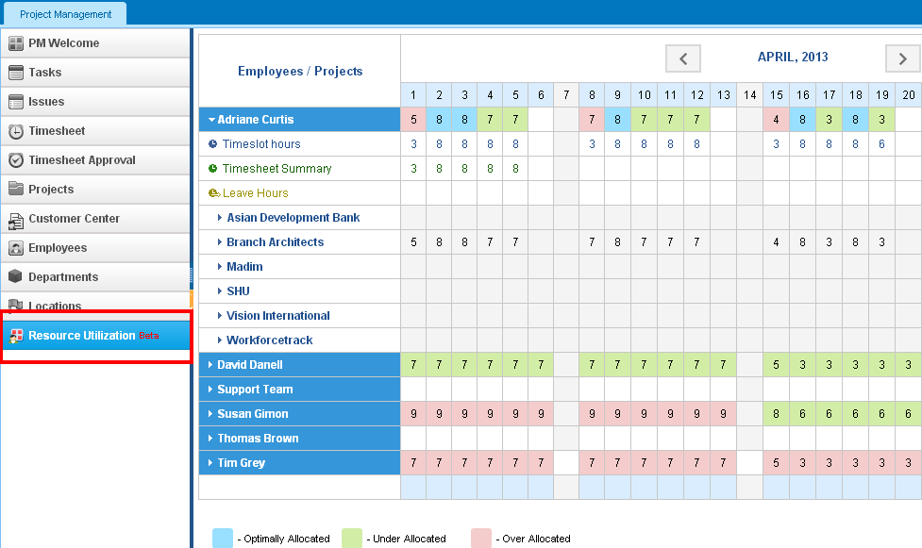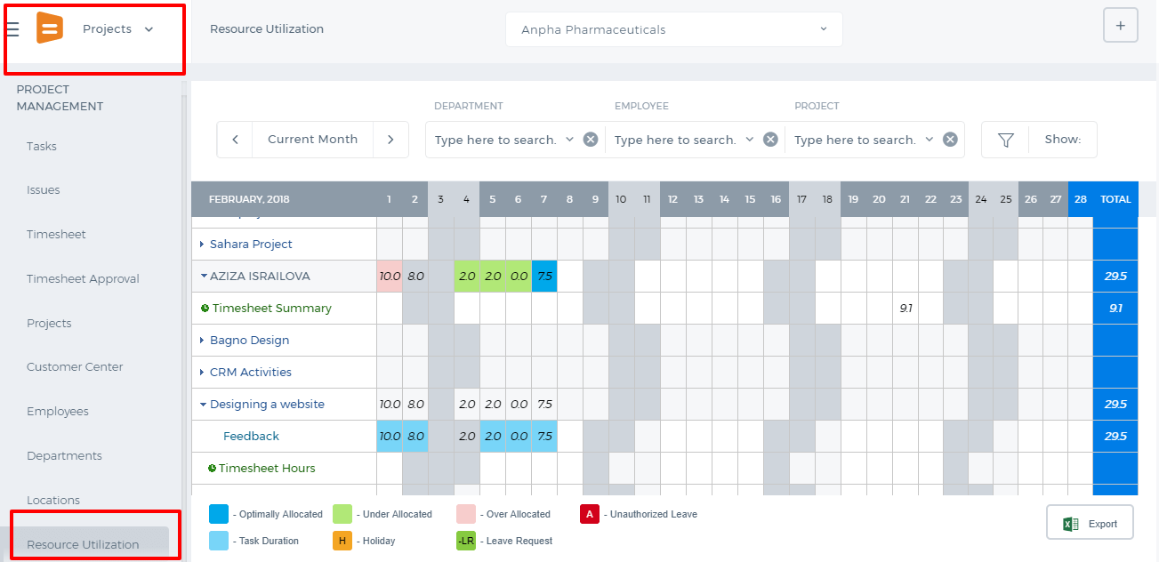 As indicated in the bottom of the Resource Utilization page: Optimally Allocated - shows the same amount of time allocated as in the timeslot hours set for the employee Over Allocated - shows more time allocated for tasks than in the timeslot Under Allocated - shows less time allocated for tasks than in the timeslot Task Duration - shows when task starts and ends Holiday - shows holidays where you cannot enter time To compare the timeslot hours to the estimated time allocated, tick the Timeslot Hours box on top of the page. To compare timesheet hours to the estimated time allocated, tick the Timesheet Hours box on top of the page. You can also filter by department or employee from the dropdowns located on top of the page. Edit Esimated Time To edit estimated time for employees, go to Resource Utilization section from the Project Management Module. Click on the dropdown next to an employee name which will populate all projects ongoing in the current month. Next, click on the project dropdown which will populate tasks. The tasks row shows estimated time allocated for each day. You can change the estimated time by double clicking on the cell. 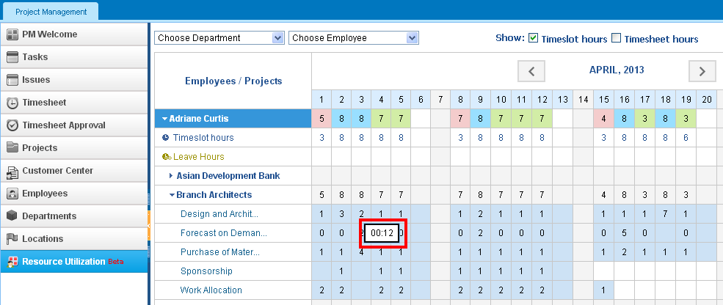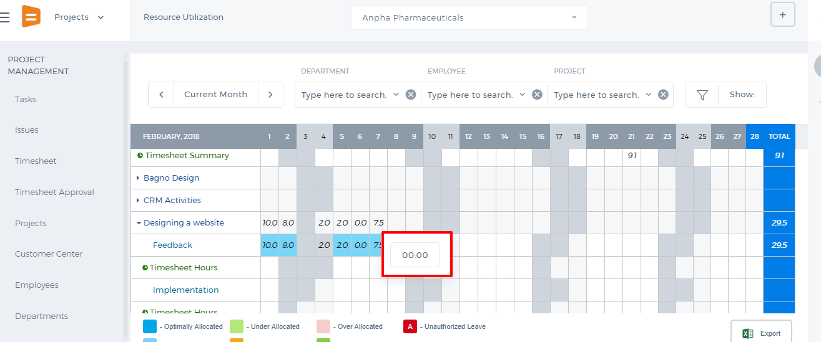 Resource Workload Resource Workload subsection under Project Summary page is available when Resource Utilization is active in your account. If this feature is not active, the Resource Workload chart will not be available under the Project Summary. 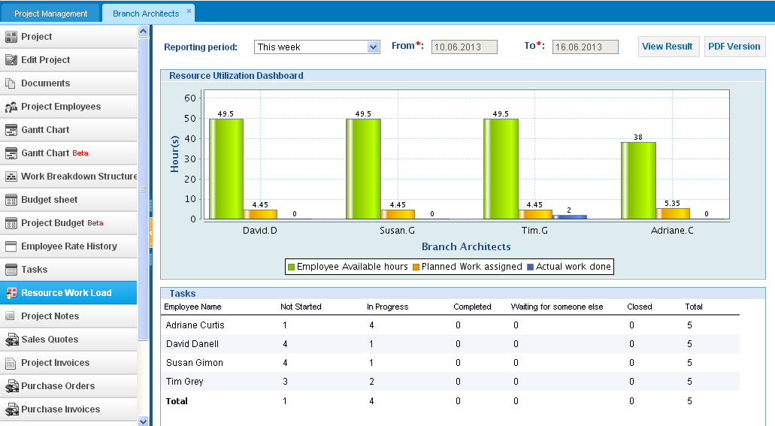Resource Workload is not available in the new User Interface at the moment.

Booking items

Booking items
With kpi.com online booking system, you are able to add and reserve items (i.e. room, vehicle, and computer). All reserved items will be saved in the Booking Items list. Add New Item and Reservation Go to the Booking Items section and choose Item or Reservation from the Add New dropdown. You need to write the item name, choose item category, and write the description for item. You do not have to indicate the number of the item, as the system will do it automatically.

Locations

Locations
The Locations section contains all information connected to the addresses and locations of your company. Moreover, the locations list can be customized according to your desire to make it more convenient for your usage by clicking Customize on the top-right. Add a New Location To add a new location, go to Locations section and click New Location that is located on the top menu. In the form, choose country and state from the dropdown, write your e-mail address, phone number and fax details. 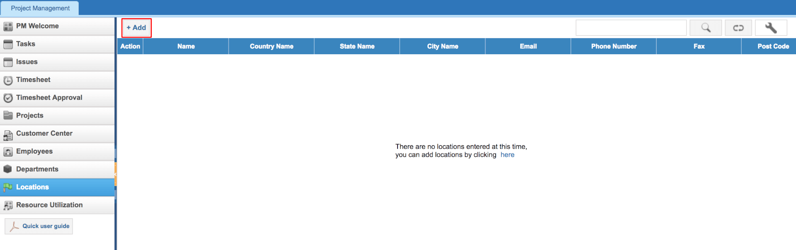 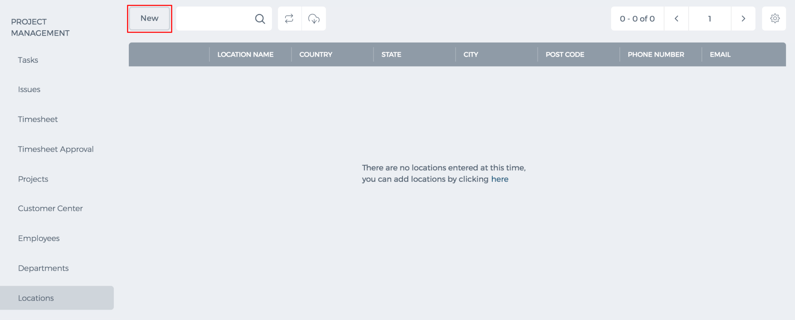 Edit a Location You will find Edit Location function from the Action dropdown in Locations list. You need to implement changes and click Update.

Departments

Departments
Departments section keeps track of departments and their members in your company. To see departments go to Projects >> Departments 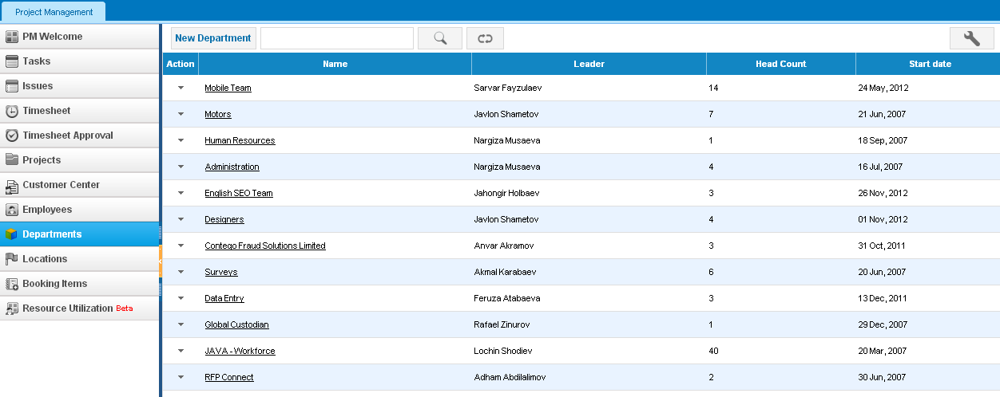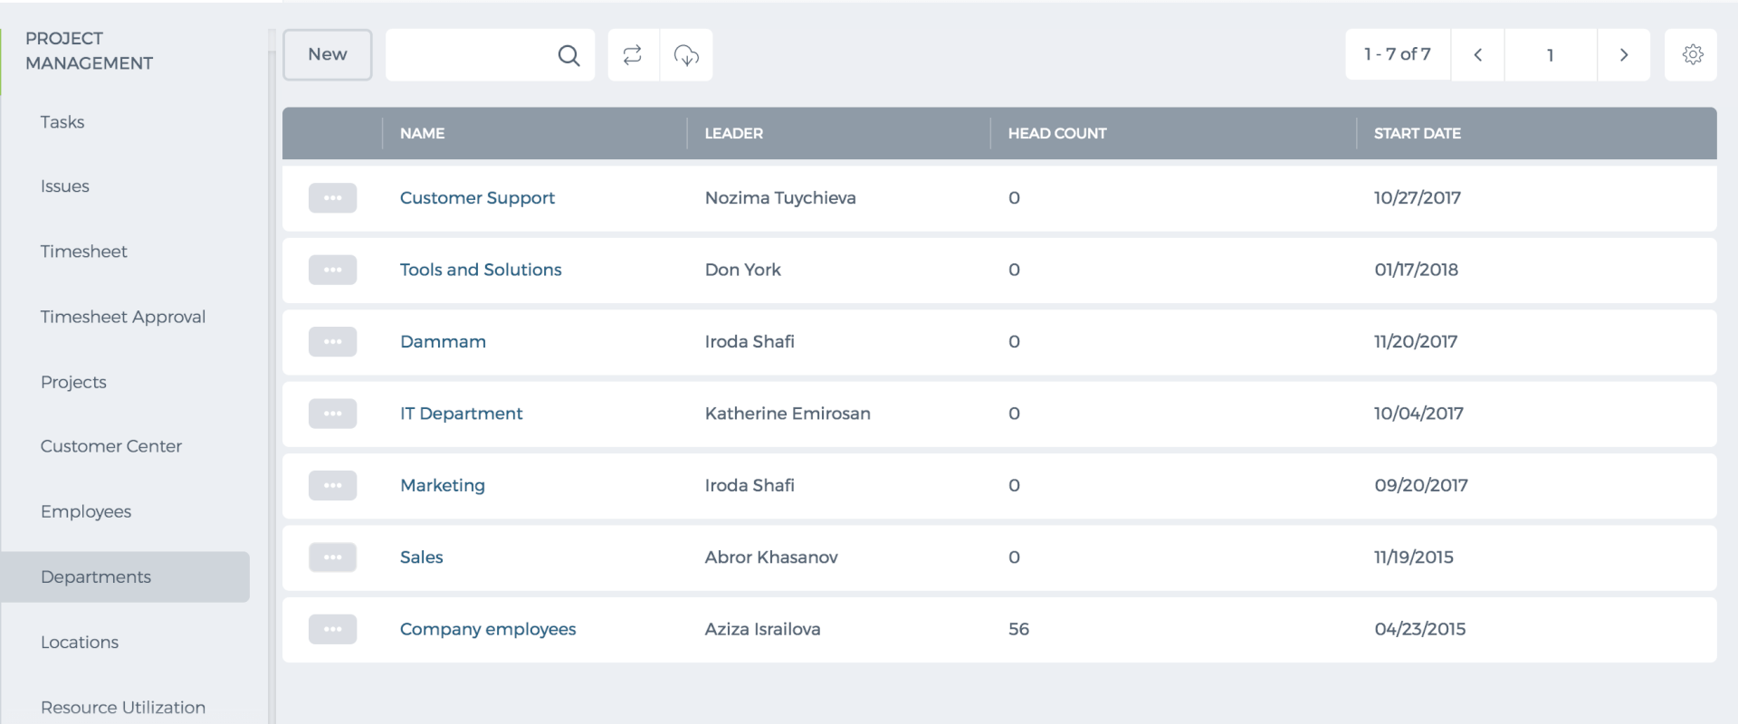 New Department To create a new Department, go to either Project Management or HRMS module and then go to Department section. Click on Add New button and fill in the form. You need to assign members and a department leader to a new department. 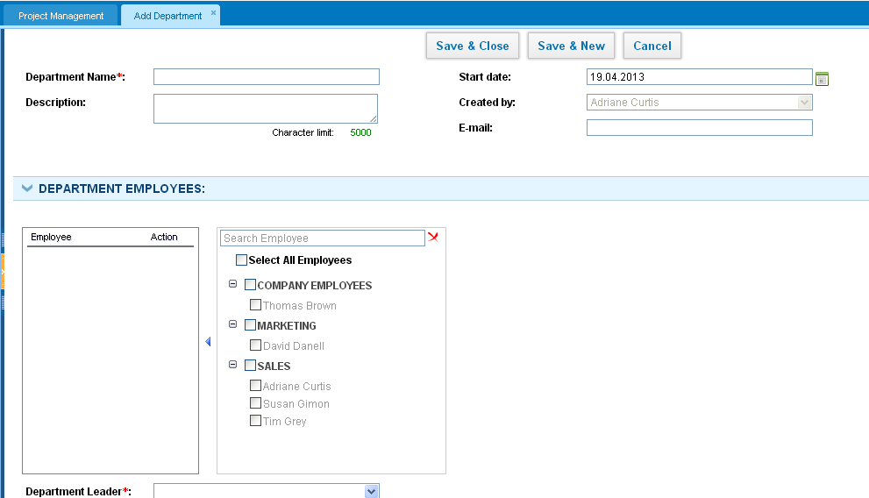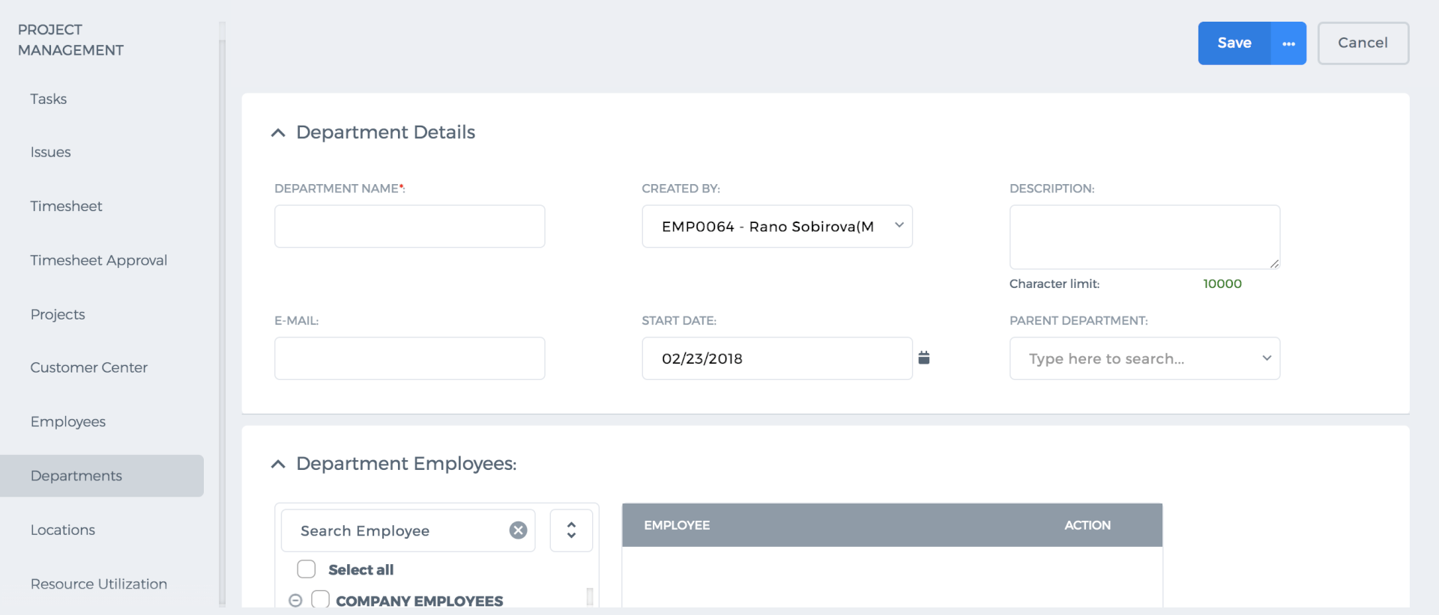 A department leader will be able to approve leave requests, expense claims of department members. Department Summary This page shows the details of the department such as when it was created, by whom it was created, members of the department and the leader of the department. You can also convert the department summary to a PDF version by click on the PDF icon. 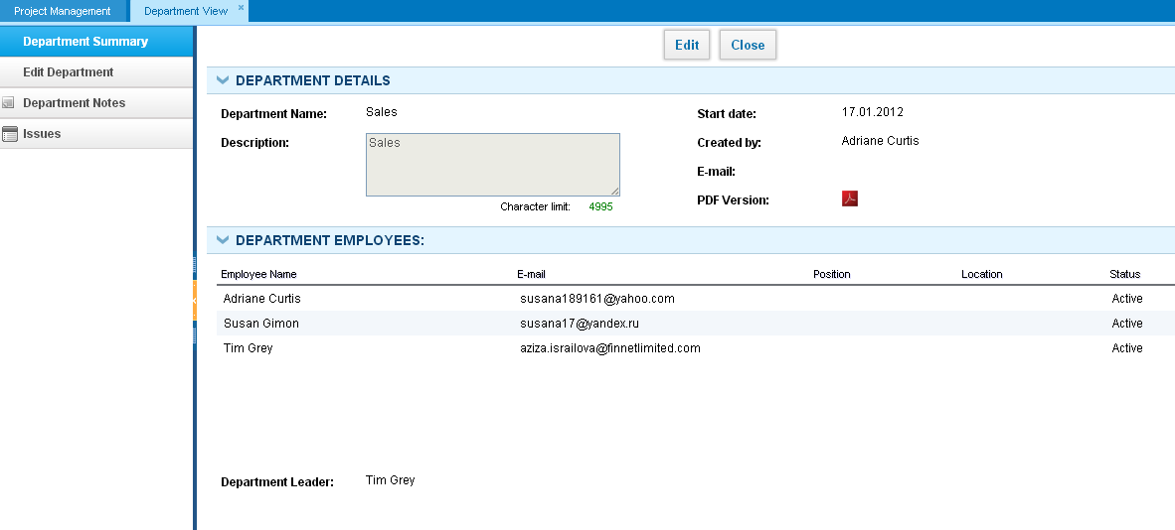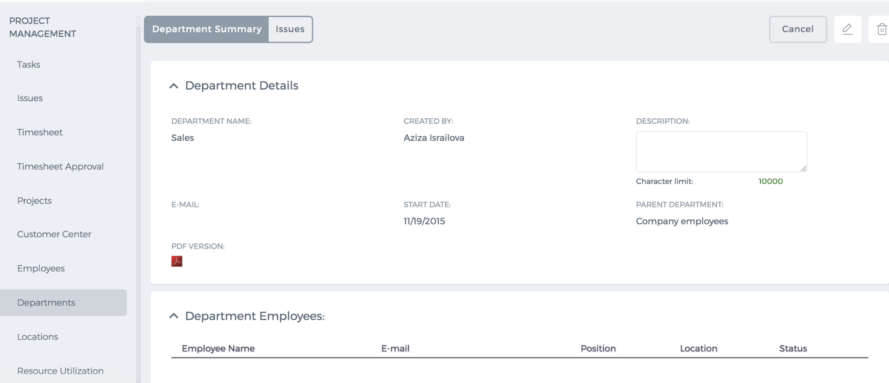 Edit Department To edit a department, please click on the Actions dropdown in the Department's list and make changes to the department such as changing the department leader, changing the name, description or the start date. 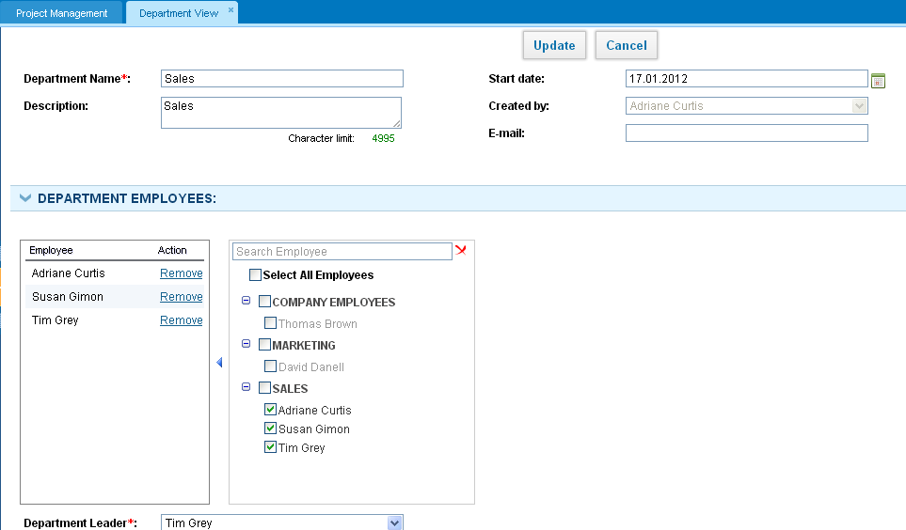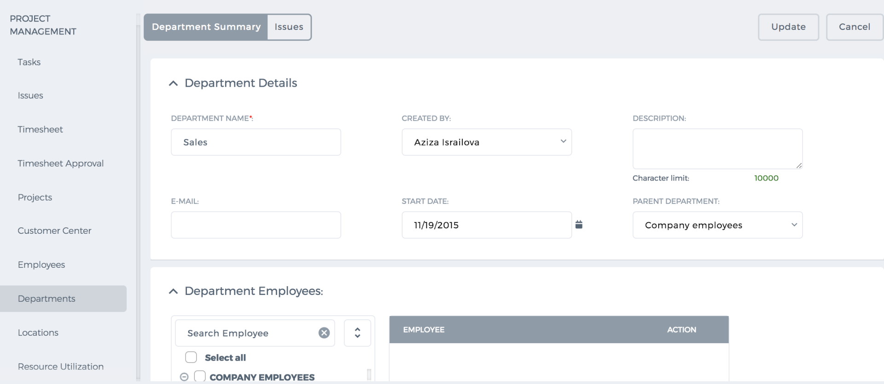 Also, you can remove some of the employees from the department either by unchecking the checkbox or by clicking the remove action. By default, when you remove employees from a department, they are moved to Company Employees department. Note that one employee cannot be a member of two or more departments. When an employee is moved to another department, the further timesheet entries will be reflected in a new department’s timesheet report. Older timesheet entries will be reflected in old department’s timesheet report. Department Notes You can leave some notes to the department you belong to. To do that, please go to Departments section, click on actions dropdown and choose Department Notes. You can make the notes public or private and save. Delete Department To delete a department, please go to Departments section and click on the actions dropdown and “Remove”. Once you approve removing an existing department, you will be asked to movedepartment members to another department. Department Issues In this section, you can add and keep track of issues related to the department. To create a new issue in the system, click on New Issue button and fill in the form. All members of the department are able to create issues and view existing ones by default.

Edit Customer

Edit Customer
To edit the Customer details, please go to Customer Center and click on the Actions dropdown and choose "Edit Client/Customer". 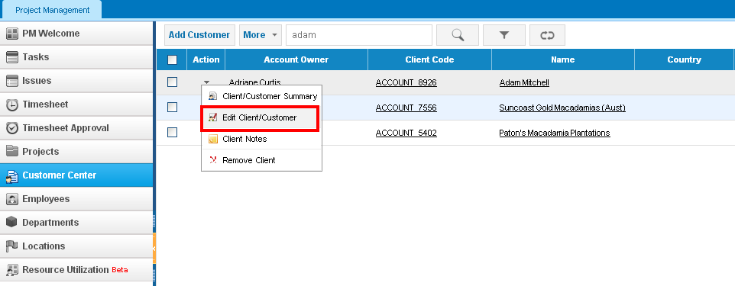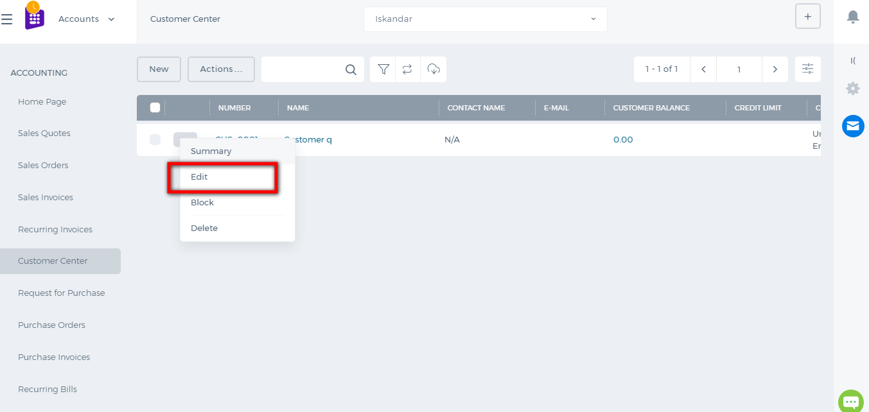 You can also edit the Customer details from the Customer Summary page. Just click on the edit icon shown below: 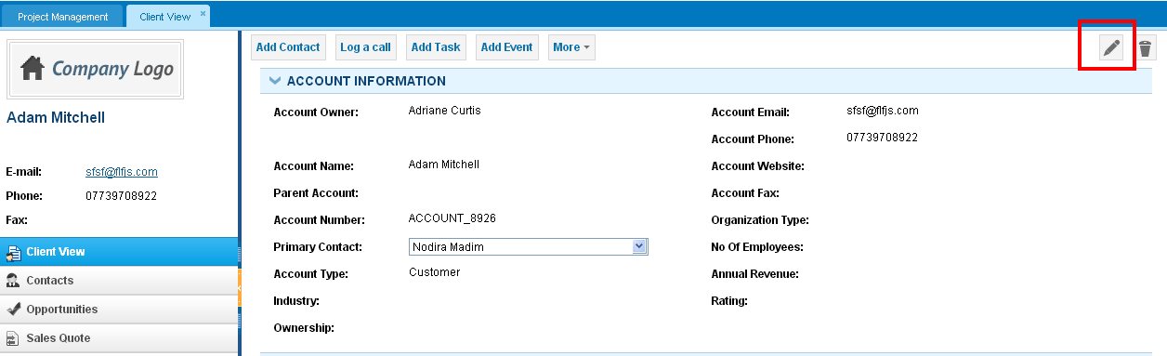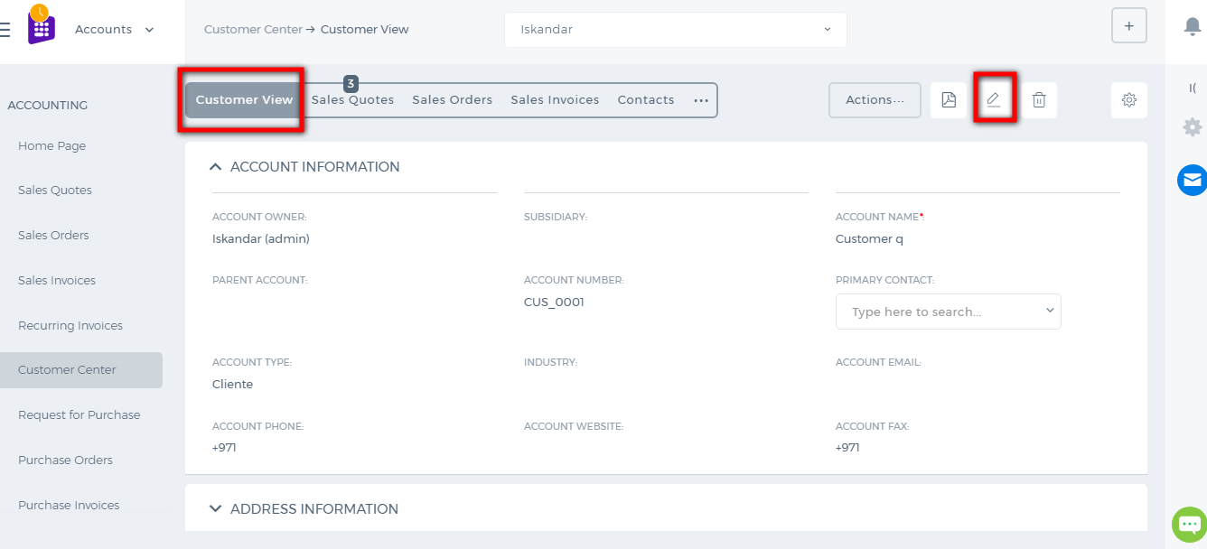 Once you update the Customer profile, the changes will be saved in all sections for the Customer.

Add Customer

Add Customer
The Customer Center in Project Management section keeps a record of all customers registered in the system. In order for an account to be a customer, the account type should be "Customer" wherever you add (from CRM section, Accounting, and Finance or Project Management). To add a new customer in PM, go to the Customer Center and click on New Customer button and fill in the form. 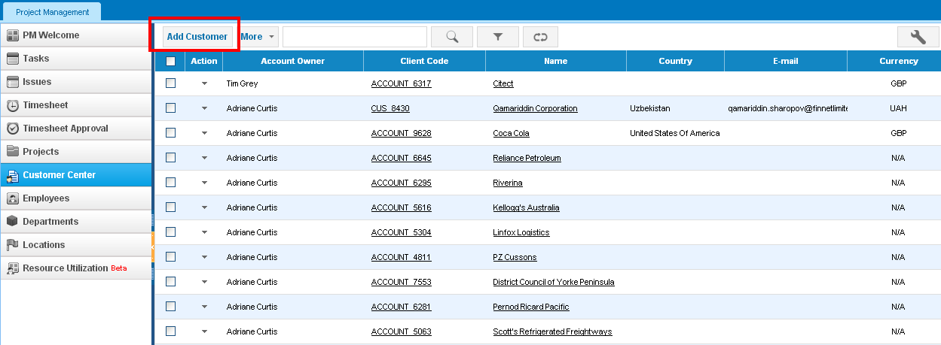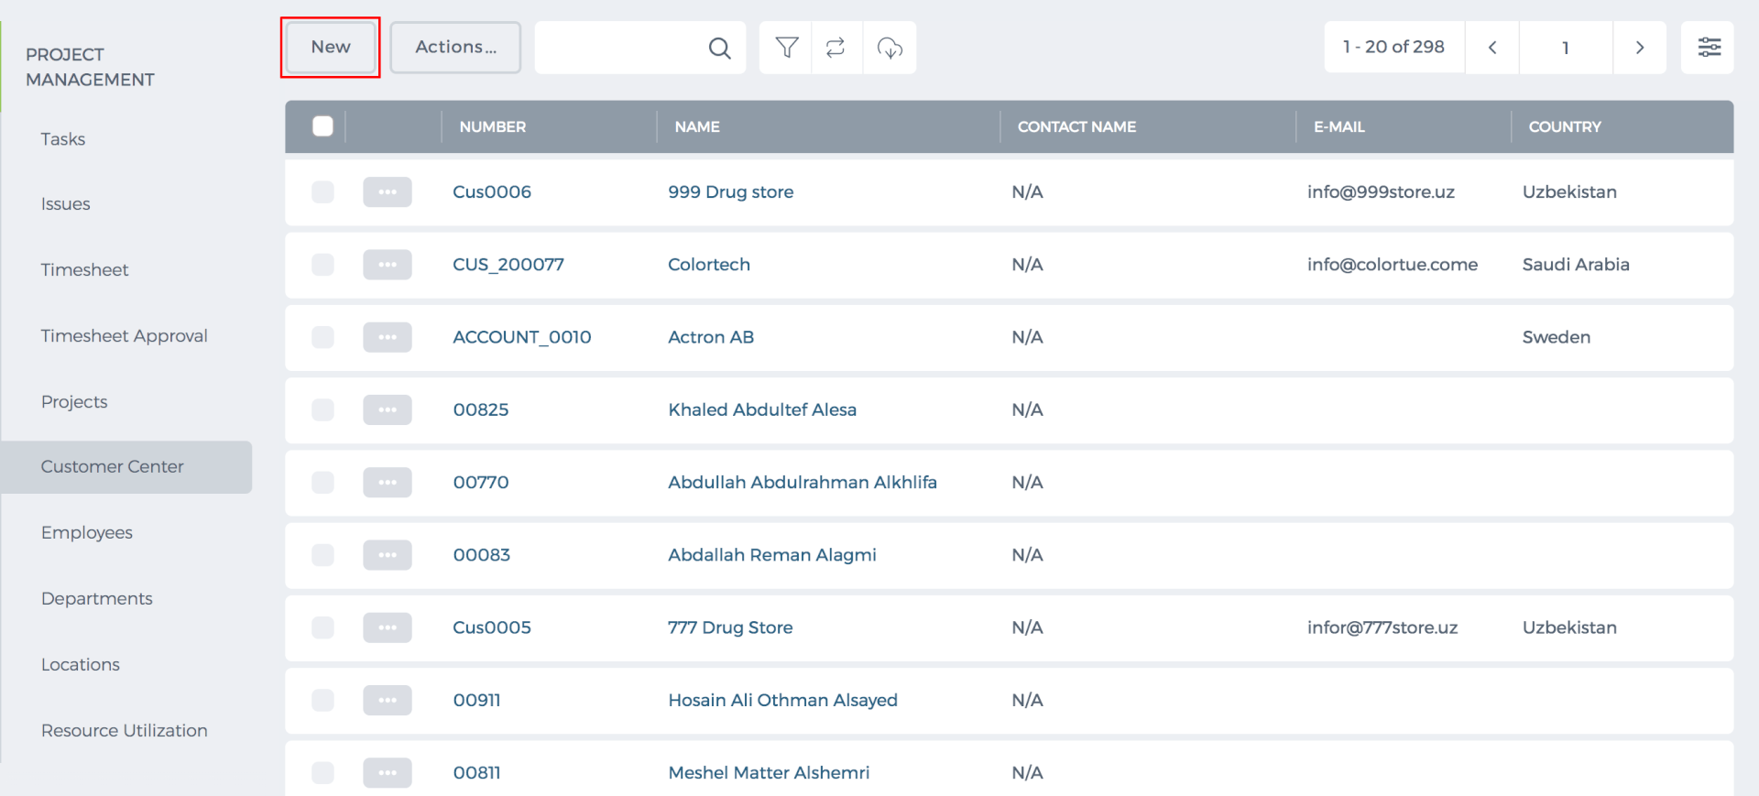 Once you have successfully added the customer, you can relate the customer to Sales Quotes, Sales Invoices, Sales Orders, Projects, Opportunities, and others. All the related items will be visible in the Customer Summary subsections 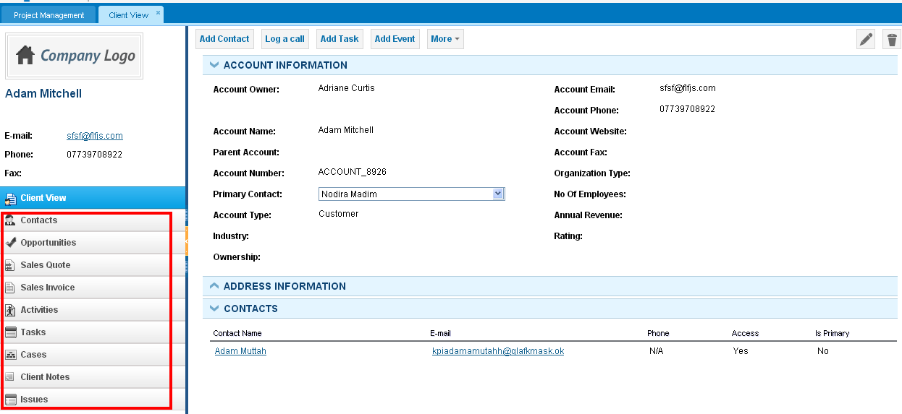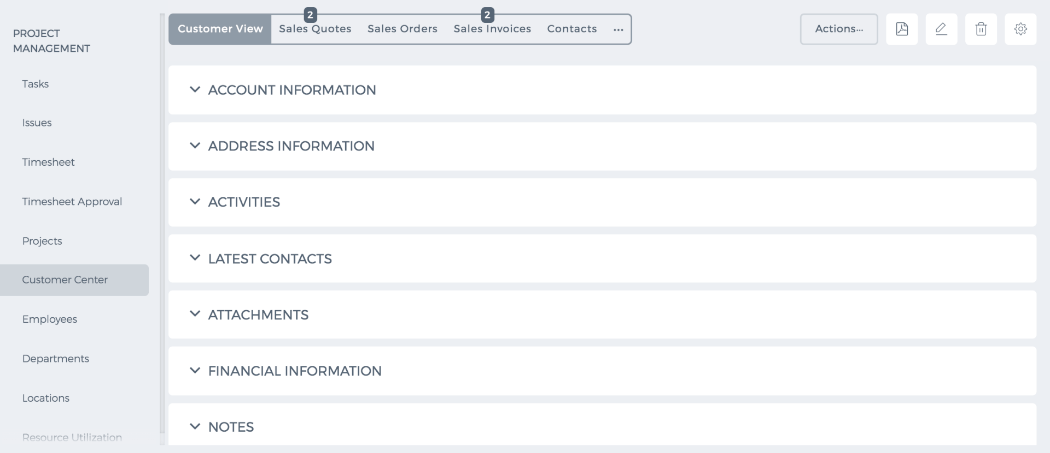 In new User Interface, you have the opportunity to link projects, cases, and activities by clicking the additional "..." button

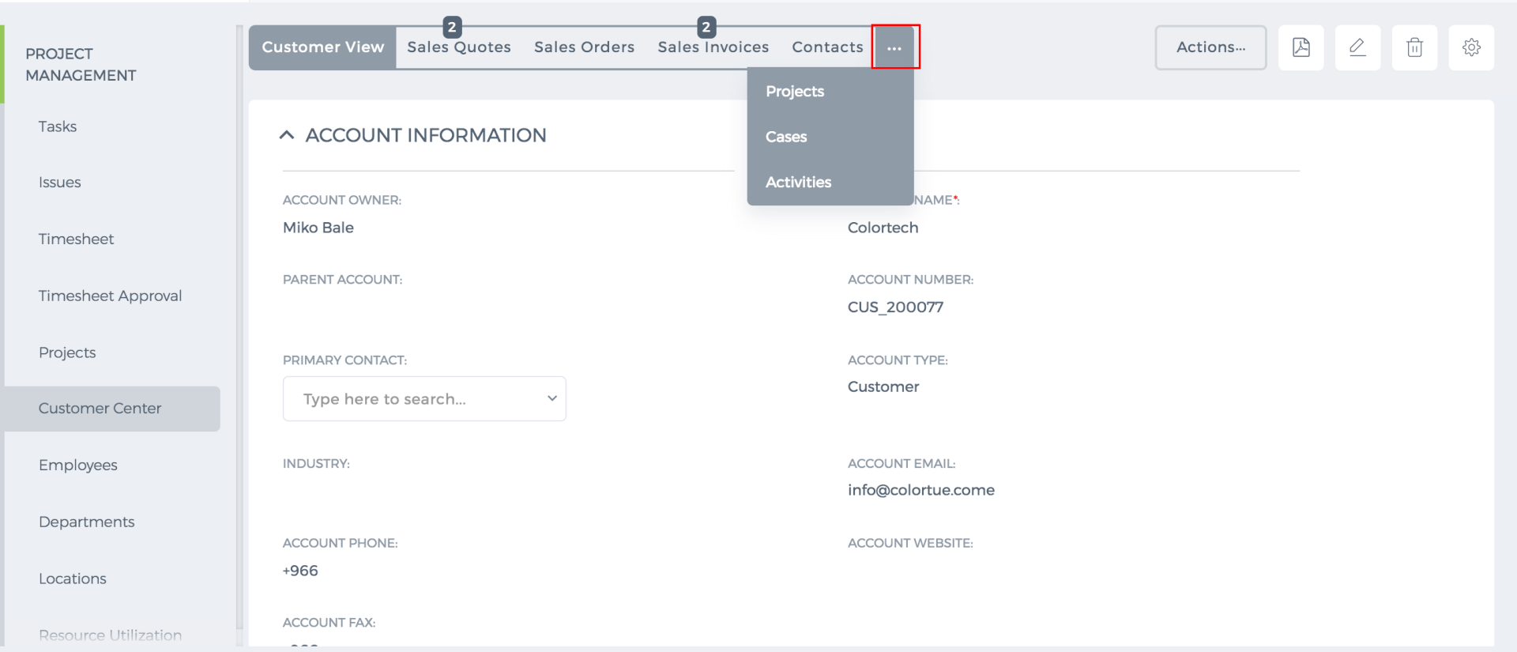
In addition, by pressing the Actions buttons, you can add contact, opportunity, event, task and look up on Google, also send sales quote and invoice.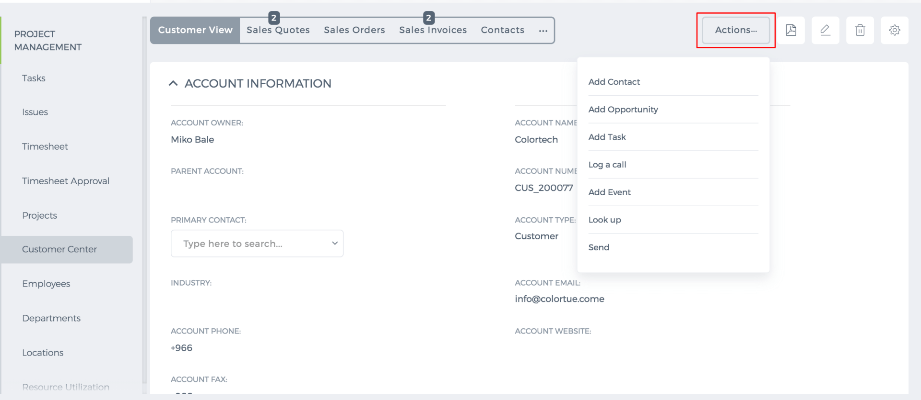

Employee Status

Employee Status
Pending Employees If employees have not yet activated their account after you added them to the system, their status is Pending. Active Employees Once the employee activates his/her account by setting password, the status becomes Active. You can make the active user's account as "no access" user. To do that, click on the actions dropdown and choose "Revoke Access". 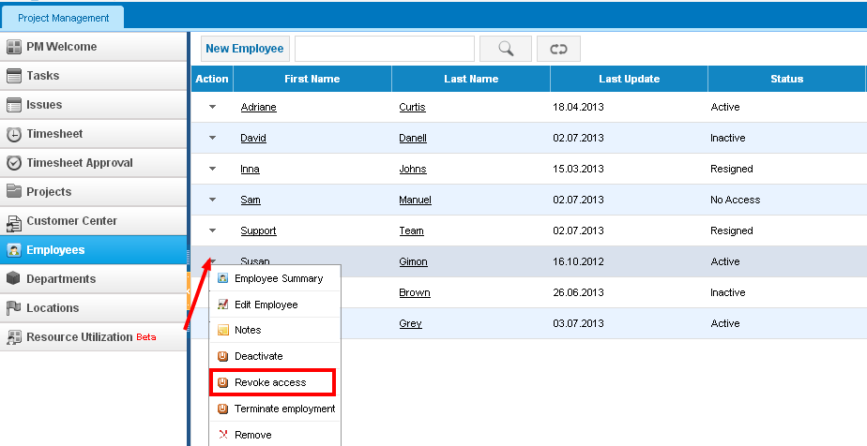No Access If you add no access users, their status is No Access. In order to learn how to add "no access" users, please refer to this article: http://wiki.kpi.com/document/employees/employees You can always activate the account of no access users who will then have access to the system from actions dropdown>>Activate button. 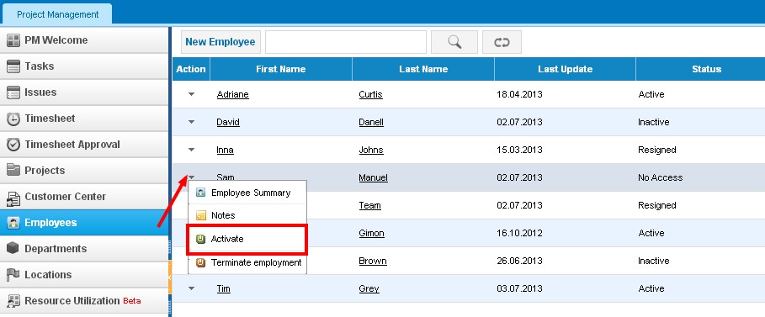The user will receive an email notification to activate his/her account. Inactive Employees If you deactivate the employee, he/she will not have access to the system and the status becomes Inactive. 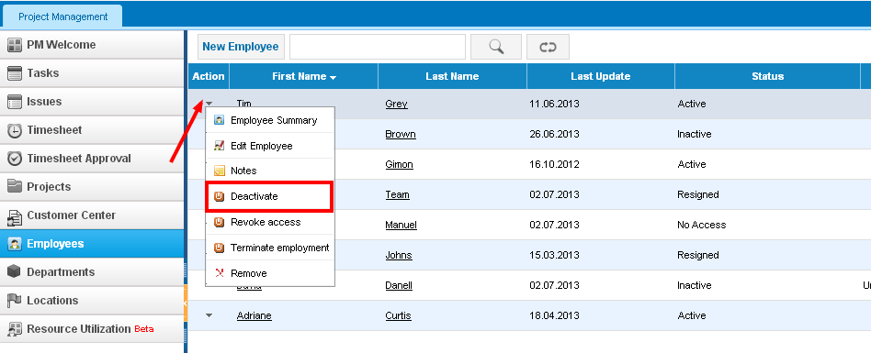You can also activate the profile of Inactive users by choosing "Activate" option from the actions dropdown. In order for the user to be able to set password, you need to send activation link from by clicking on "Resend Activation link" option. 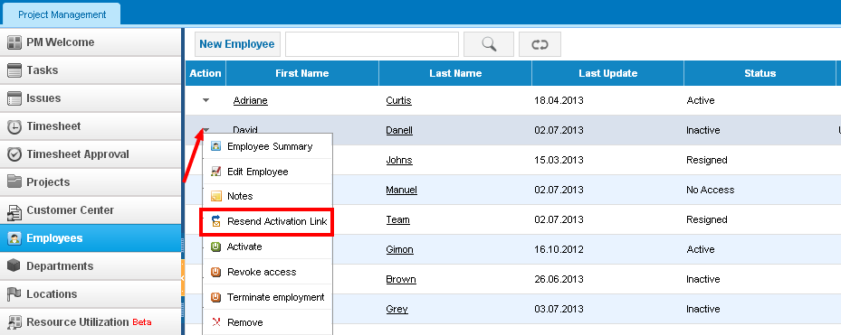Resigned Employees If you terminate the employment of a user, the status becomes Resigned. The employee will not have access to the system anymore and this gives you an opportunity to add more employees (increases license). 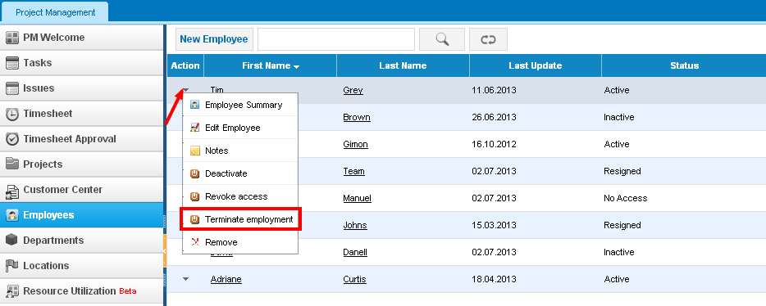

Employees

Employees
Employees section stores the list of your employees' personal and work related information. Add Employee In order to a add more users into the system, click on the New Employee button. 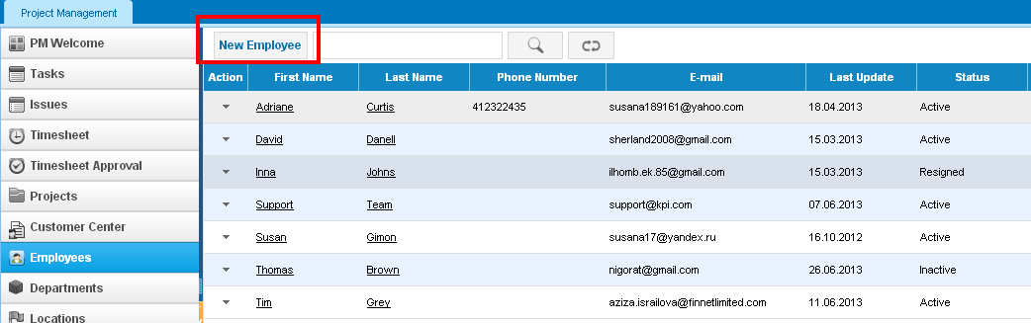Fill in the employee information such as first name, last name and email address. 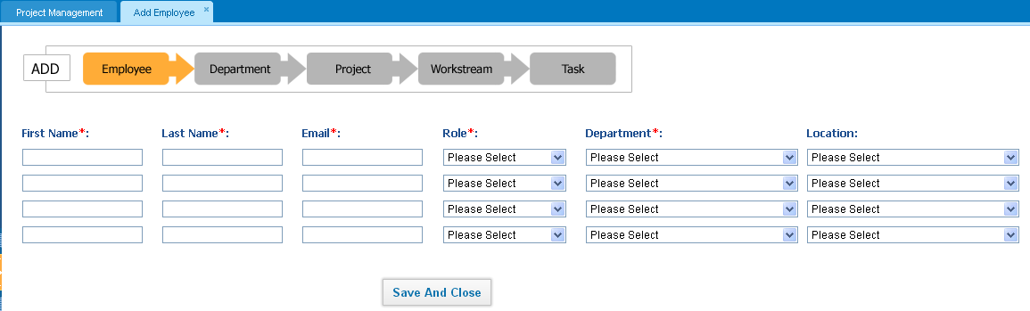Note that employee email address should be valid one, since the activation link will be sent to that email ID. Inactive Employees (No access users) You can also add inactive employees who will not have access to the system. Their employment information will just be recorded in the system. Adding inactive employee is done the same way as active employees. Click on the New Employee button and fill in the form, please check the "No Access" box. 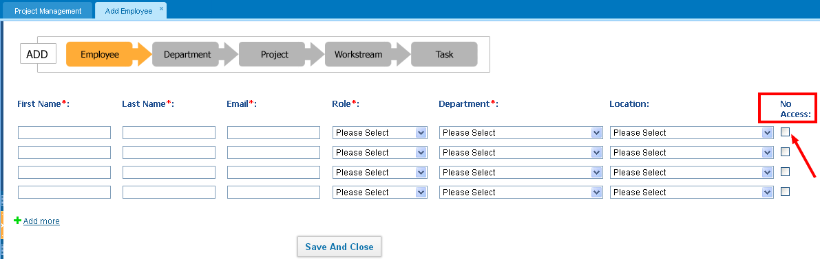If this option is not enabled in your account, please contact your account manager. Activating Account Once you have added an employee, he/she will receive an email notification on activating their account. When they press the link provided in the email, they will be asked to set their password in the system. Their username will be their email address.

Gantt Chart

Gantt Chart
Gantt Chart A Gantt chart is a horizontal bar chart, which is used in a project management. It is a Graphical illustration of the schedule that helps to plan, coordinate, and track specific tasks in project. To see the Gantt chart of the specific project, go to Project Management >> Projects and from the action menu click on Beta Gantt Chart. 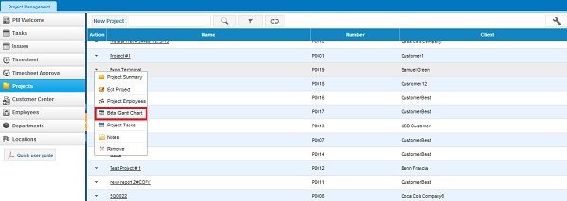If you proceed with the link following window will appear: 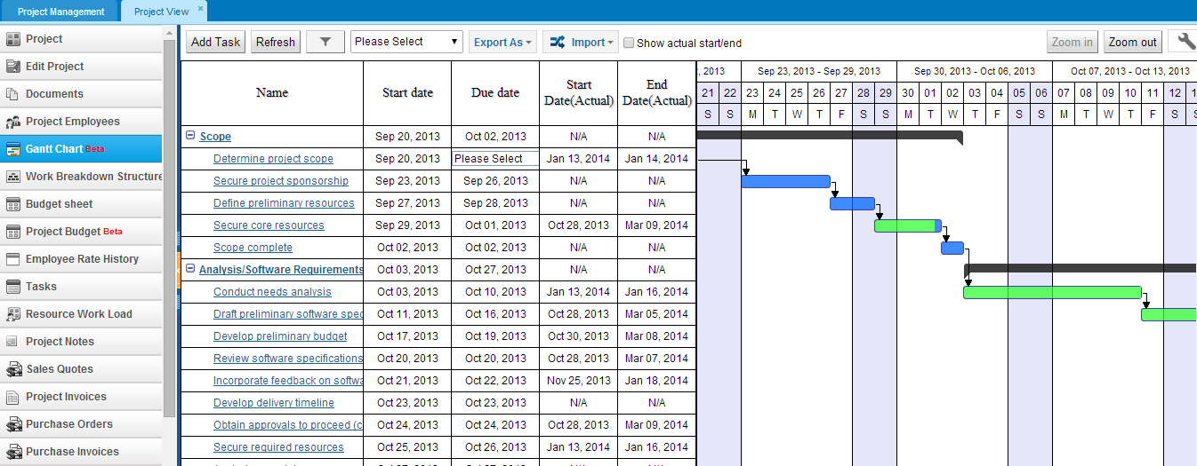Add Task –add tasks to the project. Refresh – refresh window with this button -filter the tasks by changing start and end date. After you have indicate start and end date, filter automatically changes moves back to the beginning of the week (Monday) and ending date will be automatically changed to the end of the week (Sunday). In the next box after filter box you can select an employee to filter the Gantt Chart. Export as –you can export your Gantt on excel Note: Exported excel sheet will be the same as the current view of the Gantt Chart on the browser. Import –import your projects to the system on MS project file, system will not upload projects in other formats. Show actual start/end –tick the checkbox to see the actual start and end date of the tasks. Zoom in/out – with this button you will be able to zoom in/out the second part of the Gantt chart where you will be able to see the daily, weekly and monthly tasks of the project. Customize Panel- in this panel you can add columns to be seen on the Gantt chart or vice versa hide on the Gantt chart. Moreover, in the Gantt chart with the quick cell edit option you can change information about dates, priority, estimated time and specify whether it is billable or not. In the second part also you can change the period of the tasks by moving the box of the task, also you can see how the tasks are interrelated with the specific color and what other colors mean: Black color stands on the top of the tasks which means that this task is the Workstream of other tasks. By dragging this box you can change the start and end date time of the worksteam. Blue color means incompleteness and the size of the box indicates start and end date of the task. You can change the date of the task by dragging and dropping the task. Green color, in contrast with the black color means completeness of the task. Pointers after the task which is linked to other task shows that next task is successor task which should be completed after the current task and the task which is pointing to another task is processor task. Further, administrator of the company can change permission to Gantt chart and limited roles or role will change the Gantt chart and other will be able to just view the Gantt chart.

Import tasks from MS-project

Import tasks from MS-project
You can import your project from three subsections of the Project Management module: from Tasks list, from Projects list or from the Gantt chart, but Gantt chart is not yet available in the new user interface. Click on the Import button and then MS project file. 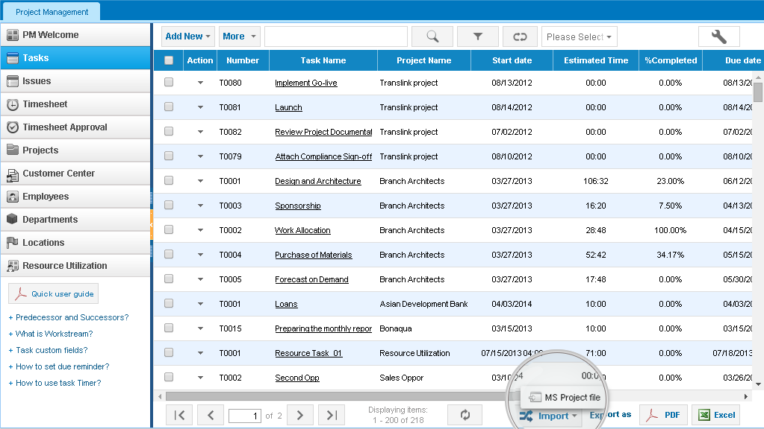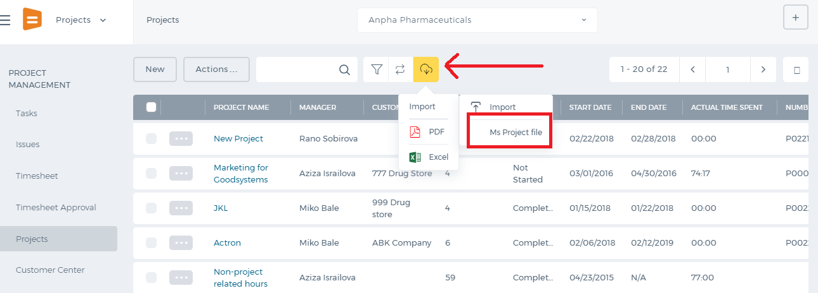 Then, you need to choose a file to import and select to which project you want to import your tasks by Select Filedropdown. Note that only .mpp and .xml files exported from MS Project are allowed to be imported. Also, there is a box called Import tasks as billable,which you need to tick, if you need to invoice your customers based on task worked hours 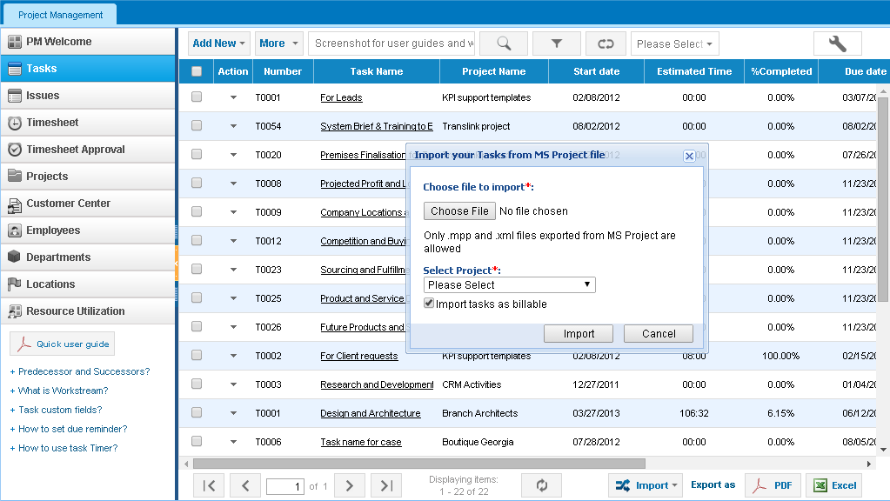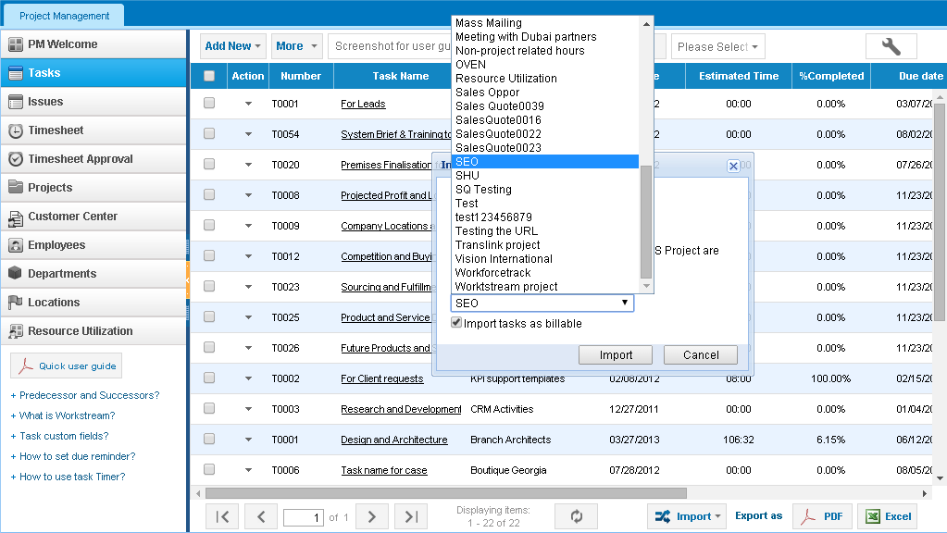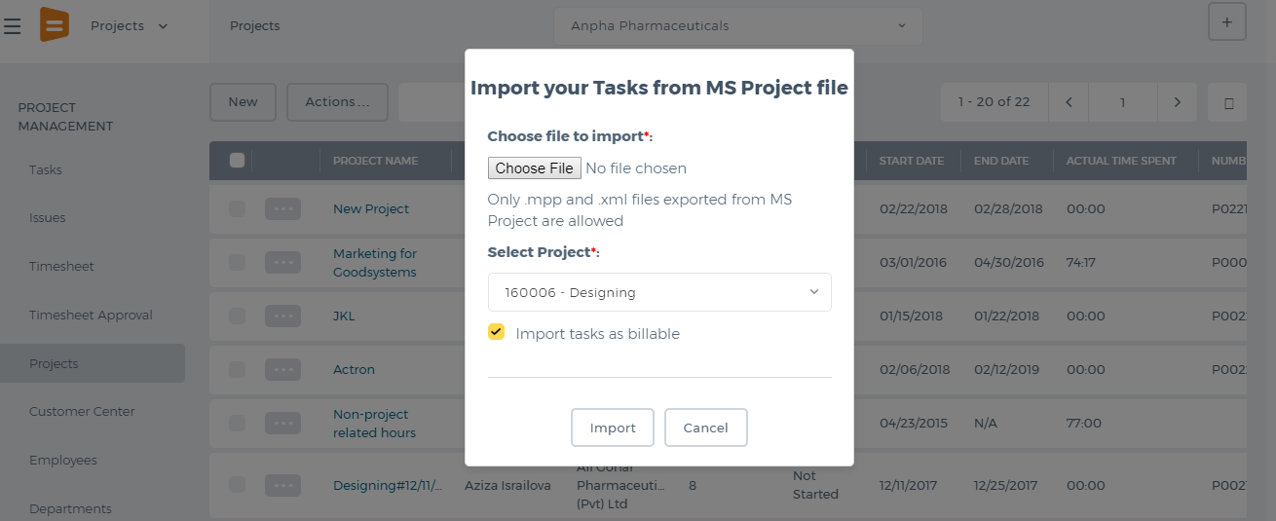 After selecting a project, click on Import and wait until it imports those tasks from MS Project file. The tasks will appear in the Task list.

Project Summary

Project Summary
The Project Summary page displays the main details of the project. 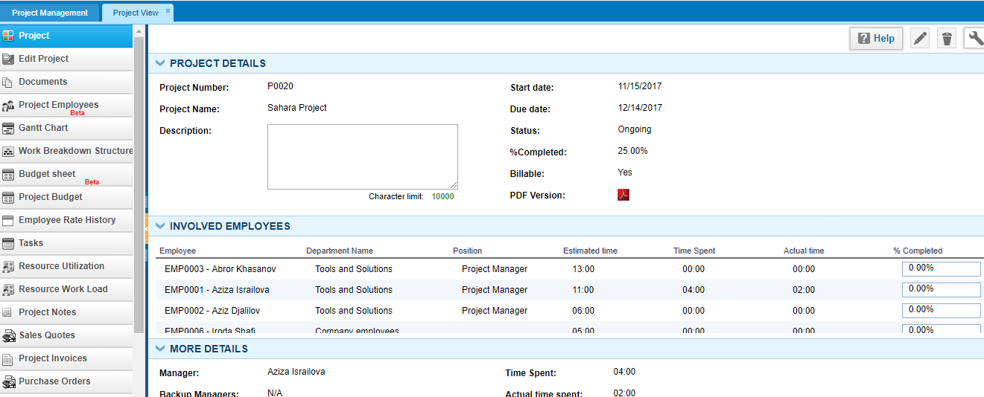 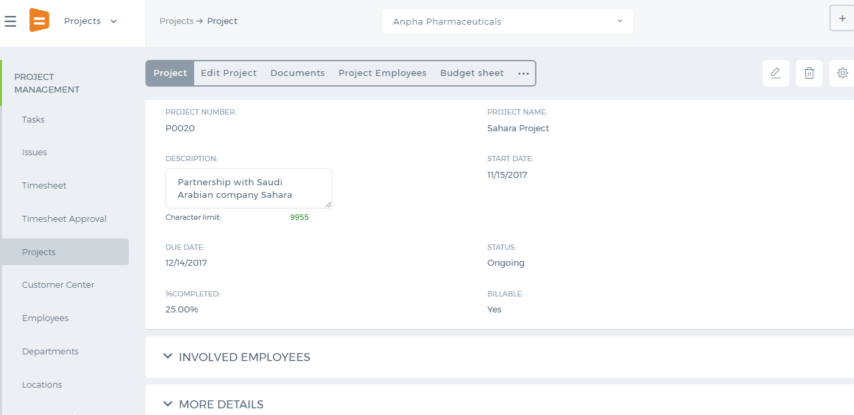 To view other information about the project, you need to click on More Details, Involved Employees, Task Details and other hidden tabs in the new user interface. Percentage Completed displays what percentage of the project has been completed. It is calculated using the completion percentage of each task and dividing it to the number of project tasks. Planned vs Actual tab displays planned start/end dates, and actual start/end dates. Actual Date is the date when employees started working on the tasks by entering the timesheet and completing the project. Planned Date is the date that you set while creating the project.
- Estimated Time is the sum of all estimated time of all tasks in the project.
- Actual Time is the sum of all approved hours in the timesheet.
- Estimated Cost is the wage rates of employees multiplied by estimated hours given.
- Actual Cost is the wage rates of employees multiplied by their approved timesheet hours.
Links shows the links to the items related to the project. You can add links while creating/editing the project or by clicking Add Links. For example, you can link the project to some of your contacts or opportunities in the CRM. Task Details Task Details displays the number of tasks for each status like Not Started, In Progress, Completed, Cancelled, Waiting for Someone else, and Closed tasks. Updates The Updates shows you the create and last update date of the project, as well as the employee who performed the update of the project. Involved Employees The Involved Employees tab lists all employees involved in the project along with their position and departments. Custom Fields The Custom Fields tab displays the extra fields created for the project forms. Attachments This tab shows the links to the files and documents uploaded to the project. You can upload more files by clicking Upload File or Documents.

