appraisal settings

VAT Reverse Charge Mechanism
What is Reverse Charge Mechanism? In the Forward Charge, the supplier of goods or services is responsible to pay tax to the government. However, under reverse charge mechanism the buyer or the recipient is liable to pay the tax to government. The main difference between Forward Charge and Reverse Charge is that the buyer of goods or services is responsible to pay tax to government instead of the supplier. Also, the tax under reverse charge mechanism is considered as non-refundable tax. How is Reverse Charge Mechanism used in Kpi.com? In Kpi.com, the only thing that you should do is to tick “Reverse Charge Applicable” in Financial Information of the supplier in Supplier Center. All Purchase transactions related to this supplier will be recorded under reverse charge mechanism. 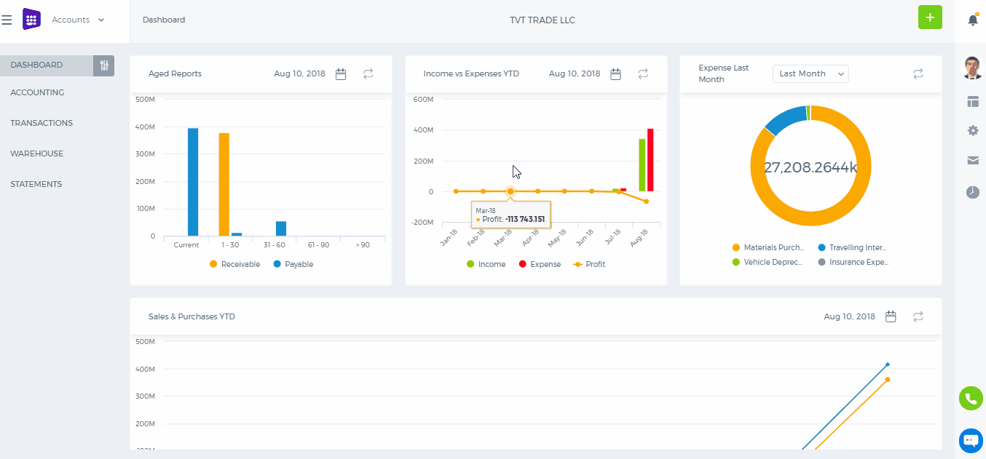 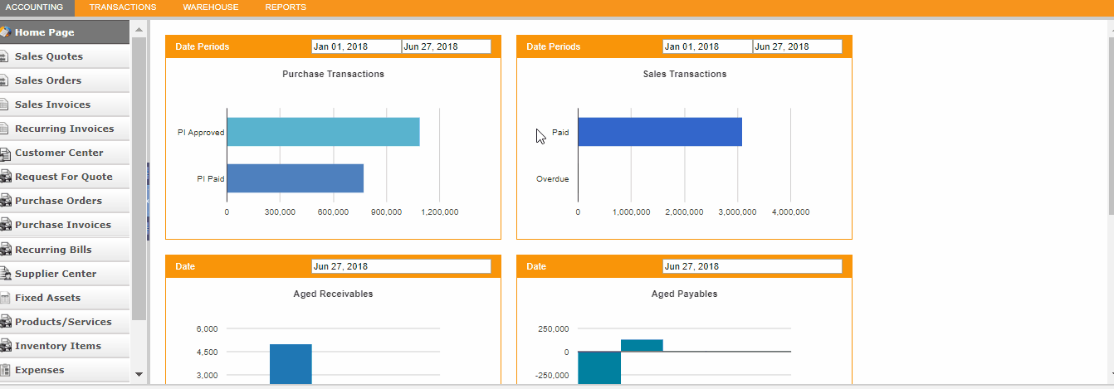

Importing data to kpi.com

Importing data to kpi.com
Import option is available in most sections of kpi.com and the file format for importing data is .csv in many cases. For tasks import MS Project file is required and for Bank Statements .ofx is also supported. The new user interface supports the vCard files,too. You can import Employees, Leads, Contacts, Companies, Products and Services, Bank Transactions, Tasks and more. In the classic user interface of kpi.com, the import option is available at the bottom right side of each section: 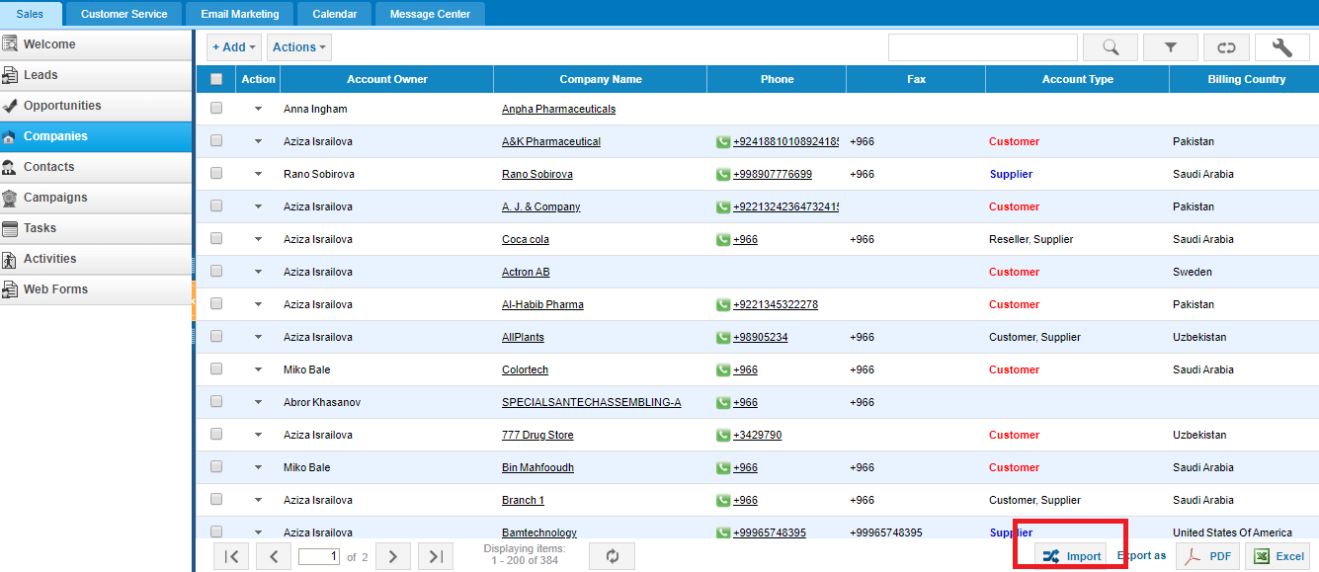 In the new user interface the import button is available on top of each setion: 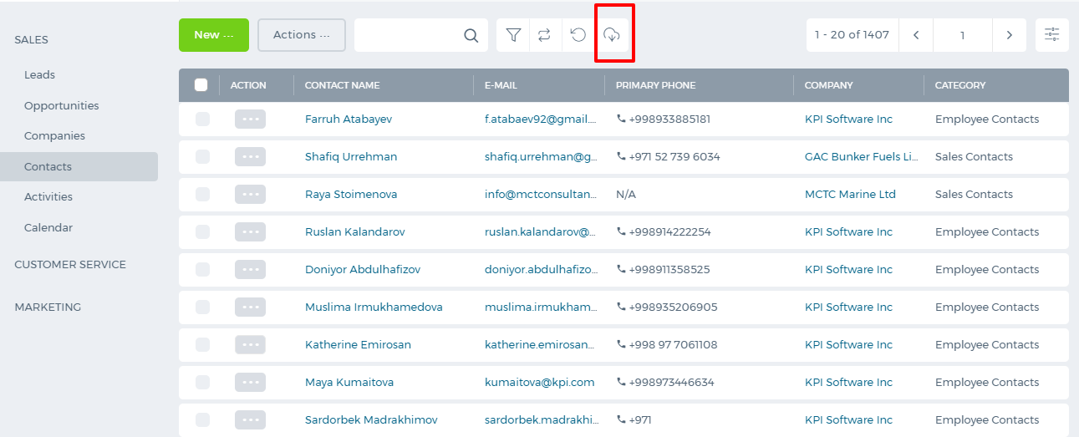 The sample .csv file is available for downloading which helps you to view how the format should be in order to successfully upload your data. 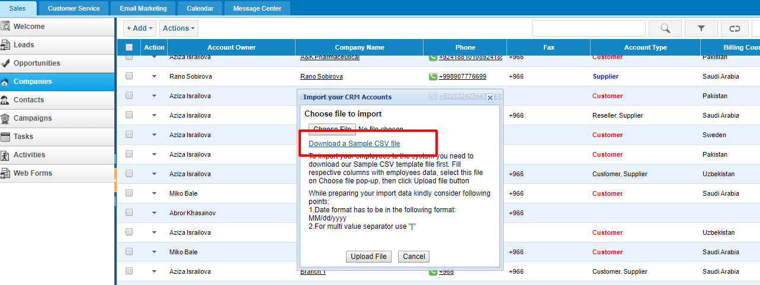 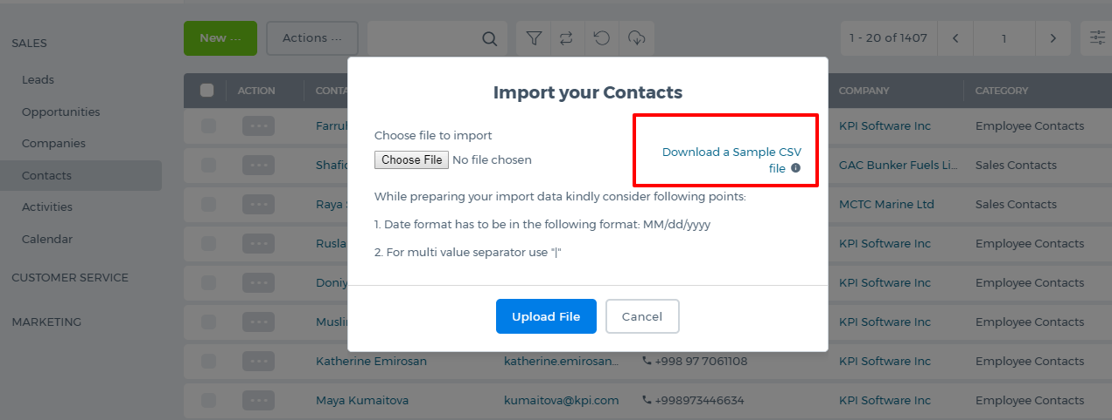 If your data is in an excel file, you need to save it as a .csv file first. 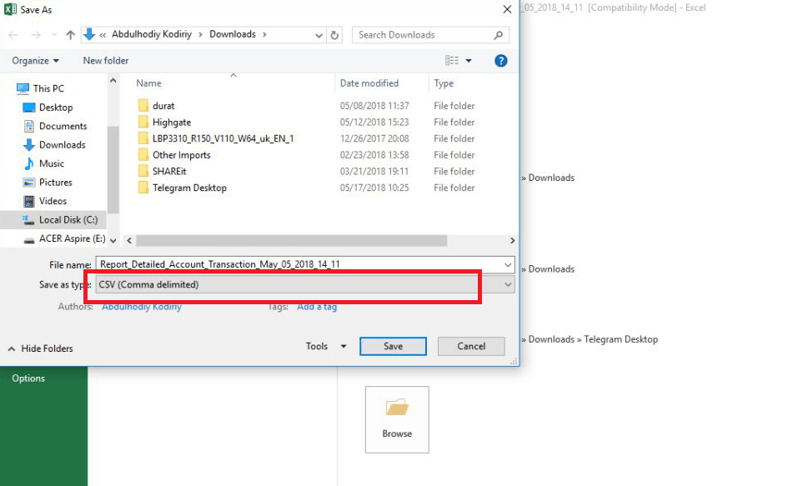 Then you can upload the file. After you have uploaded the file, the system will ask you to map the columns of your file with the system's columns. 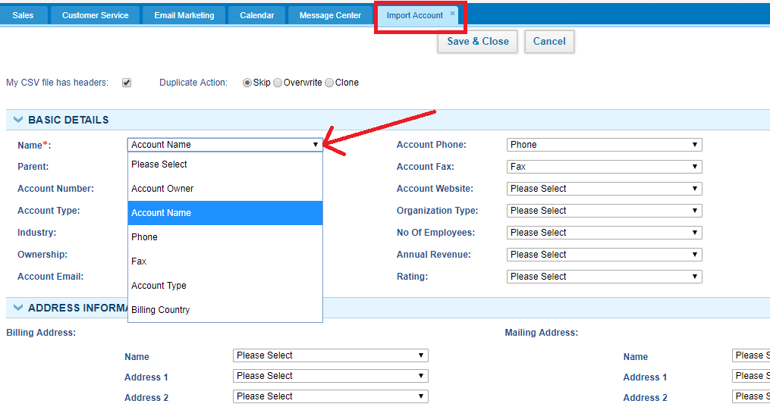 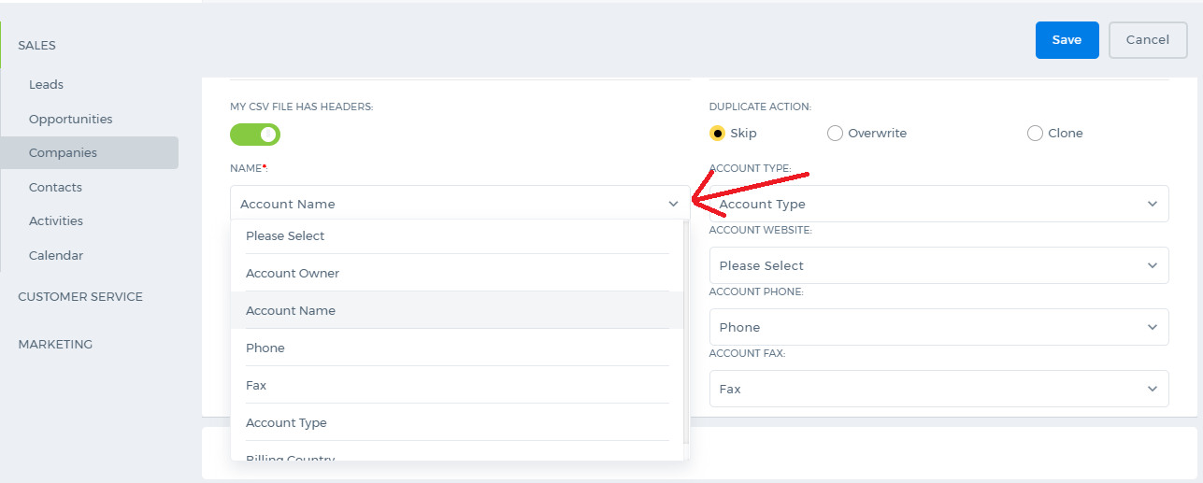 Once you have matched all the necessary columns, save it. The file items will appear in the list after some seconds. The upload time depends on the size of your file. The bigger the file, the longer it will take. Upon the completion of the import, you will receive an email notification about it. You can also track the upload process from Settings>>System Logs>>Import Logs: 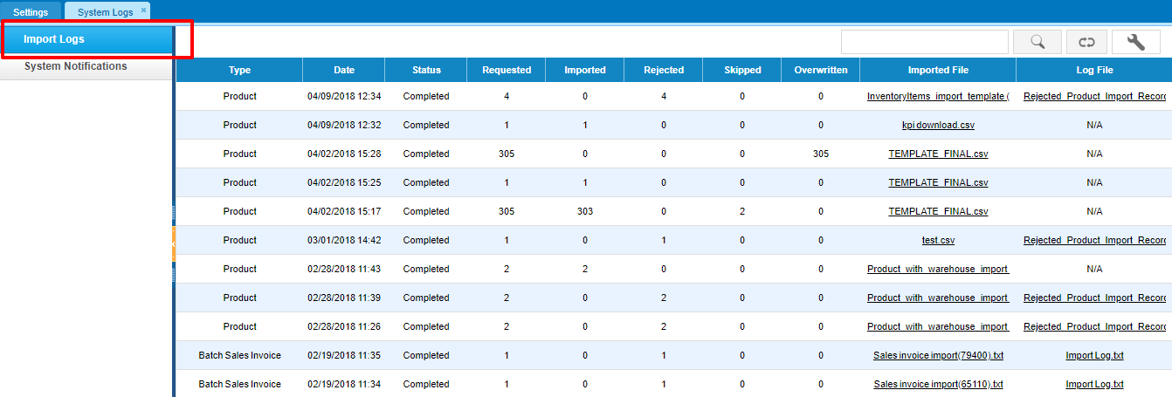 Using the Log File you can find out why some of the items were not imported. Using the instructions in the log file, you can correct the file and upload again. If you still need more assistance on uploading files, please contact Support Team at support@kpi.com.

New User Interface

New User Interface
We are delighted to introduce the new user interface of our application kpi.com to customers. It is simple, straightforward and more up-to-date. In order to get started with the new user interface faster, we would like to explain where to find and use the functions since it looks totally different now. Modules are chosen from the top left side by clicking on the dropdown. 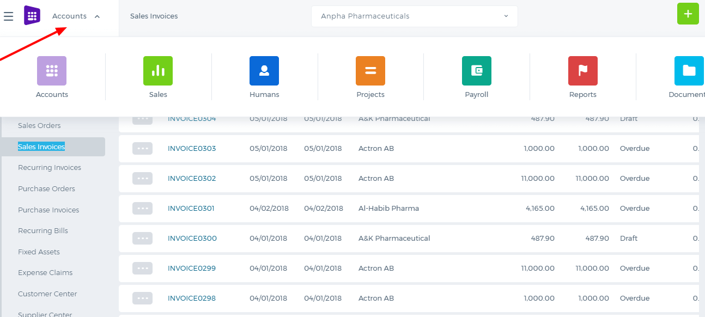 The Tabs under each module are now located on the left side menu, clicking which populates the main functions. 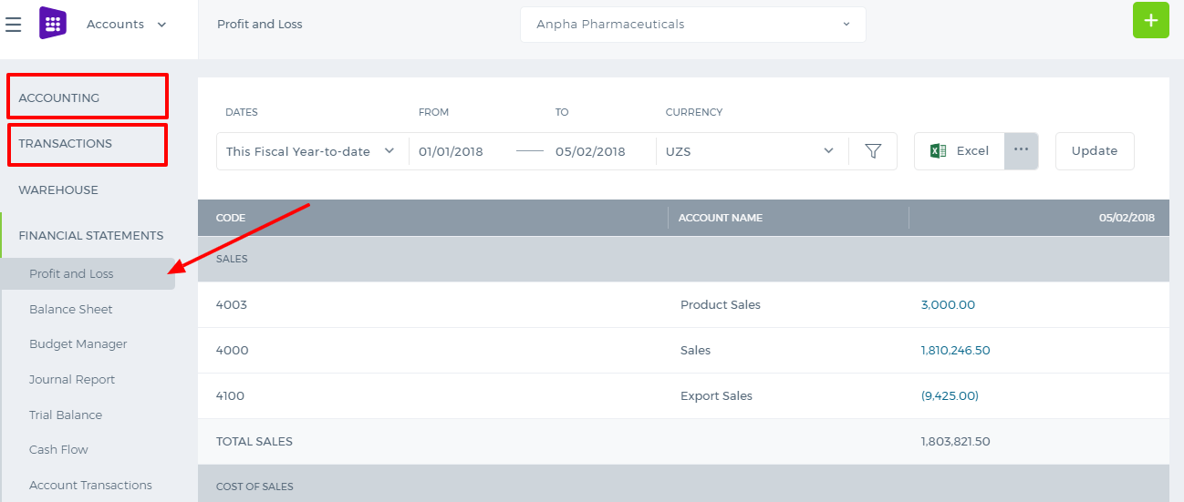 The pages and the import options are on top of each section. 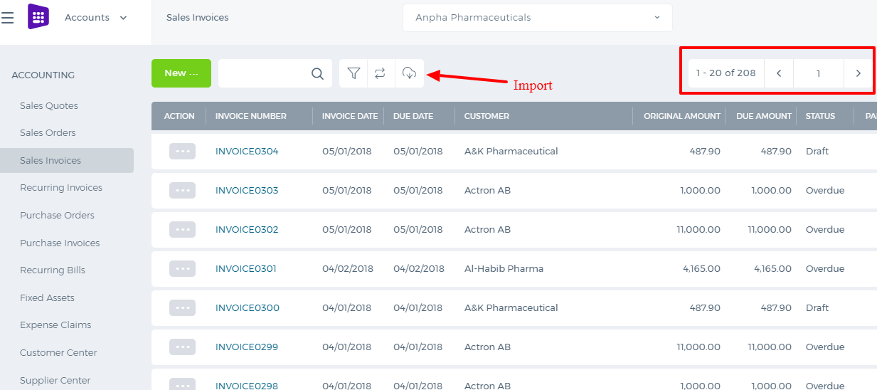 The best part of the new kpi.com is that it supports the Kanban View now. Click the icon shown in the screen shot and enjoy the lists. 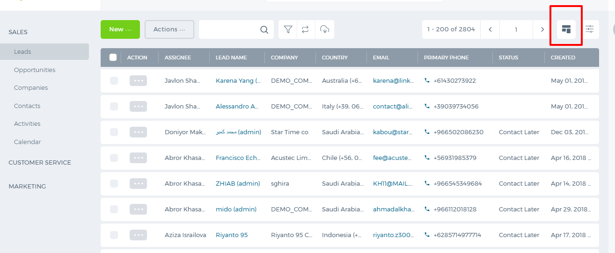 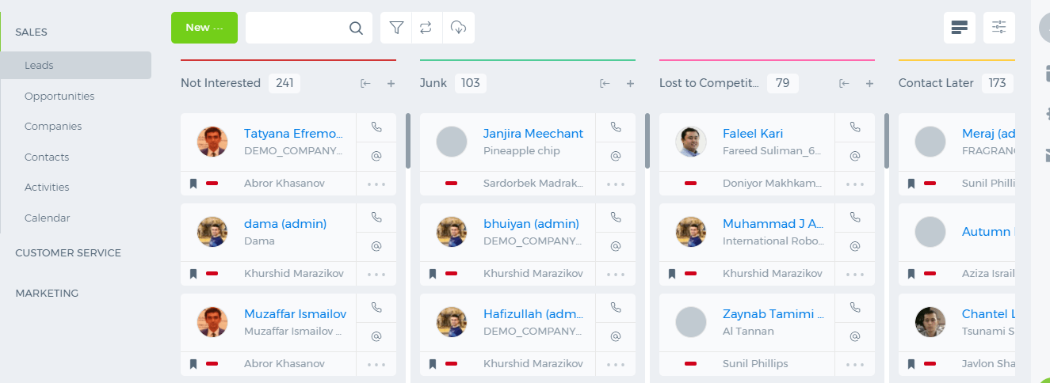 Settings in on the right side, clicking which will show you which settings to choose. 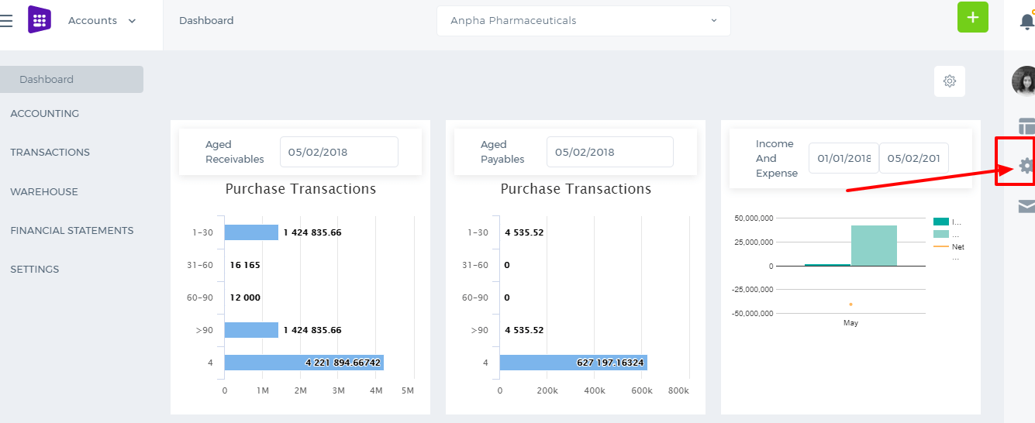 If you have multiple companies, you can switch to them using the dropdown shown in the screen shot. 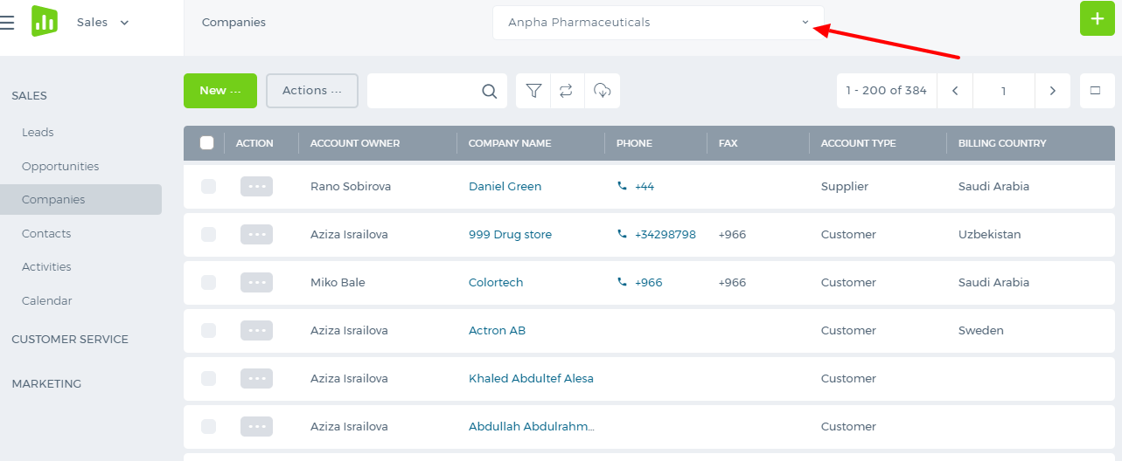 The live chat support and send feedback option are available through the icon shown below: 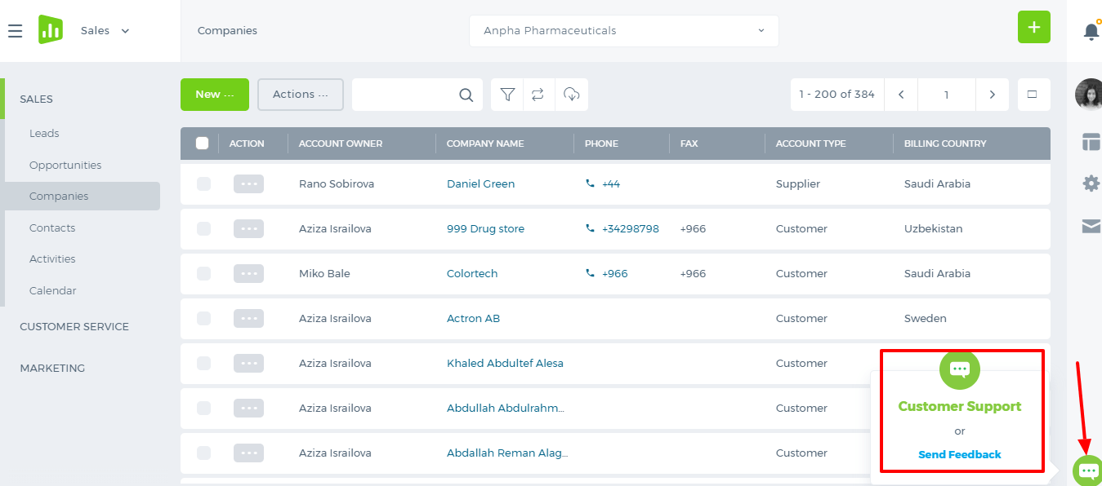

Company IP address

Set up Company IP address
In order to limit the access of company users to the system from outside of the company, you can set up your own company IP Address (or IP Address Range) through Settings>>Company Settings: 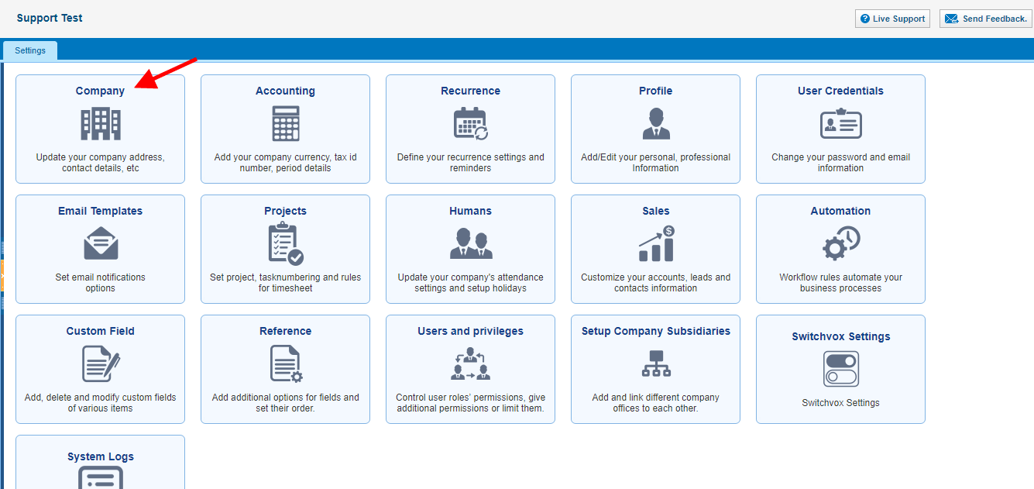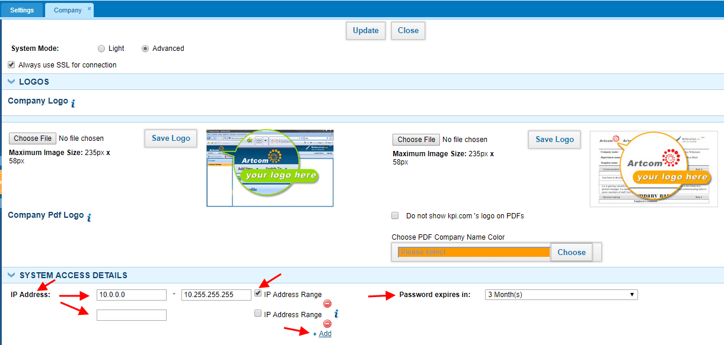 While you set up IP Address (or IP Address Range), company users can access the system only from the indicated IP Address (or IP Address Range). Moreover, you can set up Password expiration period in order to make your company account more secure.

Accounting Settings

Accounting Settings
Accounting Settings can be accessed through Settings on the top-right of the screen >> Accounting 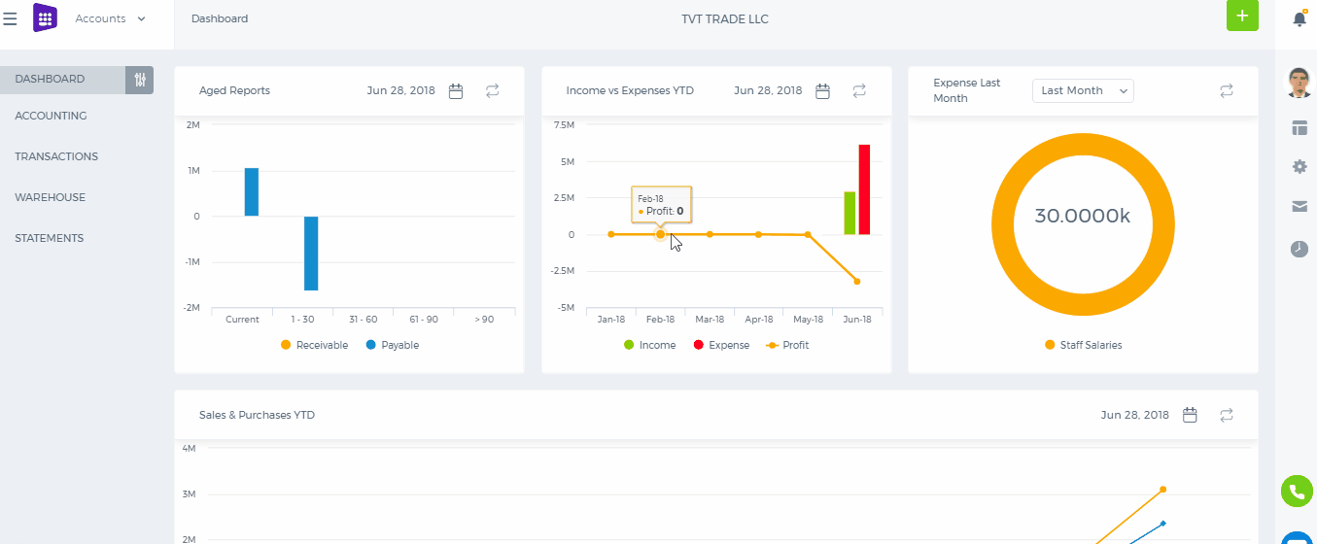 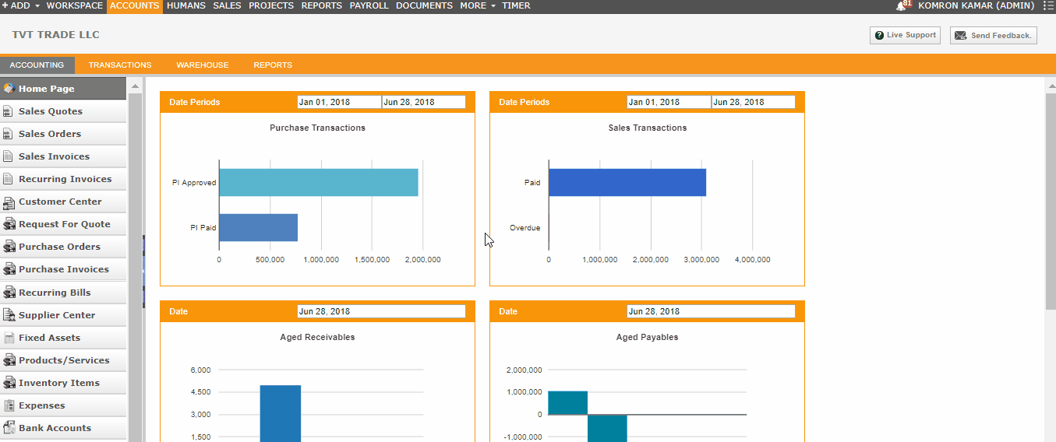 Accounting Settings lets you view and change the majority of the most important settings ranging from seeing your invoice templates and giving different discounts to your products and services to creating shipping methods and working with your charts of accounts. Invoice Settings Here you can change the format of your invoices, choose payment gateways like giving your PayPal account, your bank accounts, choose whether they are tax inclusive or tax exclusive and also choose your company logo which will be seen in your invoices. Financial Settings Here you can enter your financial settings like the currency you work with, whether they are fixed, choose the number of floating point rates for your calculations, choose whether you need VAT return report and create certain sales taxes with their proper names, percentages, period they should be calculated and so on. Account Numbering Here you can provide starting and ending numbers of your Assets, Revenue, Expenses, Liabilities and Equity. Numbering Settings Here you can give the numbers of all your documents including product numbering, sales quotes, transaction numbers, bank payments, receipts, stock adjustments, invoice numbers and others. The system is built such that every time when new document is being created, its number is generated by incrementing the previous number and thus documents will be sequentially sorted. You can also give certain date of the year from which all numberings will restart count again Tax Rates In this part of the Accounting Settings, you will be able to see your tax names and rates and also create new one by providing necessary details. Currency Rates Here you can see and manually enter your currencies and their exchange rates. Discounts Here you can view, create and set up your discounts and provide the list of products and services they apply to. Measurements You can create and change units of measurements that are used for calculation of your products. Product Category Different categories for your products and services can be created here. You can categorize your items by their color, audience they are made for, such as age group, sex, region and so on. Brands Brands of your products can be added and viewed in this section of the Accounting Settings. Shipping Method Here you can add different shipping methods by providing their names, price, which account they are charged from and their tax rates. Payment Methods In this section, you can specify methods of payments such as Bank transfer, Cash, Cheque, Credit/Debit card, Wire Transfer. Invoice Templates Here you can see templates for invoices and buy them if you wish. Chart of Accounts In this section, you can find the chart of accounts which is a listing of all accounts used in the general ledger of an organization. The charts are usually sorted in order by account number, to ease the task of locating specific accounts.

How to customize a report?

Request for quote

Request for quote
Request for quote (RFQ) - documented request of an organization interested in purchasing goods or services, to suppliers in order to determine possible purchase prices. In kpi.com you can find Request for Quote using Accounts >> Request for Quote 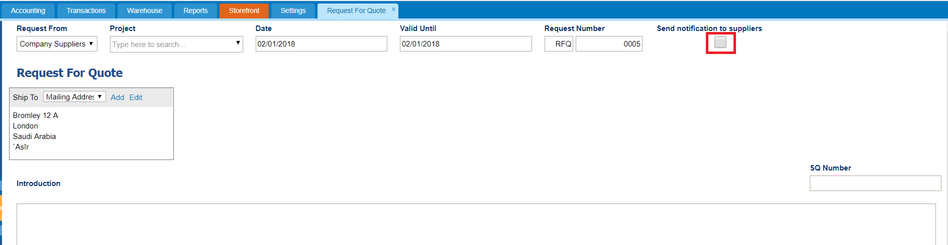 Here you can see button Send notification to suppliers which informs suppliers about that quote request by email. 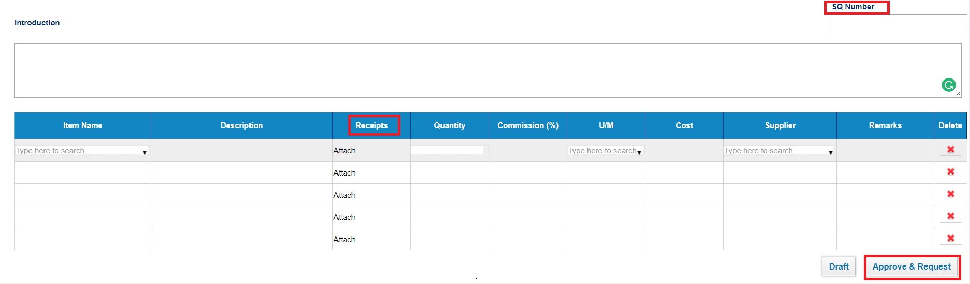 Next, you have to fill an item, quantity, supplier and other fields and then approve it. SQ number - optional field, related to sales quote. Receipts – here you can upload documents for that quote. When you have approved Request for Quote, there is an option to Send Quote to supplies or convert it to Purchase Order. 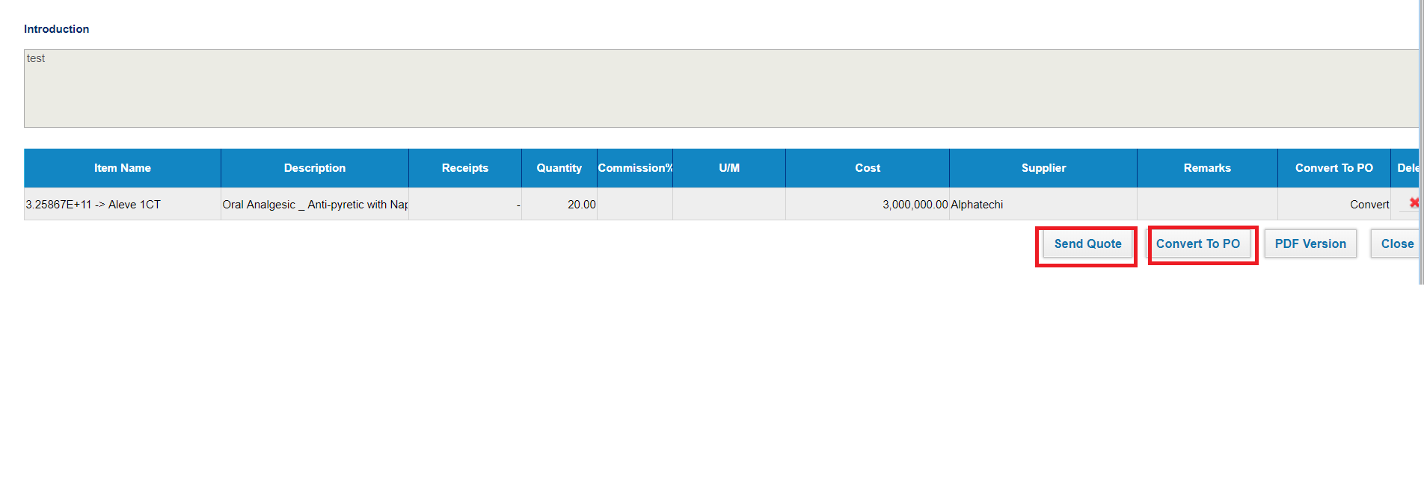

Logo modification

Logo modification
Company Logo modification In order to set up or change your company logo, you have to upload the picture of your (new) logo with the necessary size (max 235px x 58px) under the Logos section in Settings>>Company Settings. 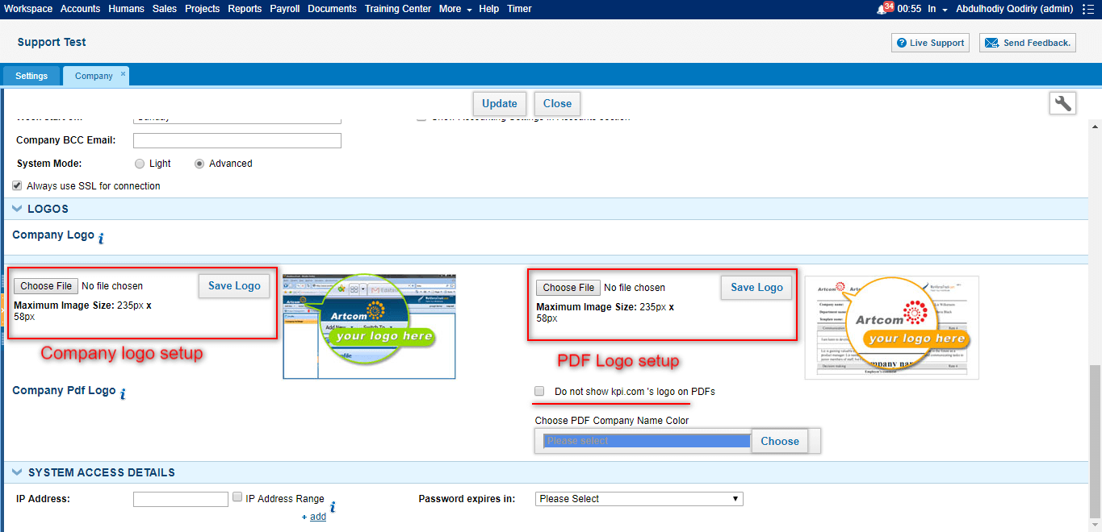 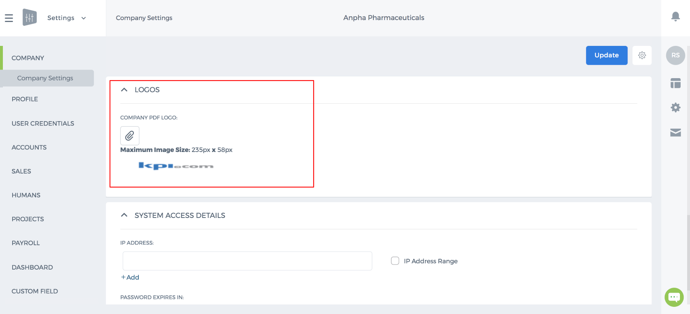 PDF Logo modification PDF logo modification is next to Company Logo settings as indicated above where you can easily save your company logo to be shown in all default PDF templates in your company account. Additionally, you can make kpi.com logo invisible on your default PDFs. At the last, you can update the company settings in order to save all performed modifications.

Recurring tasks

Recurring tasks
A recurring task is a project-related task that can repeat at regular intervals (such as daily, weekly, monthly etc) and always have the same duration and attributes. For example, you might define the daily project progress meeting as a recurring task. To create a recurring task in kpi system click on the Advanced Options on Add task form and tick Recurring checkbox. It will show different recurrence options: 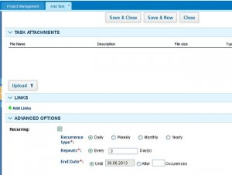 Once you have checked recurrency option and fill the blanks, you can see your all repeated tasks in Task field in Project Management : 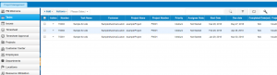 Now you can check all progress of your task in Timesheet, starting from the data of creation: 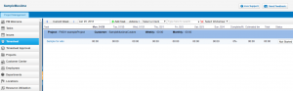

Request for purchase

Request for purchase
Request for Purchase is a request where you ask your purchasing department to provide a particular quantity of a material or a service for a particular date. You can add Request for Purchase in kpi.com using Accounts >> Request for Purchase 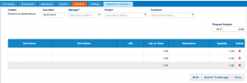 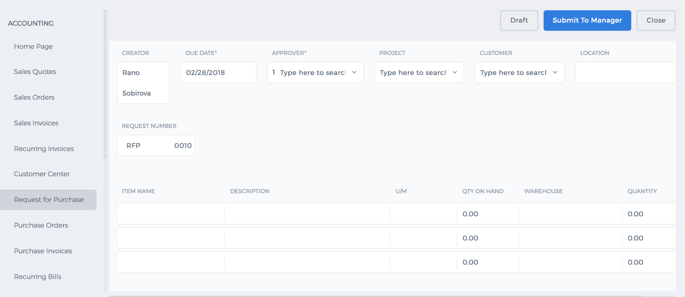 Creator – the person who creates request for purchase Due Date – required field to fill, date until that particular request is active Manager – a responsible person, also required field to fill Project – to which project this request is related When you fill all the fields, click Submit to Manager – it will automatically send the request to responsible Manager and if manager approves it will show the status Approved. If you are the manager, system shows Save and Approve automatically : 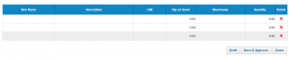 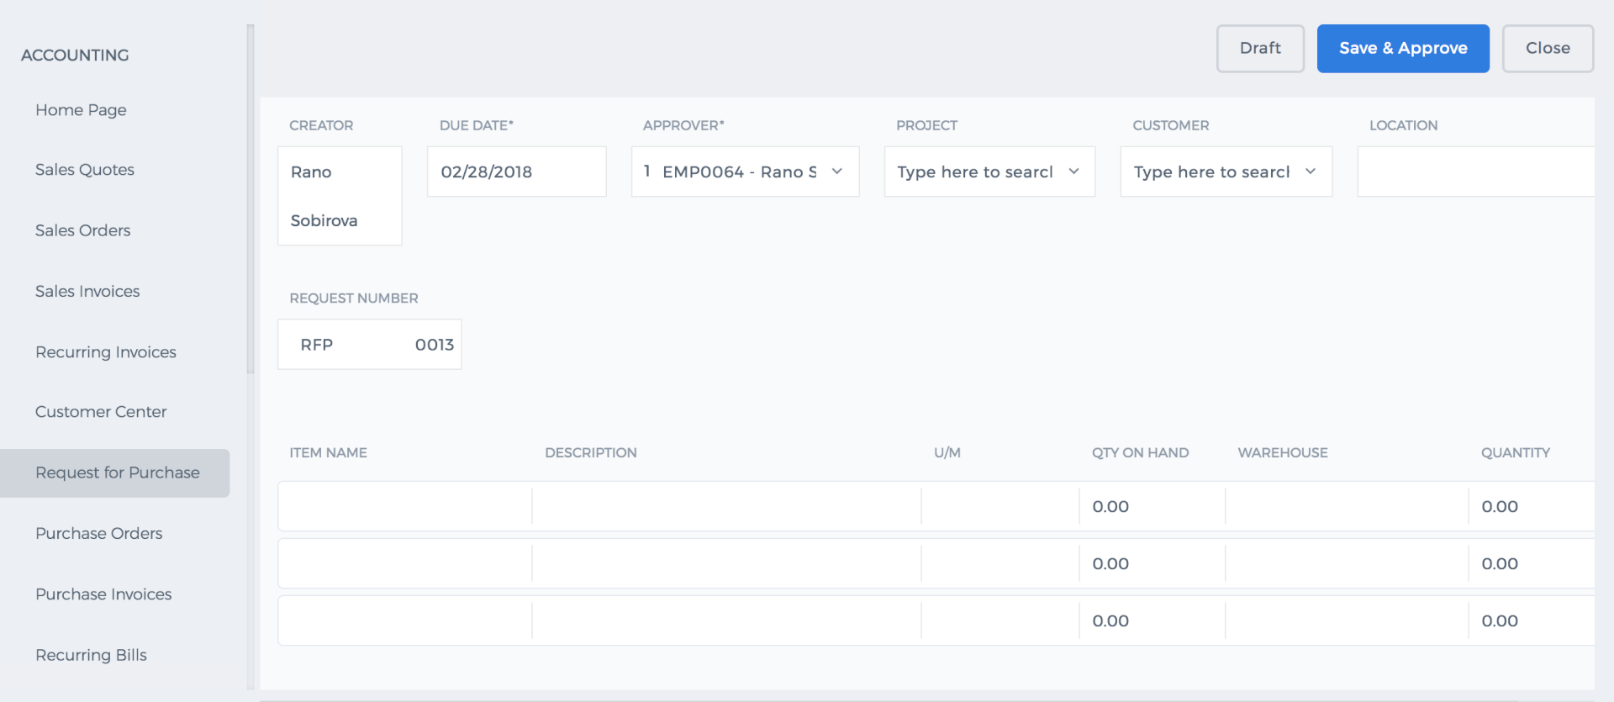 When the request is already approved by the manager, you can convert your request to PDF version or convert to Purchase Order, RFQ, Stock Adjustment: 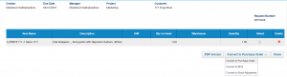 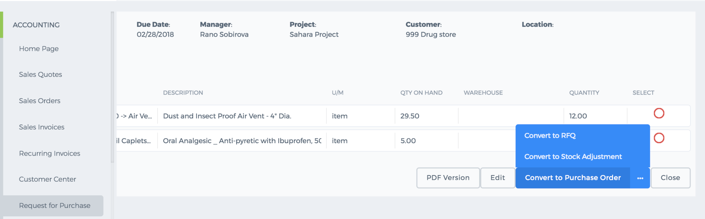 If you click Convert to the Purchase Order, it will show you new Purchase Order table with an already selected project and date, you can fill other information by yourself and then convert it to Purchase Invoice. 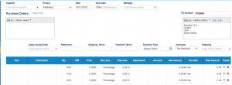 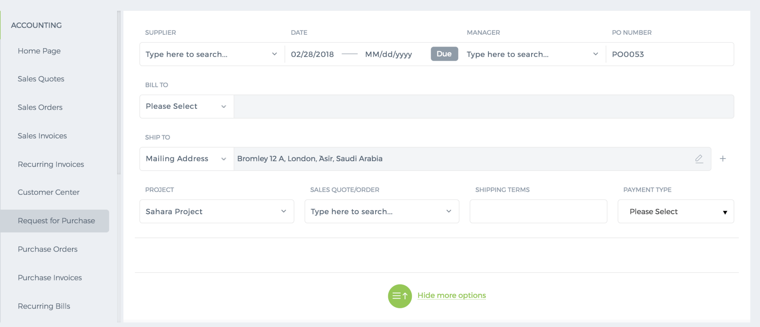

Warehouse

Warehouse
A warehouse is an additional feature, activated by per request and also the place to store products in different locations.
You can find a warehouse in Accounts >> Warehouse >> Warehouses
You can add a warehouse by pressing “Add” button and fill the information of warehouse.
There are searching and customization features in the top right corner.
In addition, all warehouse can be exported in PDF or Excel format. You can do it in the bottom right corner.
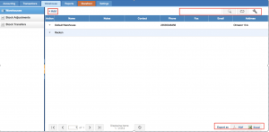
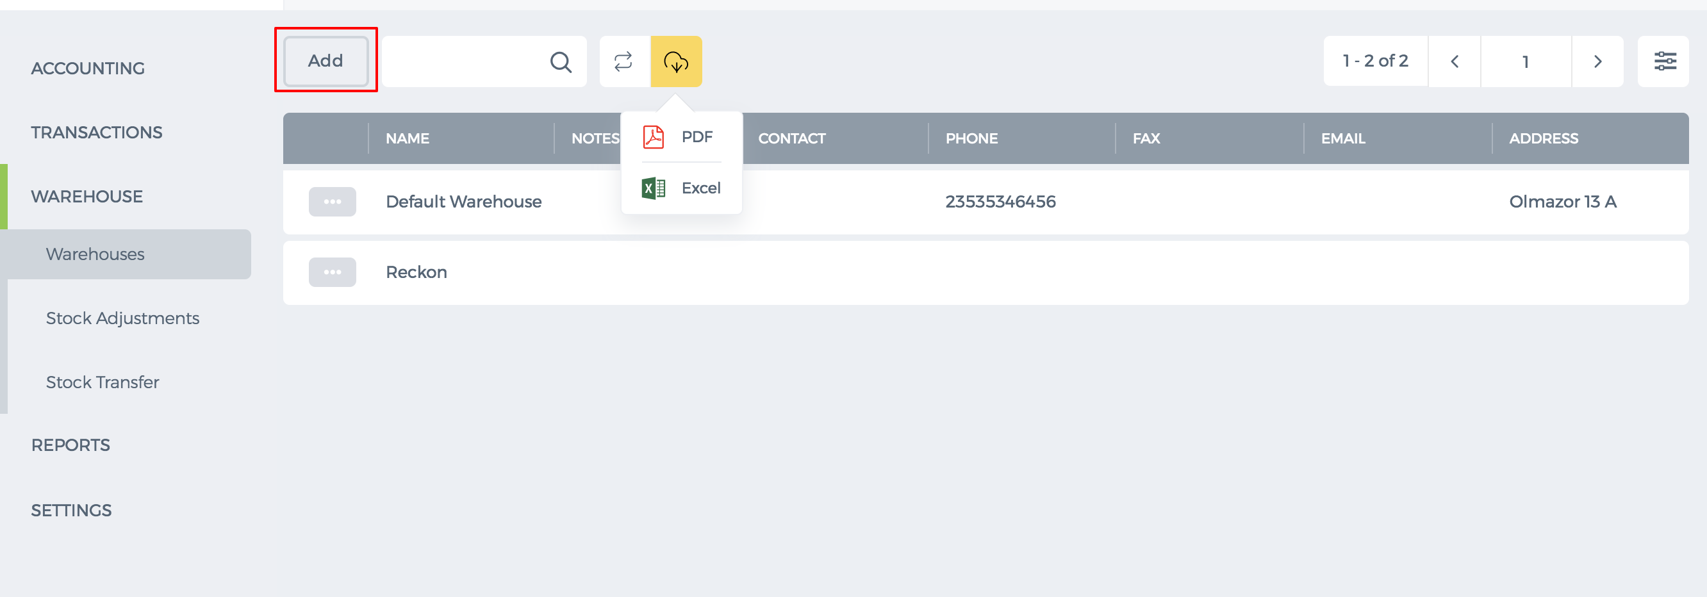 In new User Interface, to customize Warehouse List Panel press on indicated below button. 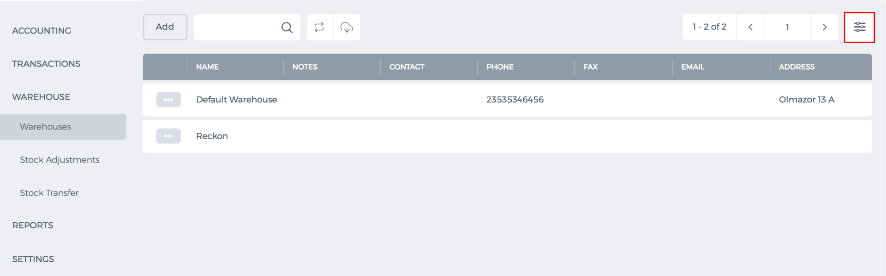 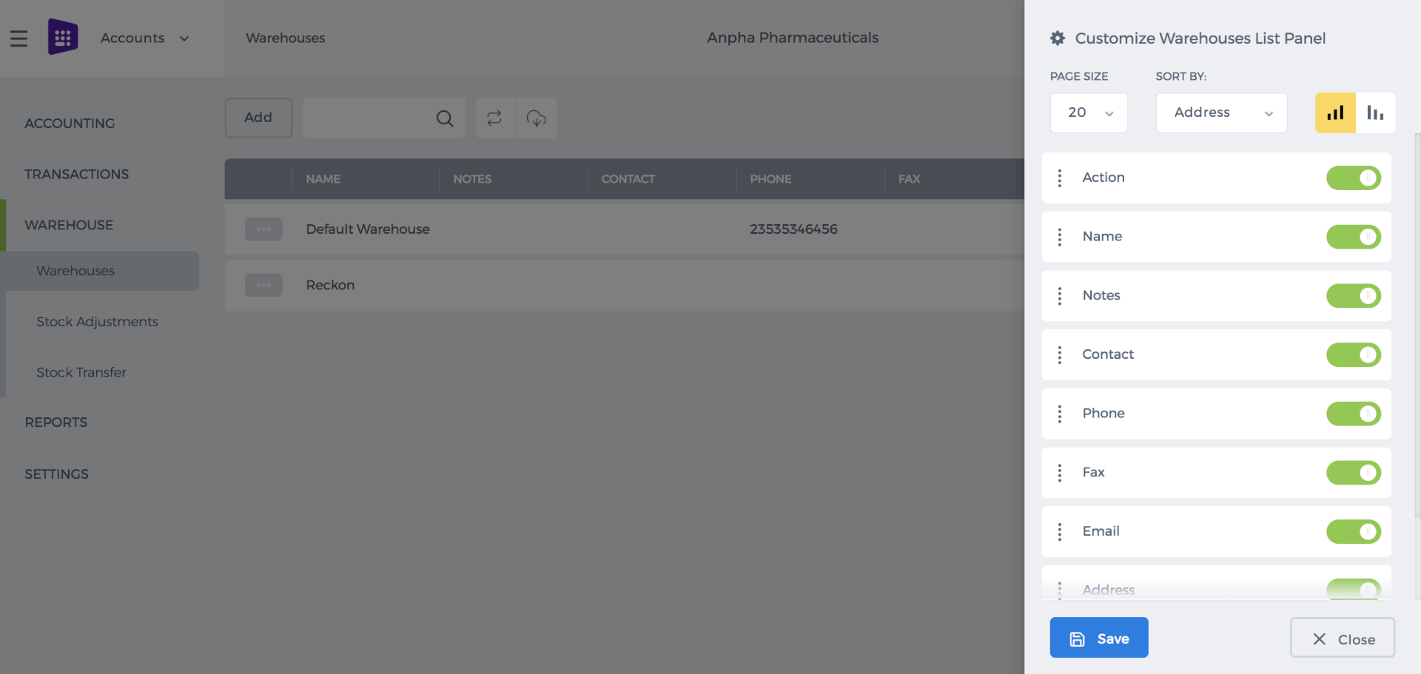
By clicking Action button you can edit the info of warehouse or see the products.
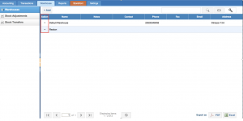
In new User Interface by clicking the Action button, you can edit/delete warehouse and see products in it. 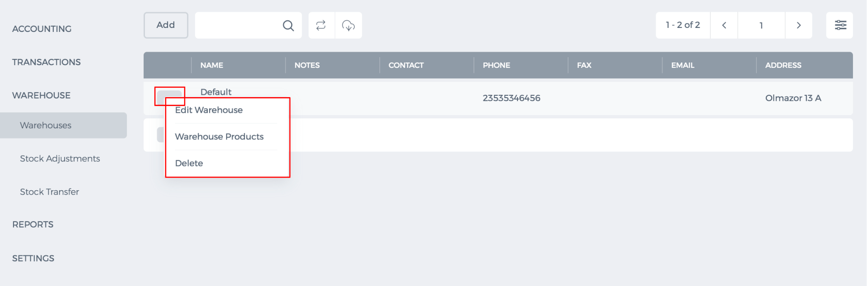
To add a product to the warehouse, go to Accounts >> Accounting >> Products/Services. Choose any product and open it.
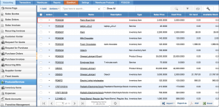
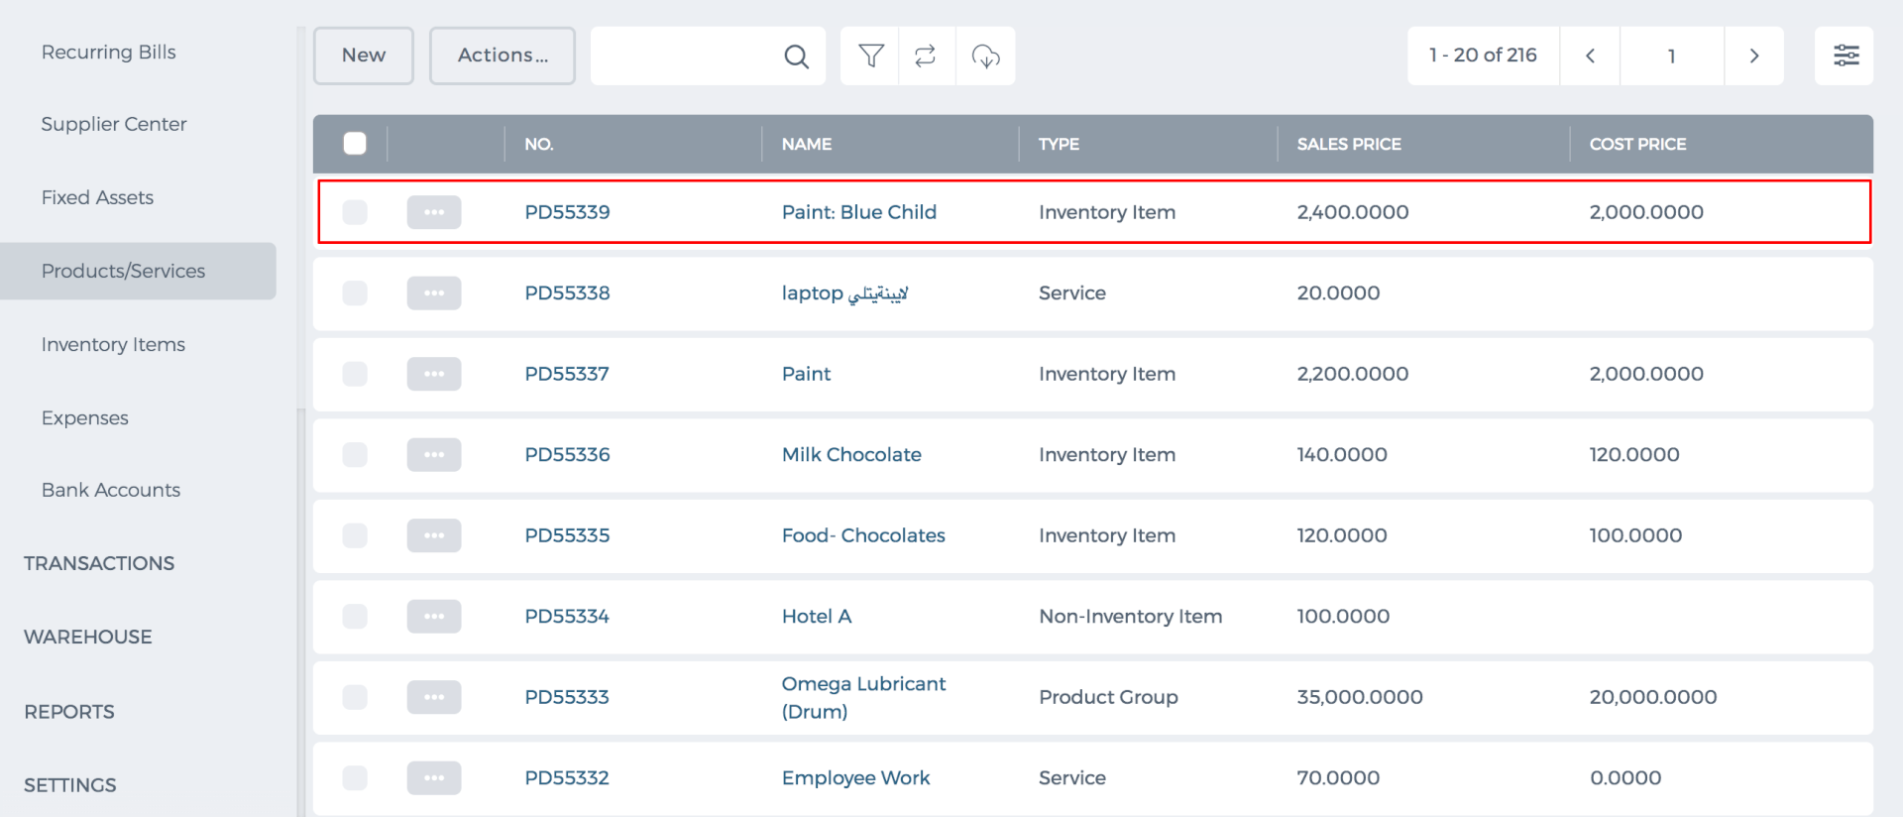
After that, find the Inventory Stock Information and select the warehouse, in which the chosen product should be placed.
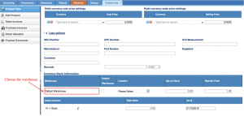
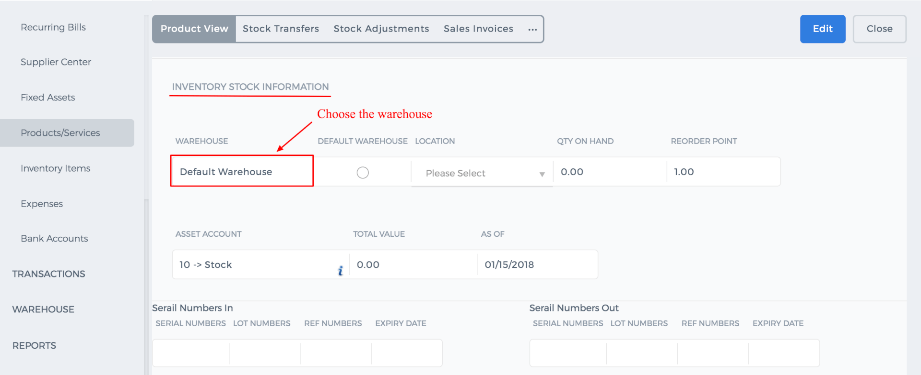

Bank Payment

Bank Payments
Accounts >> Transactions >> Bank Payments
You can add a bank payment by clicking the button “Add”, after that indicate the bank account, narration, reference, project and fill the given table. At the end, press button “Save”, a new bank payment will appear in the list. Another way to add bank payments is to import them.
You can also get all your payments by exporting them in Excel or PDF format.
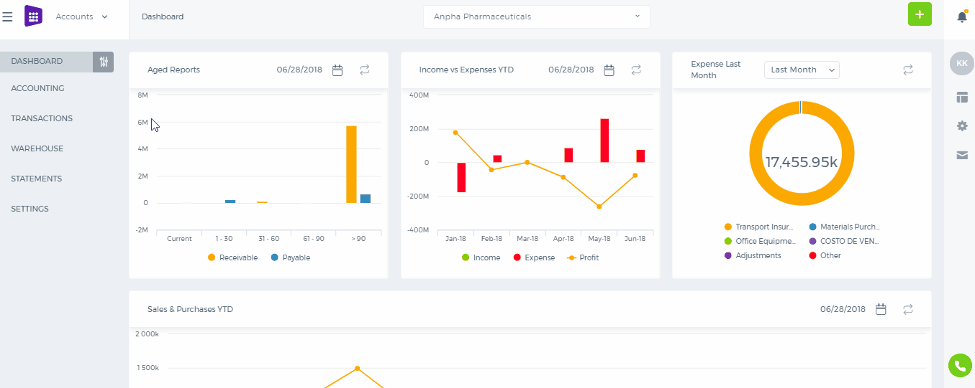
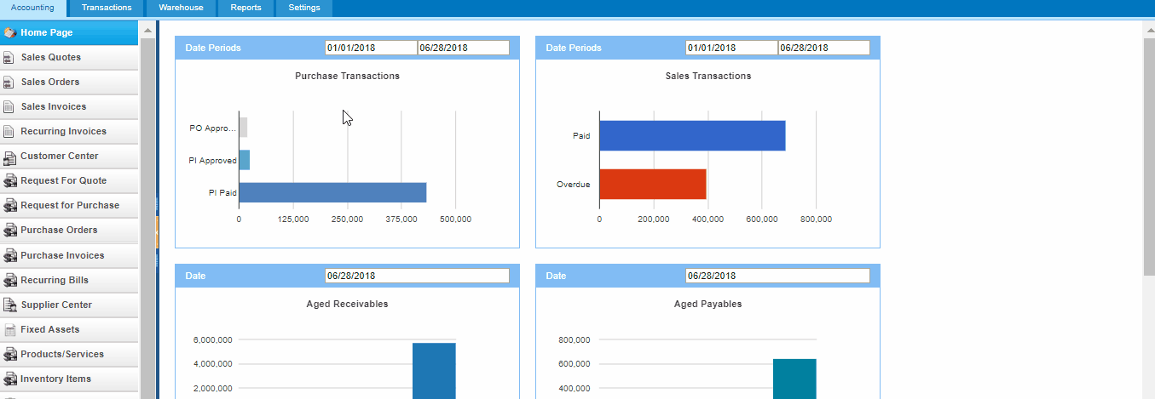
You can find a bank payment by pressing the search button. In addition, you can filter them by project, creator and data period. After filtering, you are able to reset by clicking the third button. While the fourth button is required for customization columns.
Action column provides options such as view, edit, delete and print pdf bank payment.
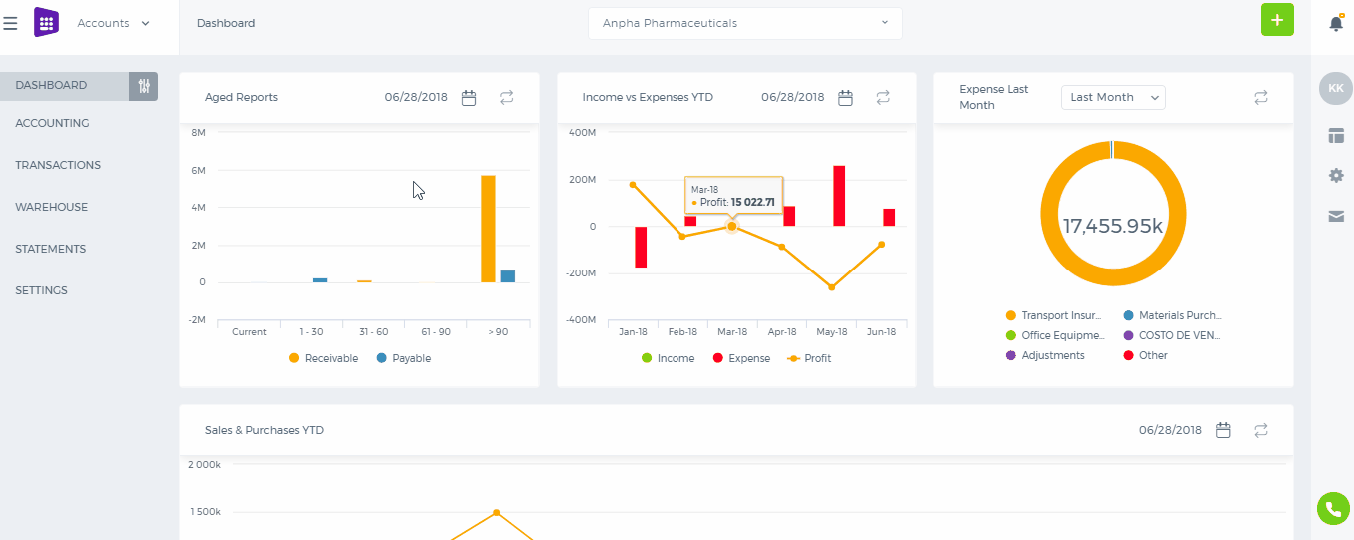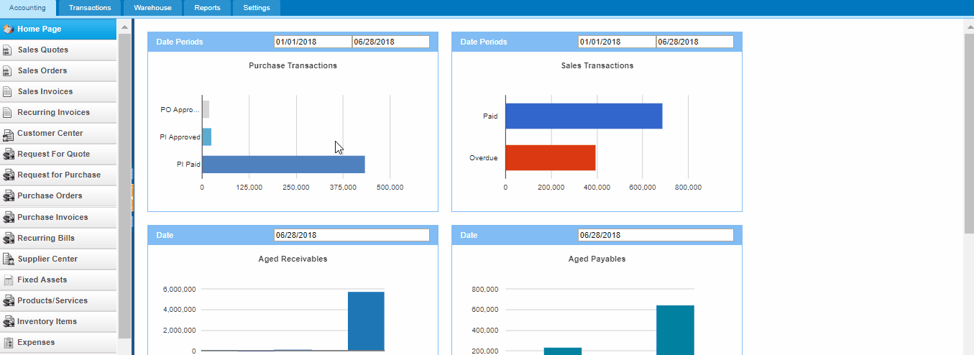

Overtime Payments

Overtime Payments
Along with monthly salaries, employees can also be rewarded for their overtime working hours. Administrators and HR managers can set up how much each employee should get for their overtime hours in the Payroll module. In Payroll Employees page, each employee has the payroll settings. Overtime settings can also be found there. 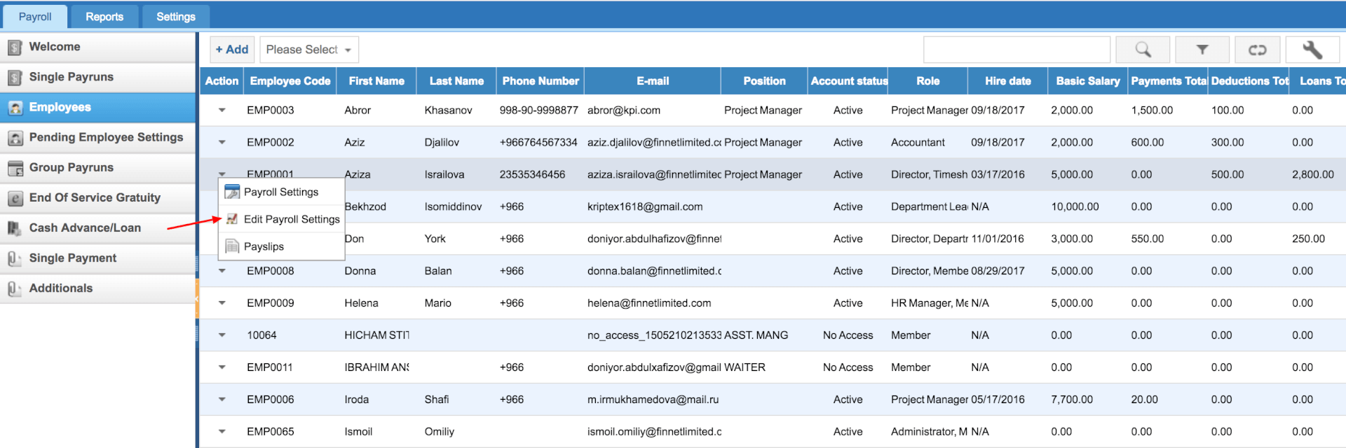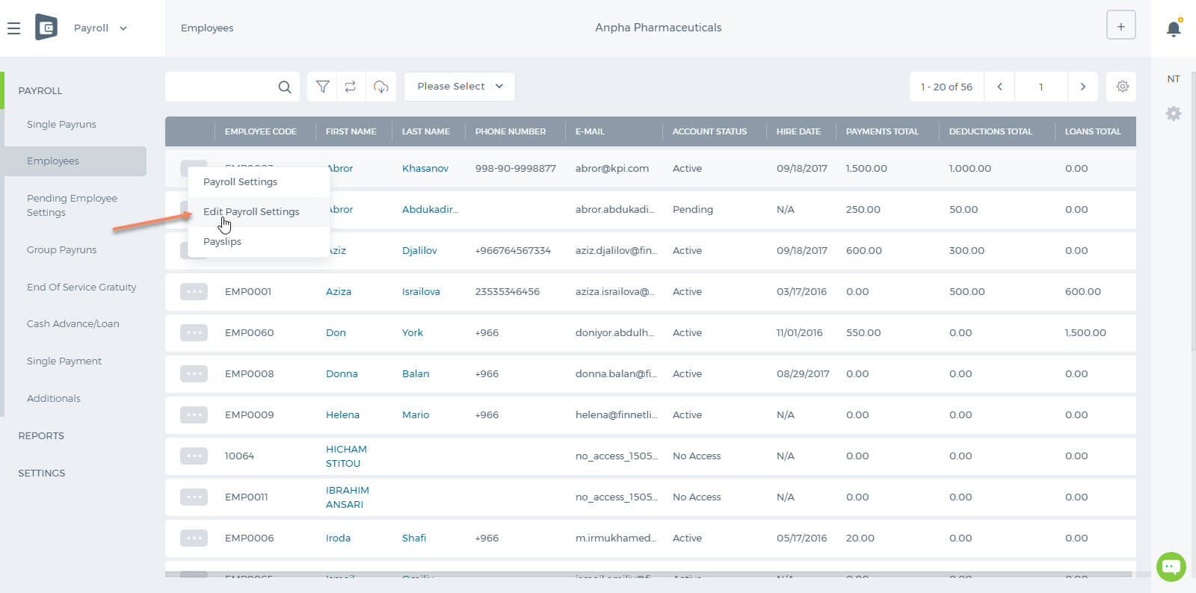 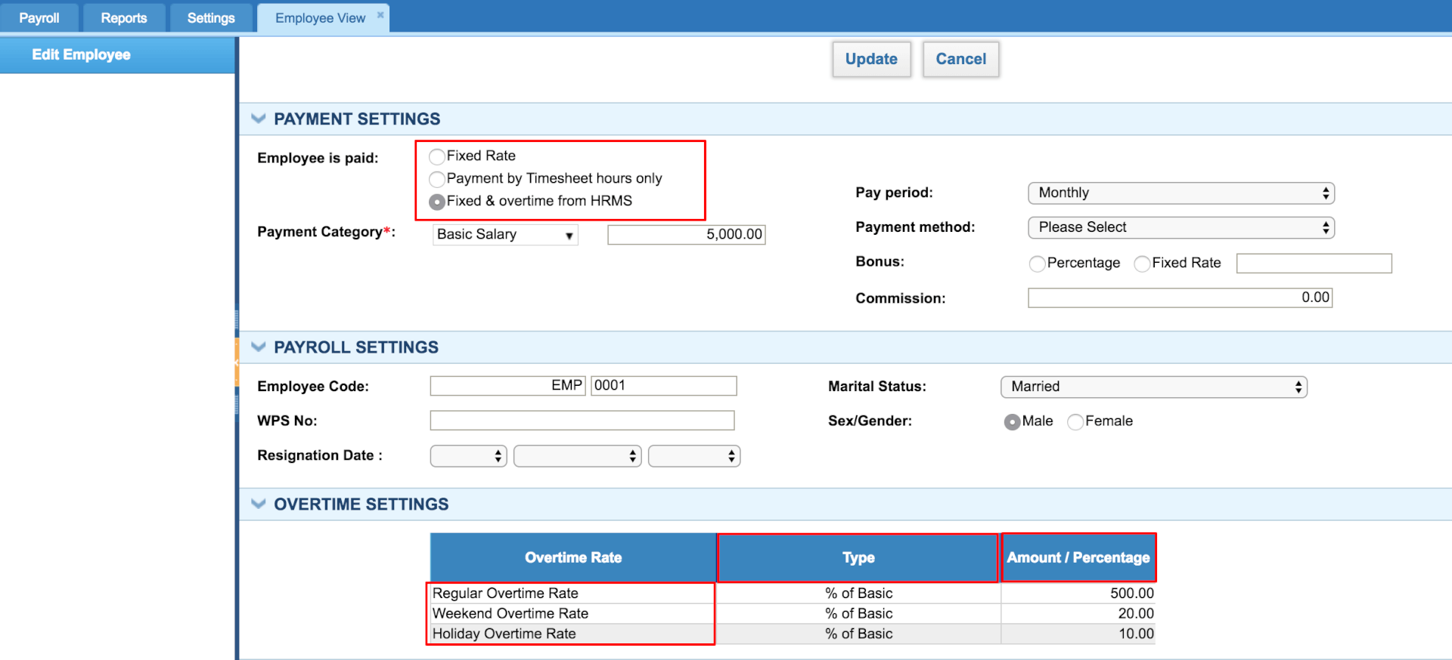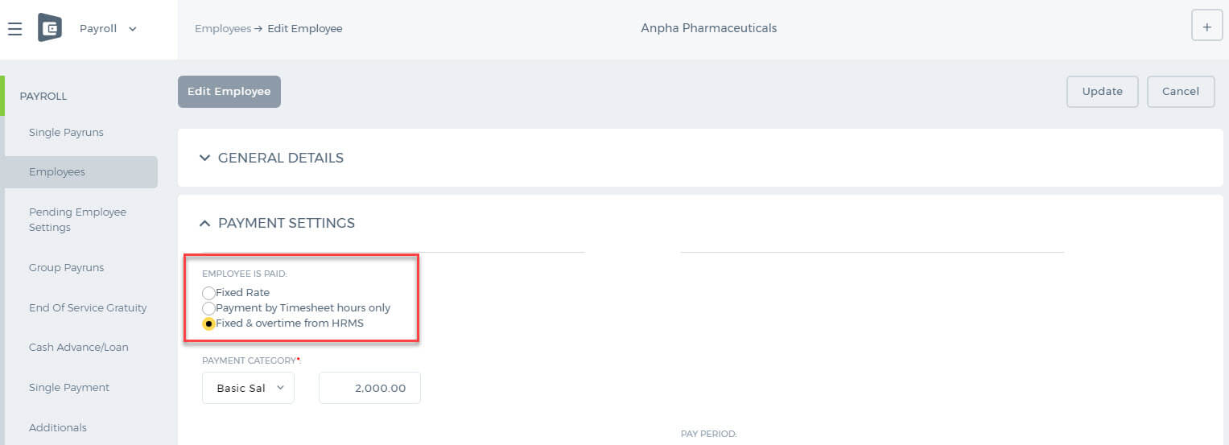 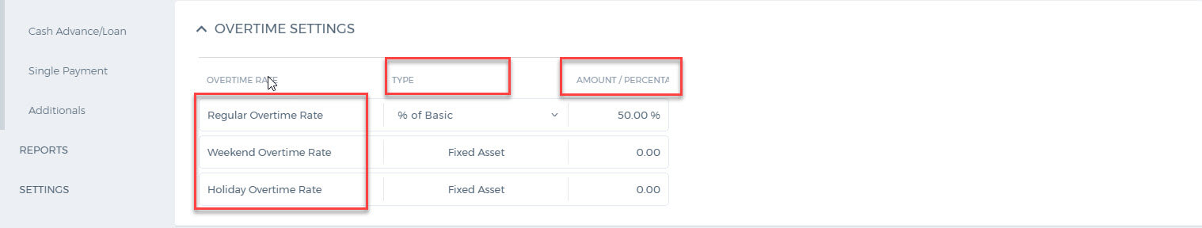Under the payment settings, "Fixed & Overtime from HRMS" should be chosen, if the company employees should be paid for their overtime hours. There are three types of Overtime rates: Regular Overtime Rate - it is paid when the employee works overtime during the working days. Weekend Overtime Rate - it is paid when the employee works on day offs. Holiday Overtime Rate - it is paid when the employee works on holidays. There are two types of payment rates: Percentage-Based or Fixed. When the fixed rate is chosen, the employee overtime hours will be multiplied by the amount set up under the Amount/Percentage column. When the percentage is chosen, the employee overtime hours will be calculated based on the basic salary multiplied by the percentage. The rates are per hour. The employee worked hours can be checked from Humans>>Attendance Tracking>>Attendance report. The application records hours either from Biometric Device (if integrated) or from the login/logout total hours. Weekend overtime hours are highlighted in grey. The employee also worked on the Weekend - 50 hours. When the managers generate payrun for the employee, the overtime payments will be automatically calculated and applied to the payments table. 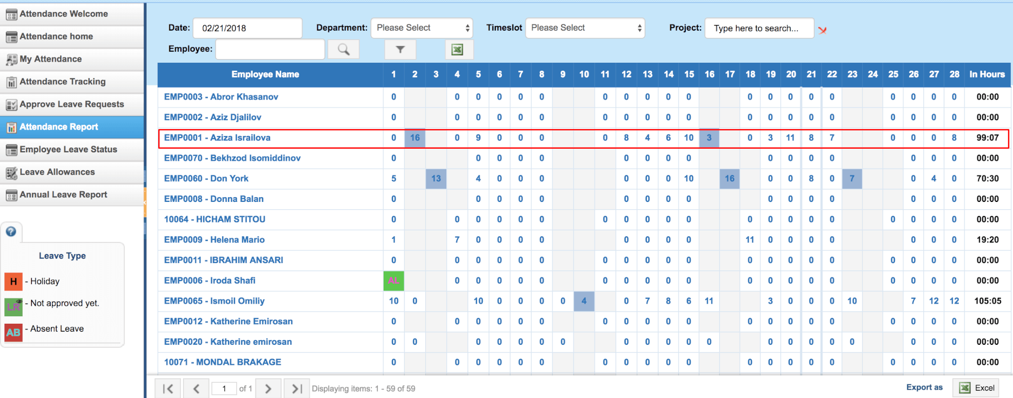 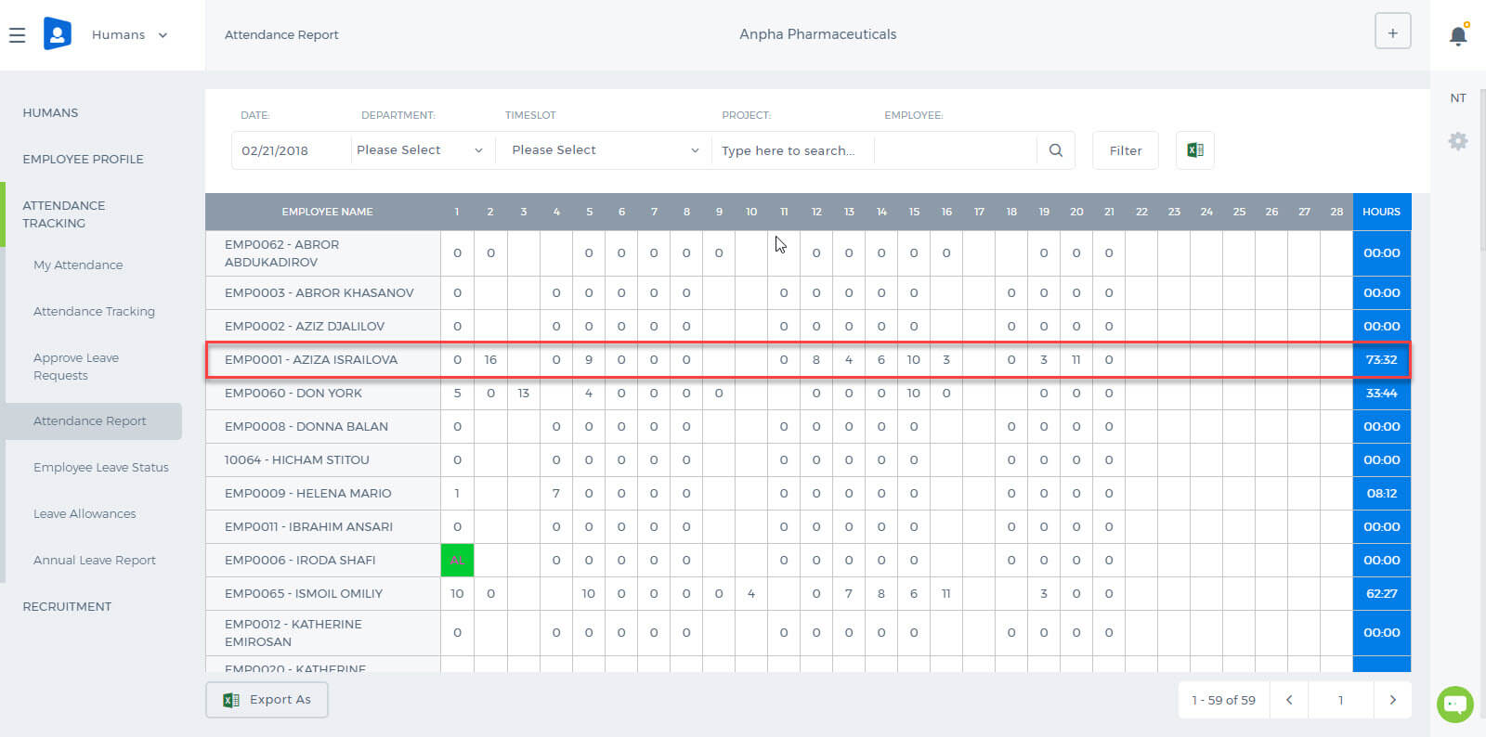 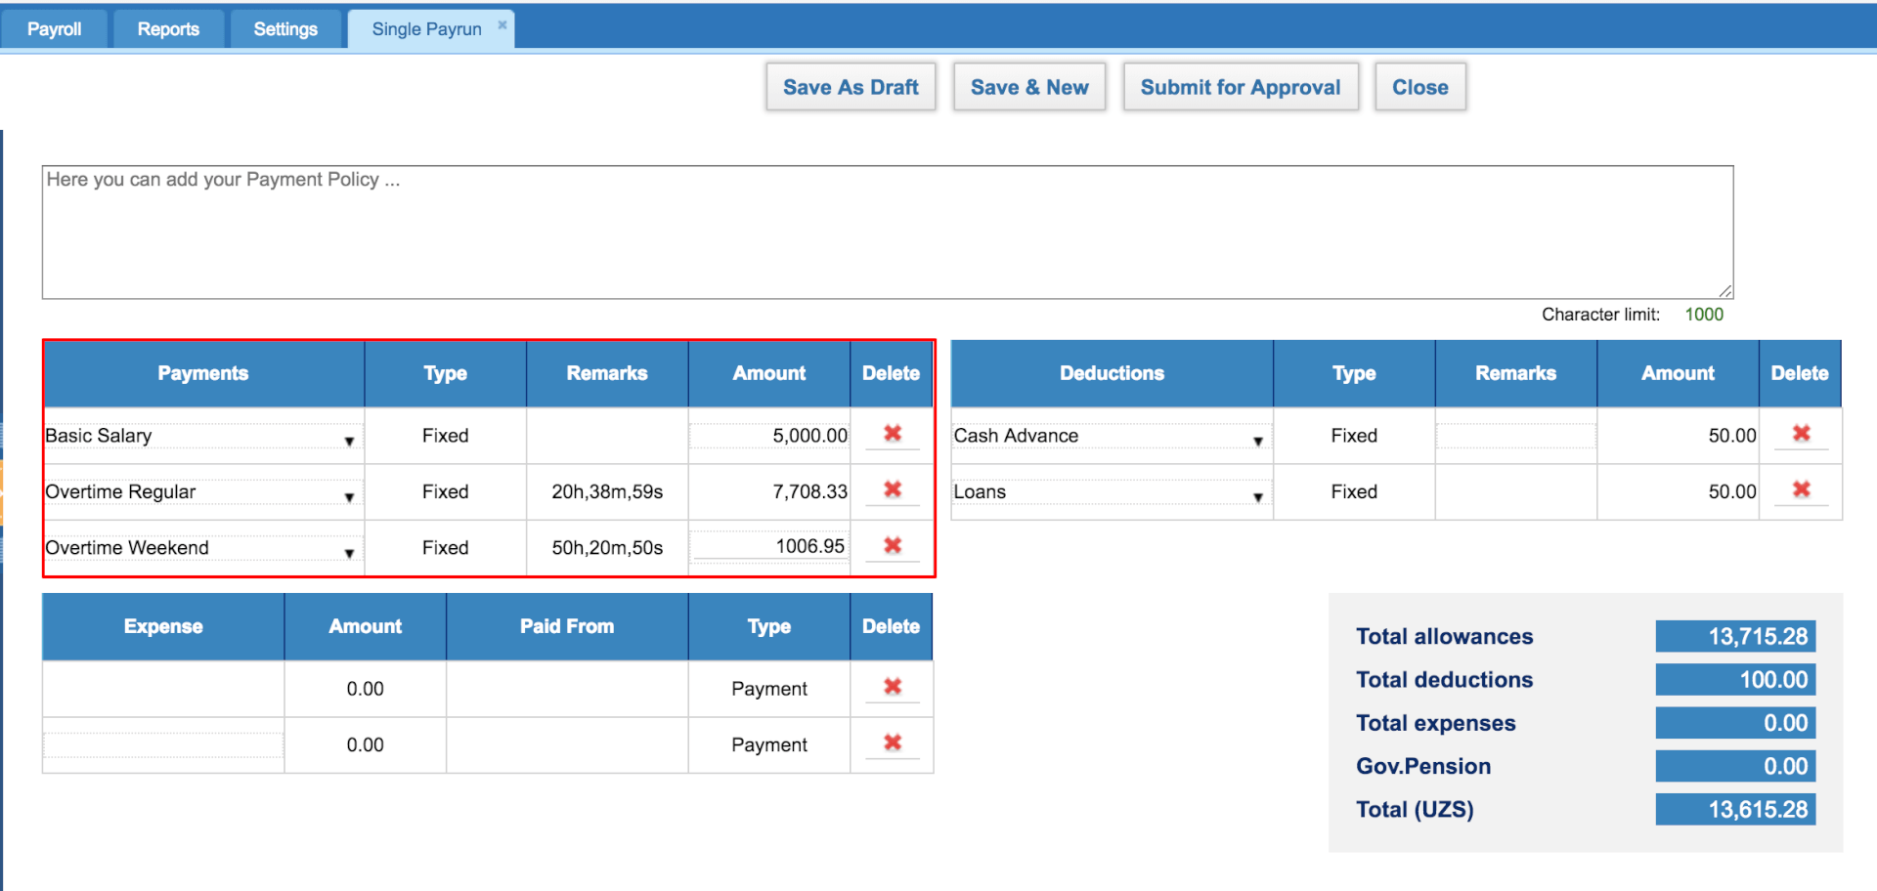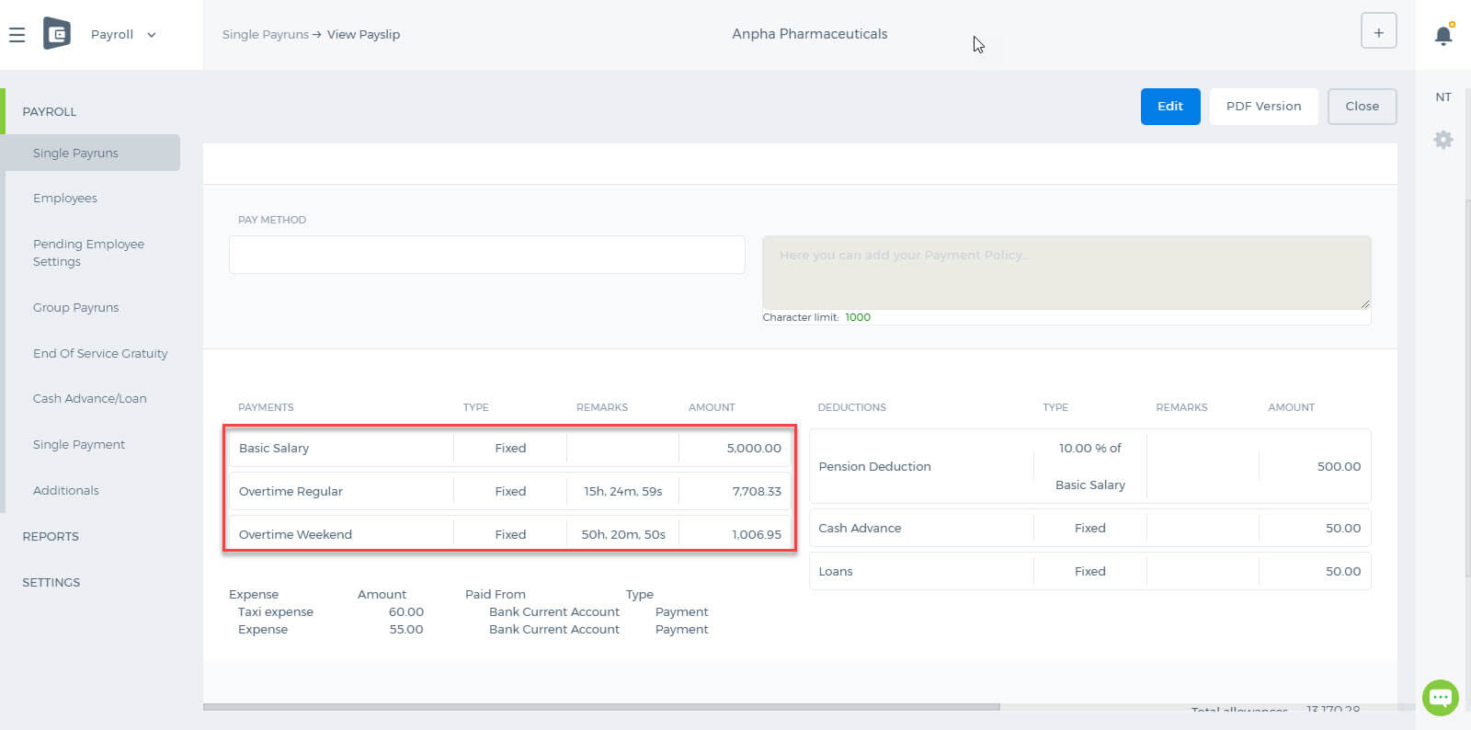The above overtime calculations are based on fixed rates. For example, during the weekend the employee worked 50 hours and his/her rate for the Holiday Overtime is 20 (UZS). So the payrun is 1,006.95 (UZS). The percentage based (% of basic salary) overtime hours calculation is as follows: salary / working days*8 = hourly rate overtime based % hour * ((hourly rate /100) * overtime based)

Adding Pictures into the Signatures

Uploading a picture
In order to upload a picture you need to go to Documents>>Public>>Upload File (which size should be 5MBs per upload) 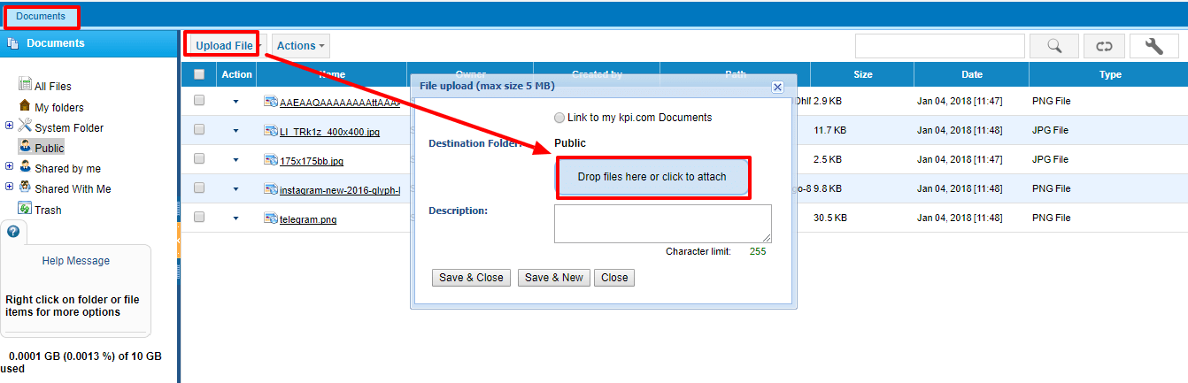 Then, you need to get a URL of that uploaded file, go to Action menu and copy the URL of chosen file. 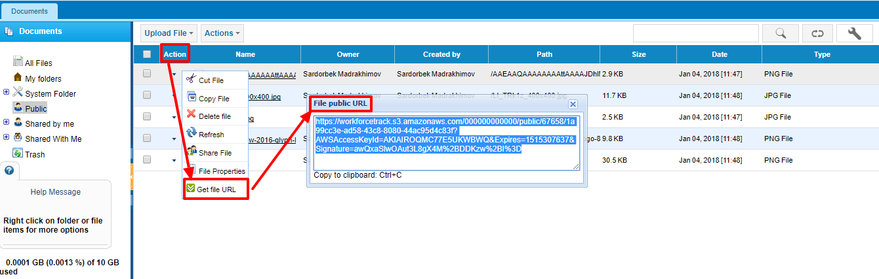 Afterwards, go to the Settings>>Email Templates>>Signature, where you can Add New Signature or Edit existing one. You can add a picture by pasting your copied URL link, like in this example: 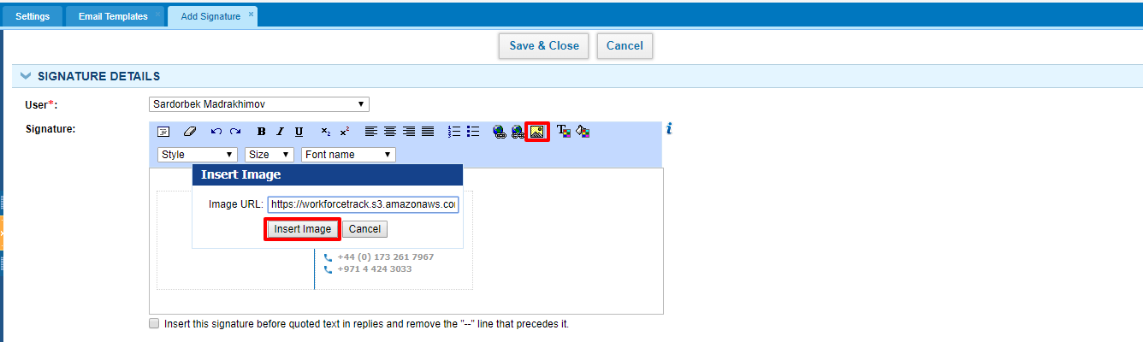 After Save&Close you will get a view like in this example, depending on what did you add and write. 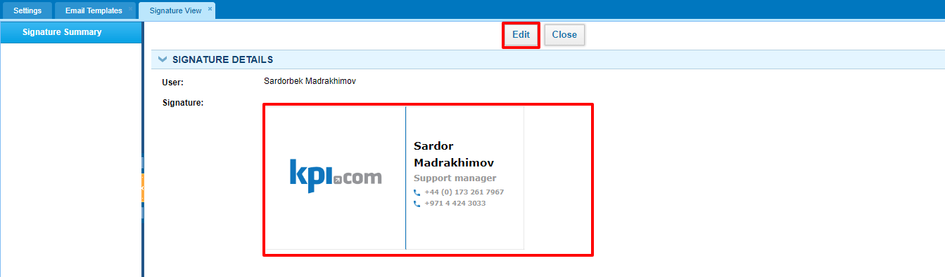

Importing Employees

Importing Employees
There are two ways for importing employees:
- From Humans (HRMS Section)
- Projects (Project Management Section)
In the Humans Section (HRMS)>>Employees>>Import, then you need to upload filled and saved CSV Excel sheet, after refreshing your page you can observe all Imported Employees. 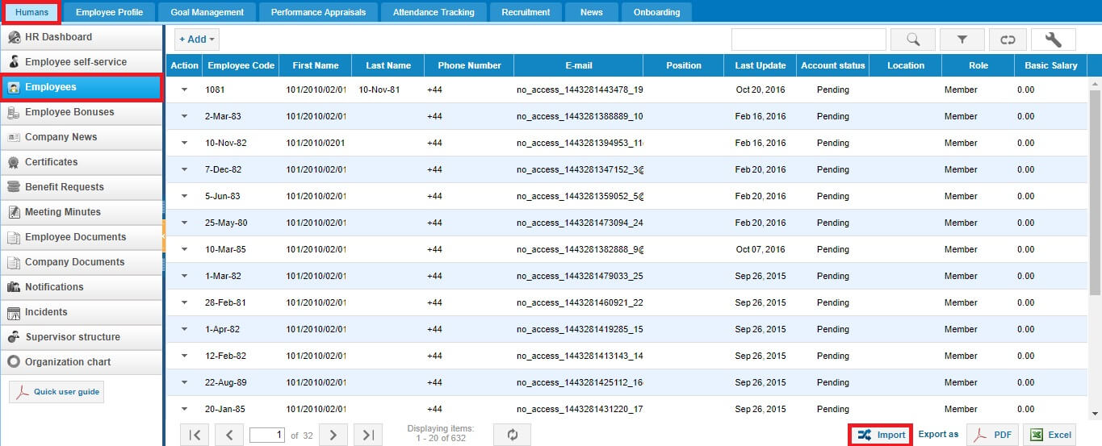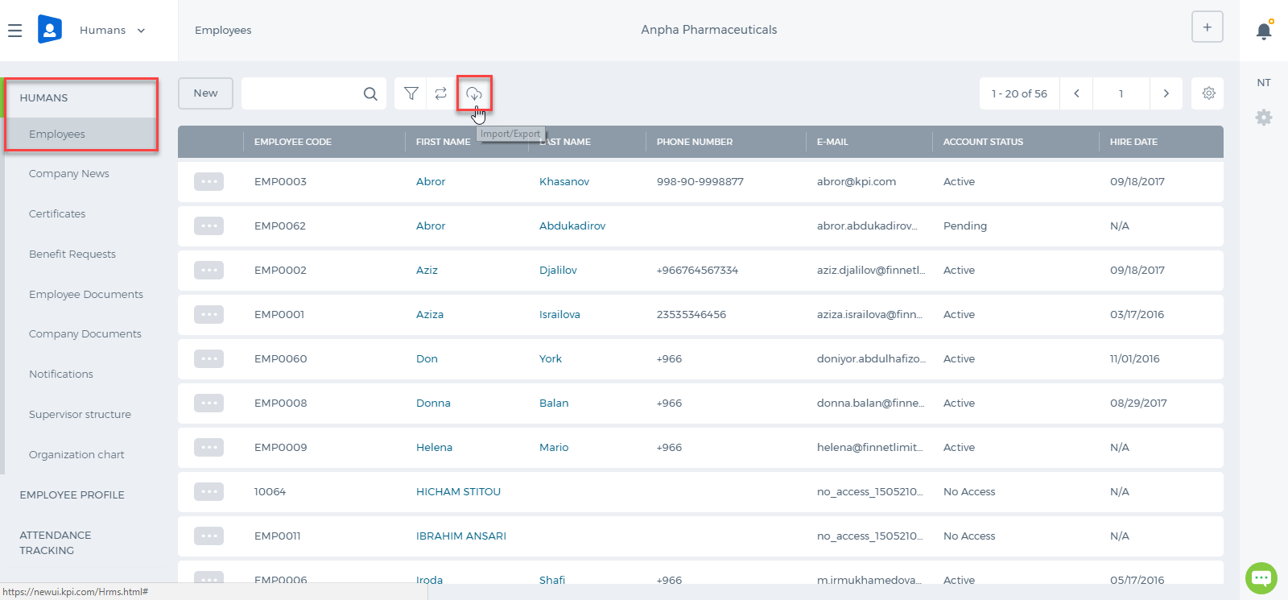 For the Projects (Project Management Section)>>Employees>>Import, same steps would be taken as in the Humans. 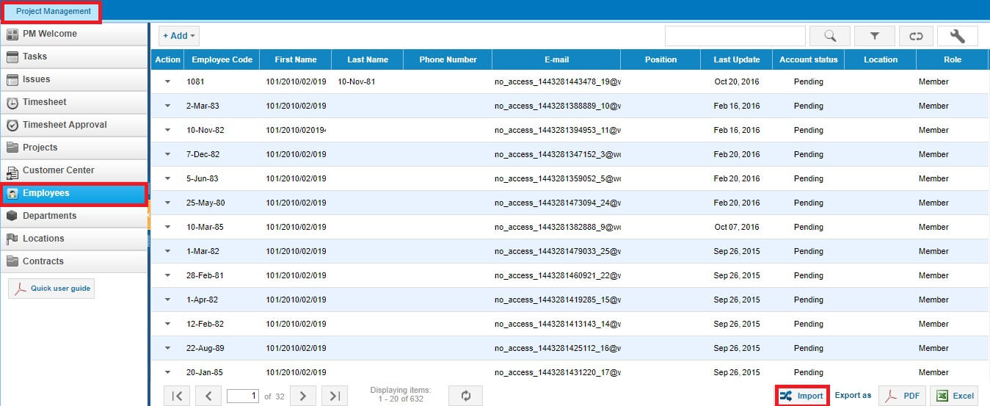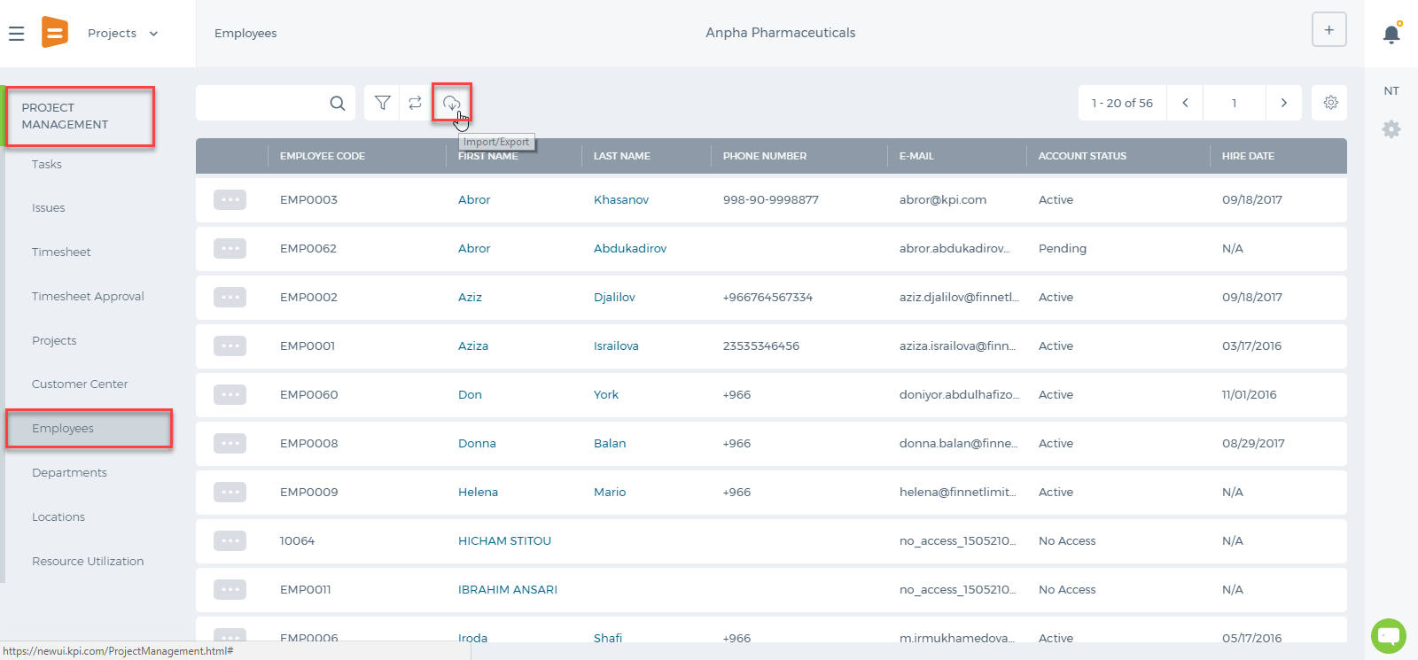 CSV Excel Sheet should look like as in the Example: 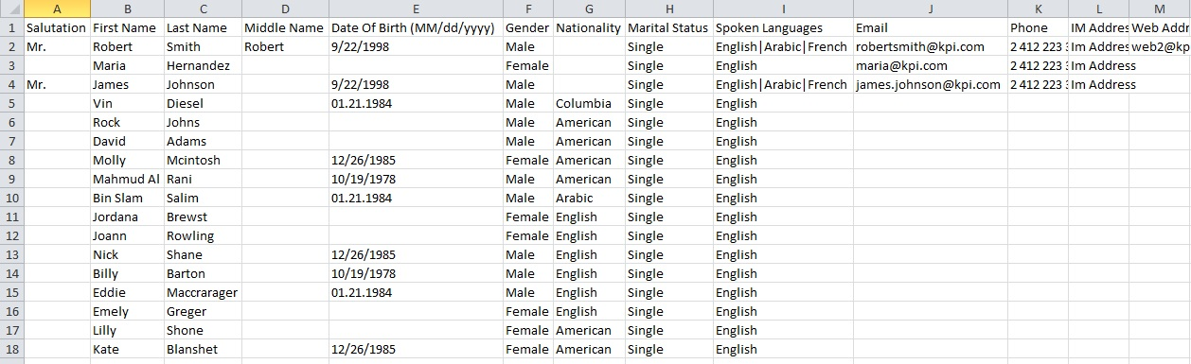 After checking the all information is presented in CSV file. Now you can upload it to the system. Moreover, pay attention to following Two main points: 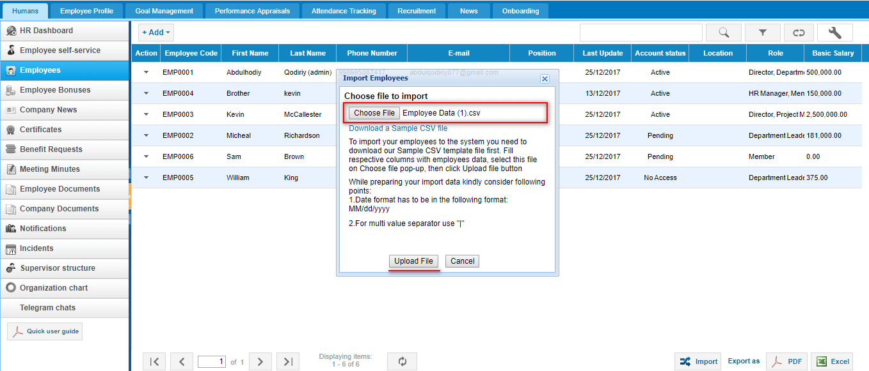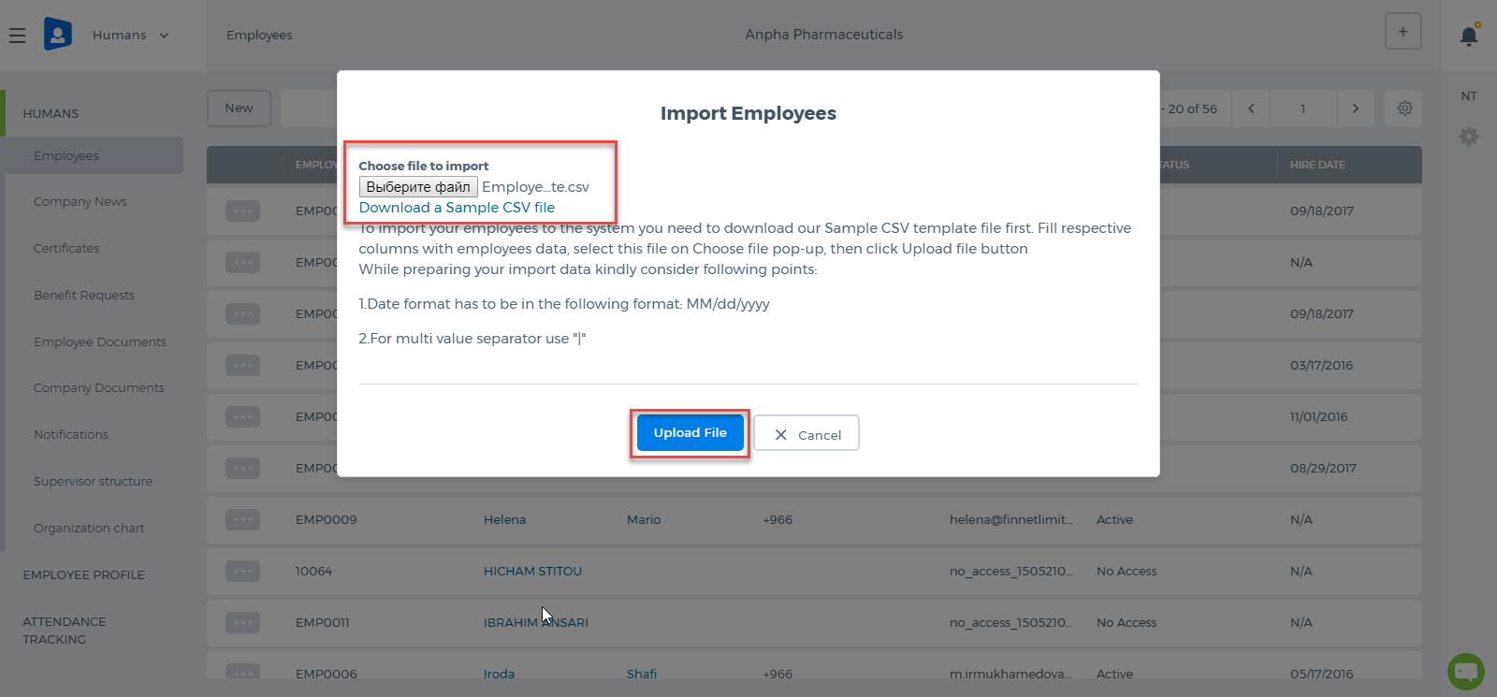 After uploading the file following page will appear. In these page, you have to check all system fields matching correctly. Once you complete checking, press the Save&Close button: 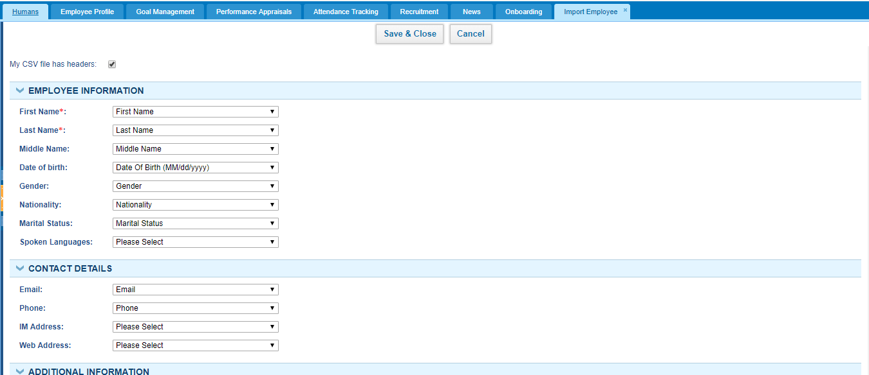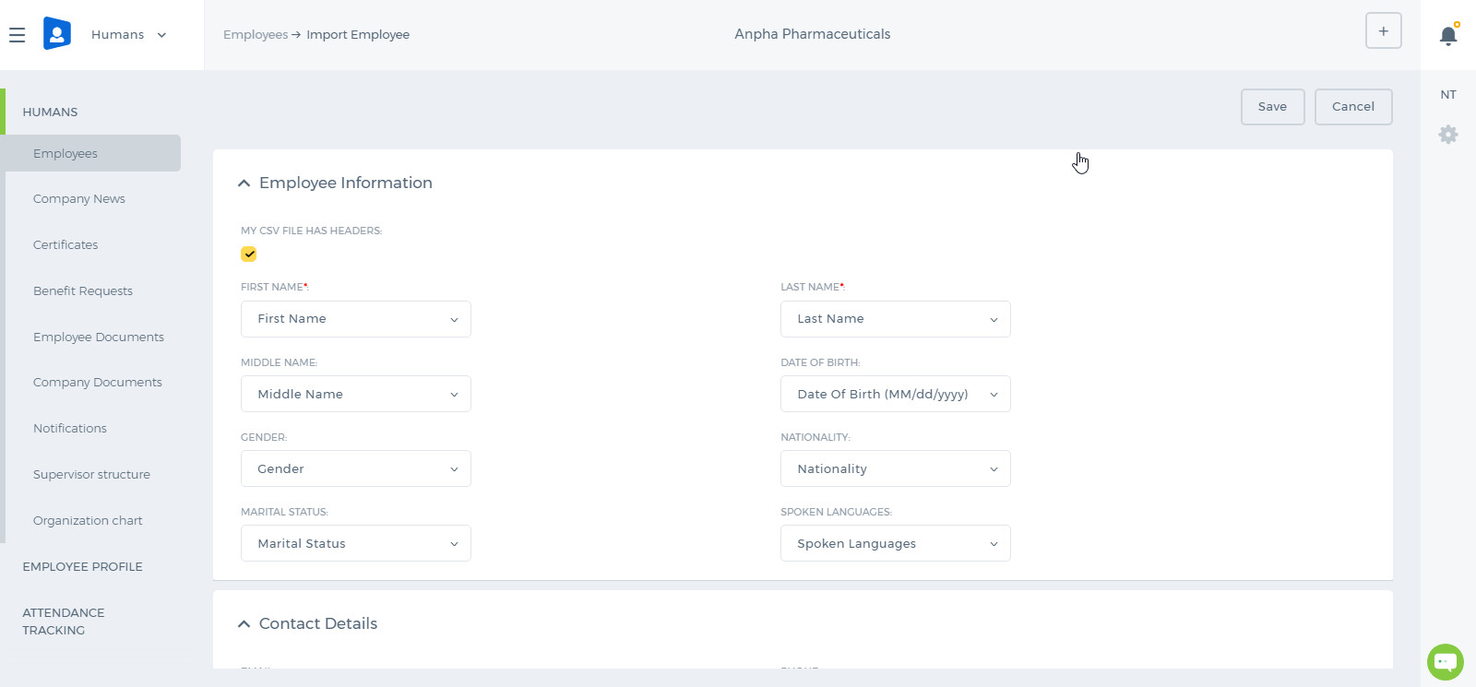 If Employees are not uploaded, you should check Settings>>System Logs>>Import Logs: 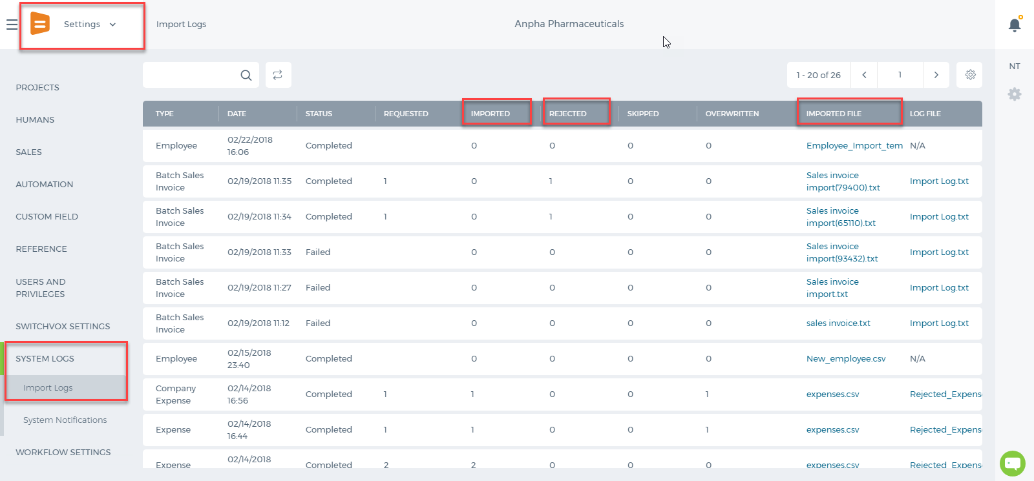

Annual Leave Report

Annual Leave Report
Annual Leave Report is activated by request and is not available by default. Annual Leave balances are added in Leave Allowances page. 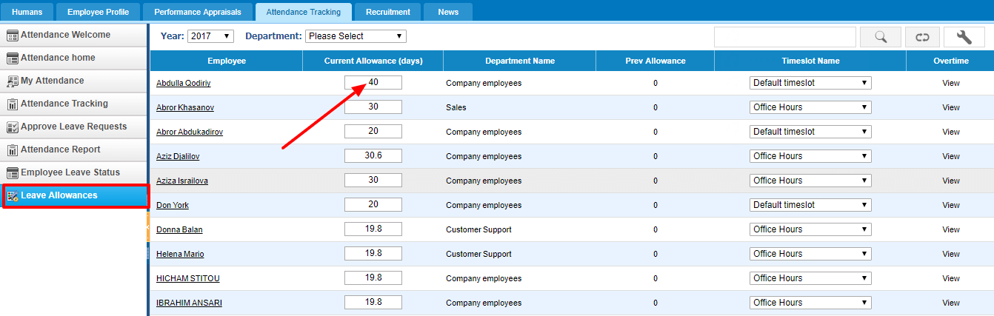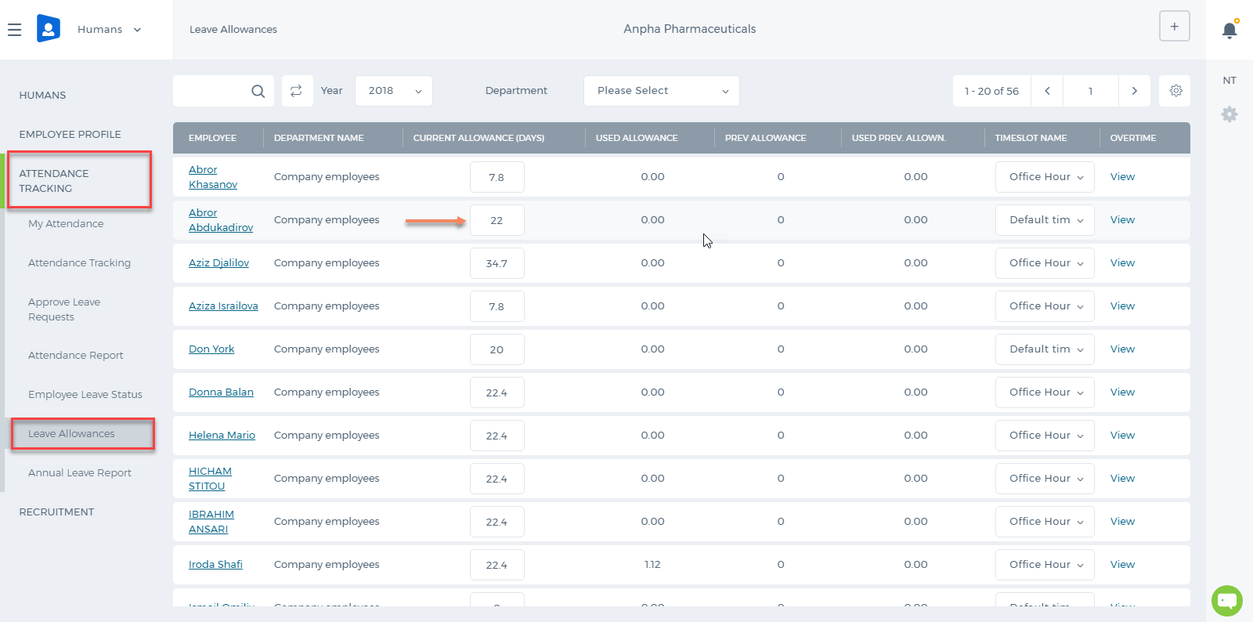 Annual Leave Report shows each employees current leave balances as of date chosen. 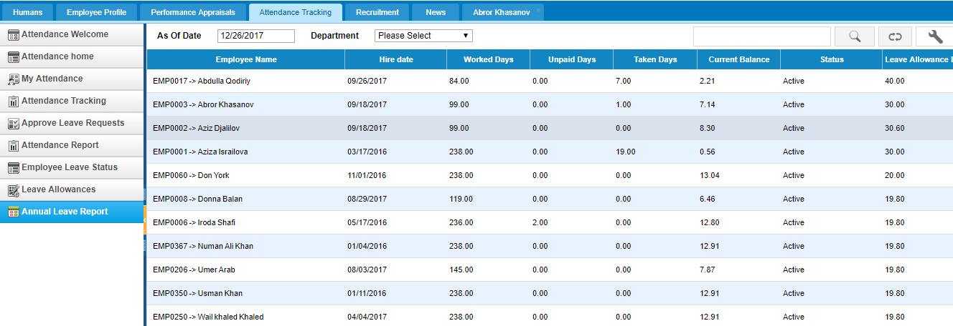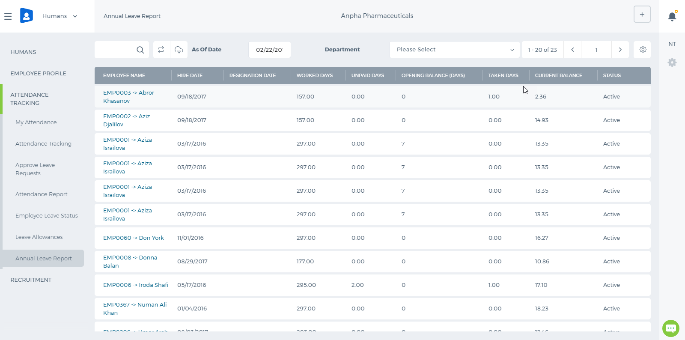 The formula for the Current Balance is as follows: Number of Worked Days( Leave allowance days/365 ) - Taken Days. For example, Aziz Djalilov's Hire Date is September 18, 2017 and till December 26, 2017 he has worked 99 days in total. He is Allowed to take 30.6 days as an annual leave in 2017. So his current balance is: 99(30.6/365) - 0 = 8.3 Opening Balance Date for Leaves An administrator can set an opening balance date for all employees leave balances, which means that the leave balances are effective starting from that date. The opening balance can be set from Settings>>Humans>>General Settings 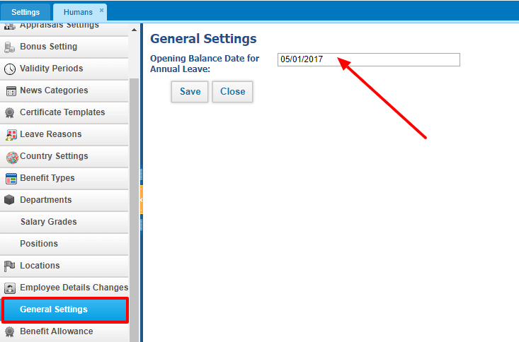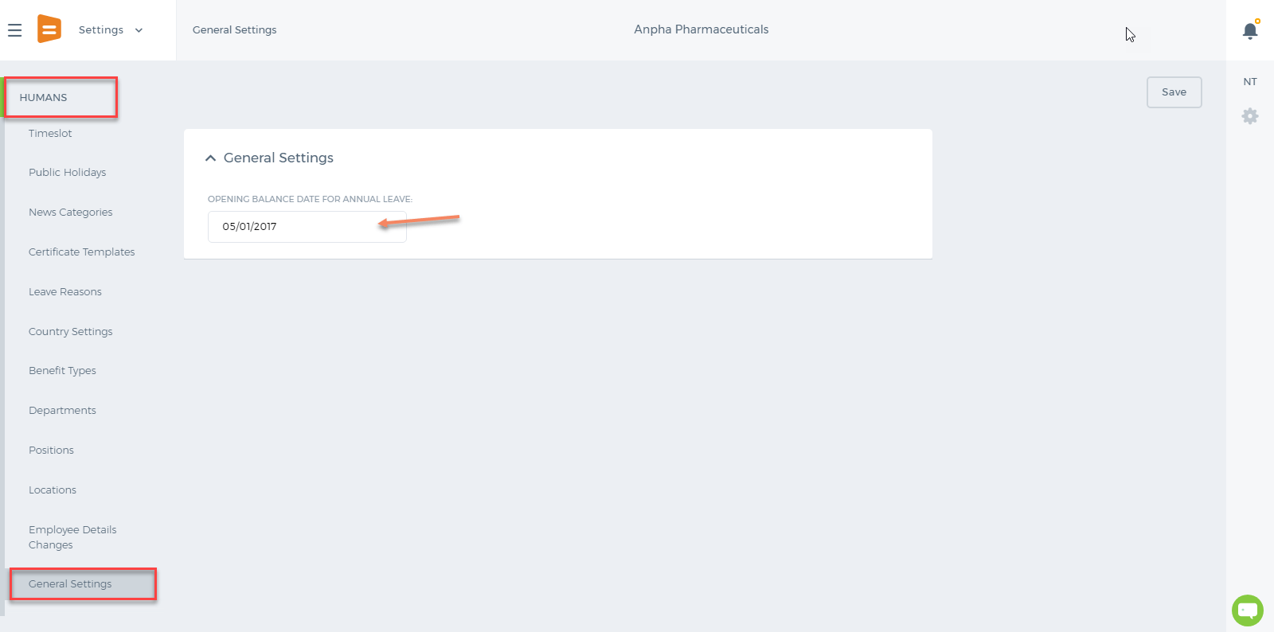 This date is also shown in the Annual Leave Report. If the Hire Date is before the Opening Balance date, then the balances effective date is going to be the Opening Balance Date. If the Hire Date is after the Opening Balance date, then the balances effective date is going to the Hire Date. 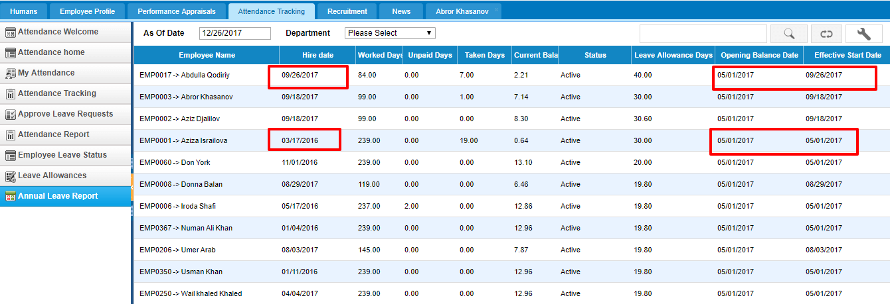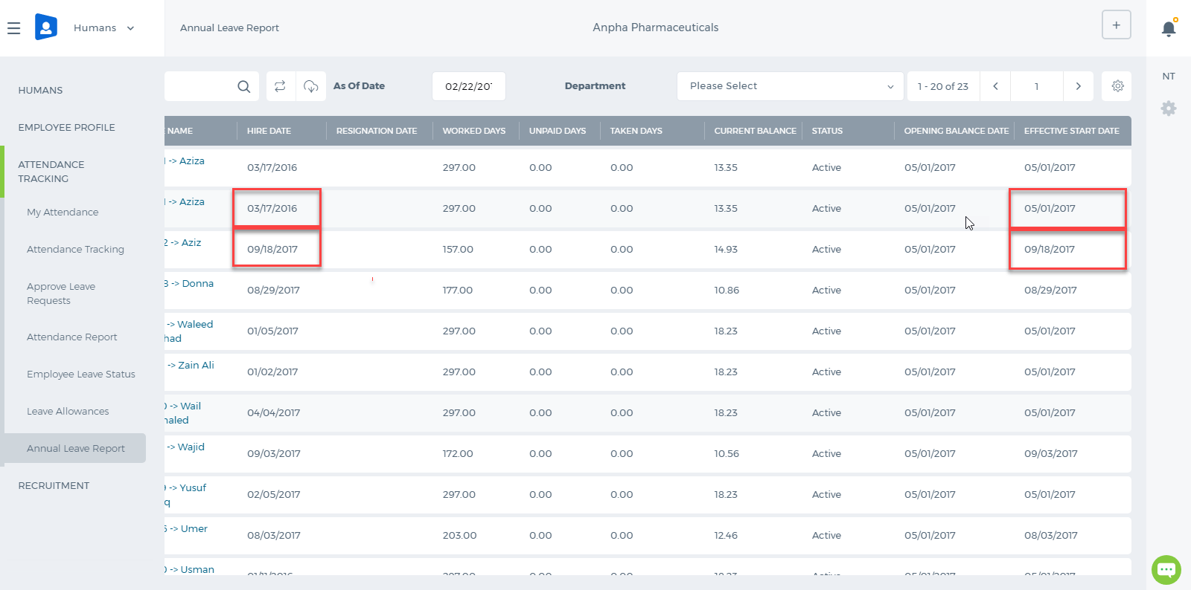 So the number of worked days depends on the Effective Start Date. Opening Balance Days If the employees already have the balances as of the opening balance date, then the opening balances are just added to the current balance, so the formula is as follows: Number of Worked Days( Leave allowance days/365 ) - Taken Days + Opening Balance Days. The Opening Balance Days column can be enabled from the Customize icon on the right hand side corner of the report. 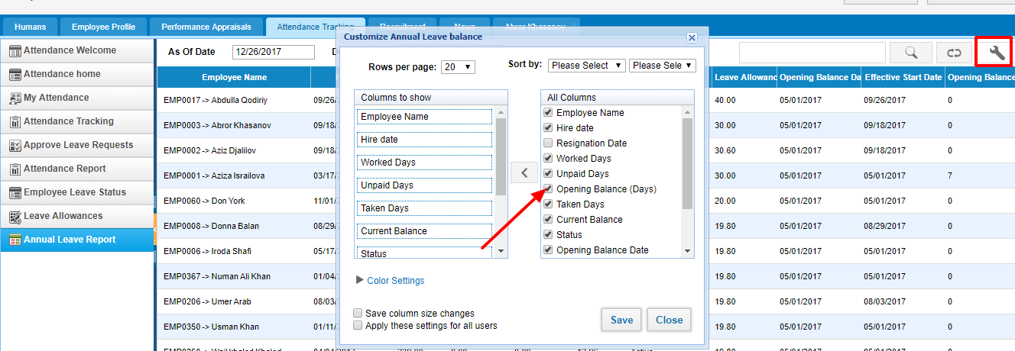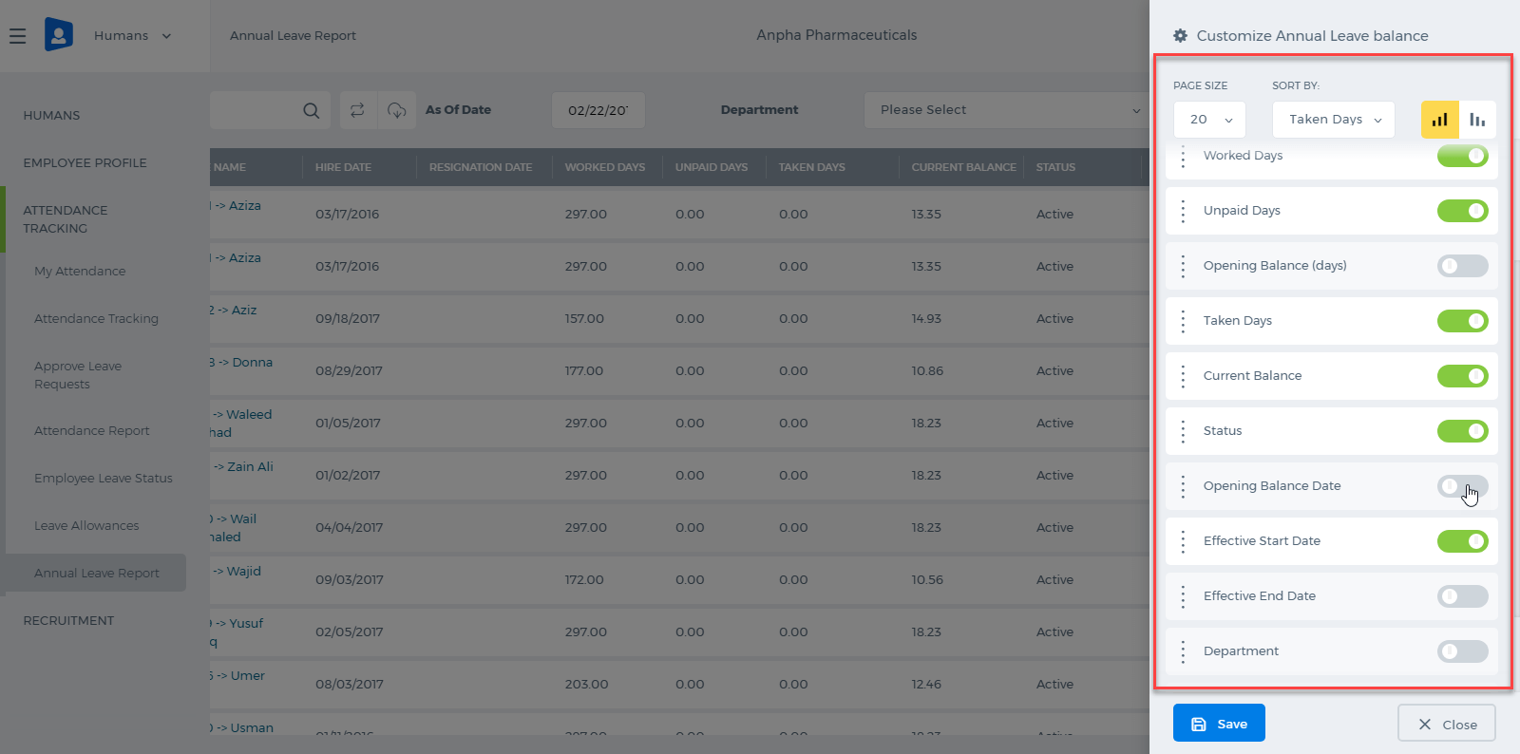 After the column is enabled, a double click helps you to enter opening balance days for each employee.

Leave Reasons

Leave Reasons
In Humans>>Attendance Tracking Module, there is an Annual Leave Allowance settings where HR managers can set annual leave balances for their company employees. Leave Reasons other than Annual are available at Settings>>Humans>>Leave Reasons page. On the same page, you can add more leave reasons too. 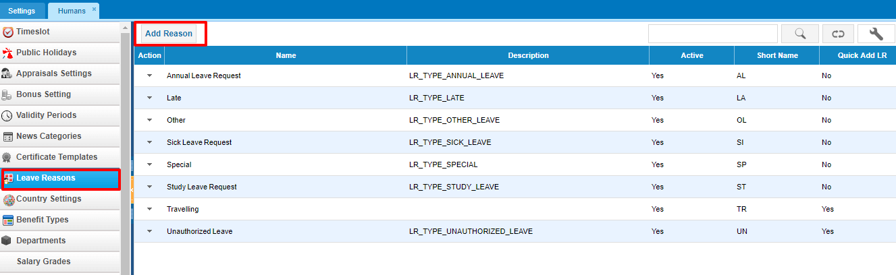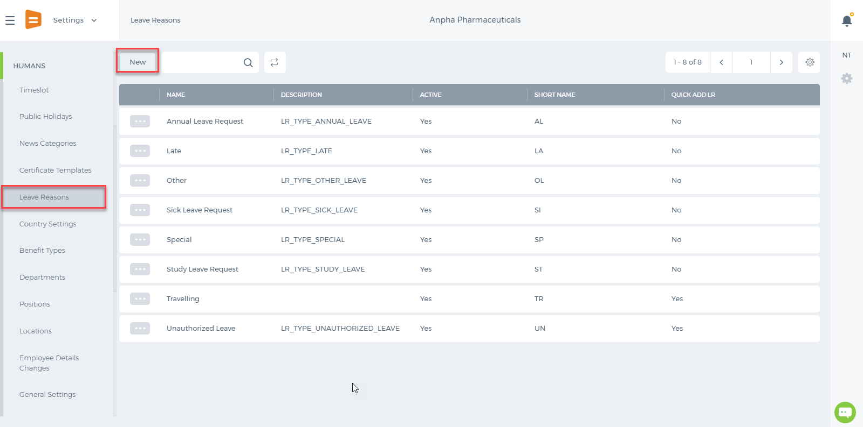 The balances for each leave reasons can be set up by editing the Leave Reason from the actions dropdown. 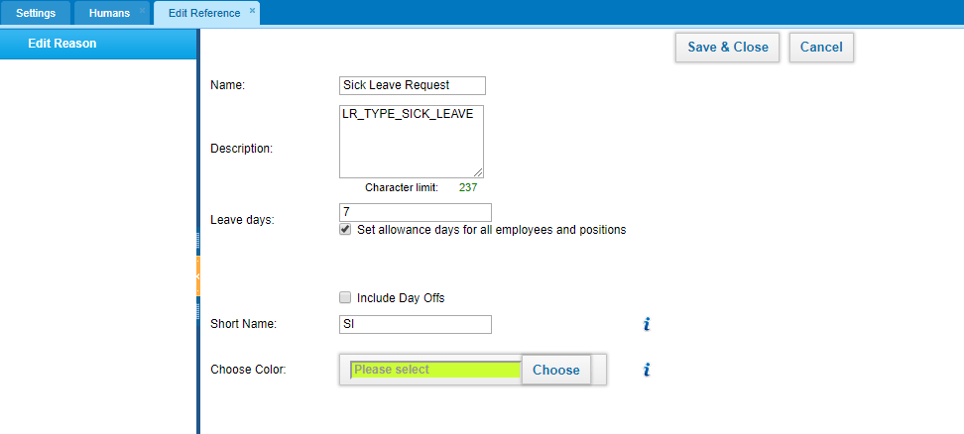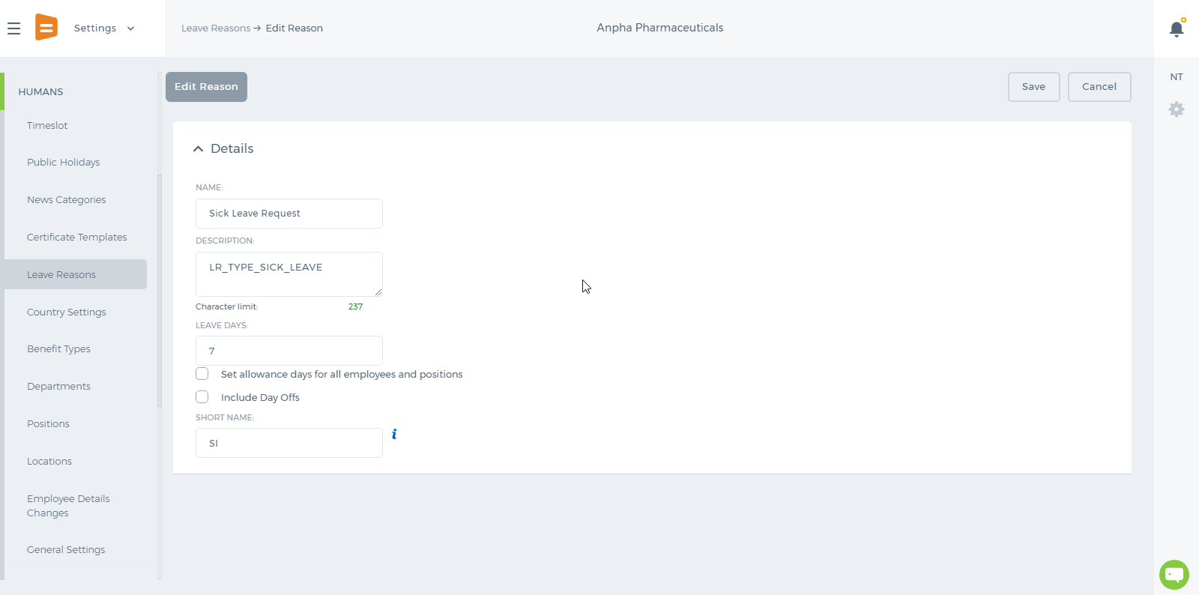 After the days have been set to the leave reasons, the balances show up in the add Leave Request form too, so that the employee knows how many days are allowed per year and how many days are left/taken. 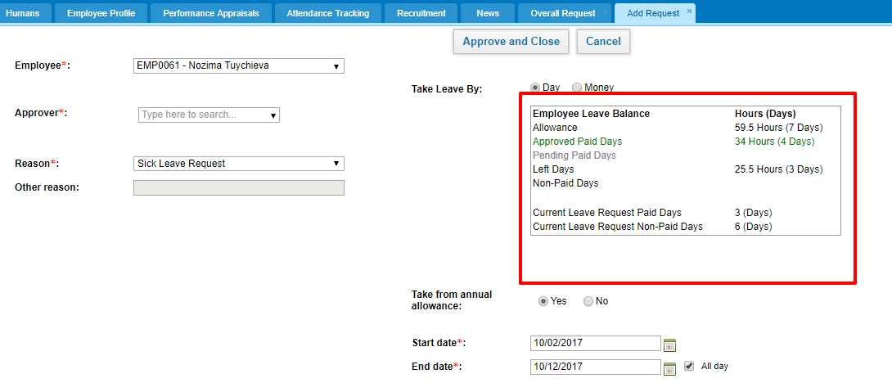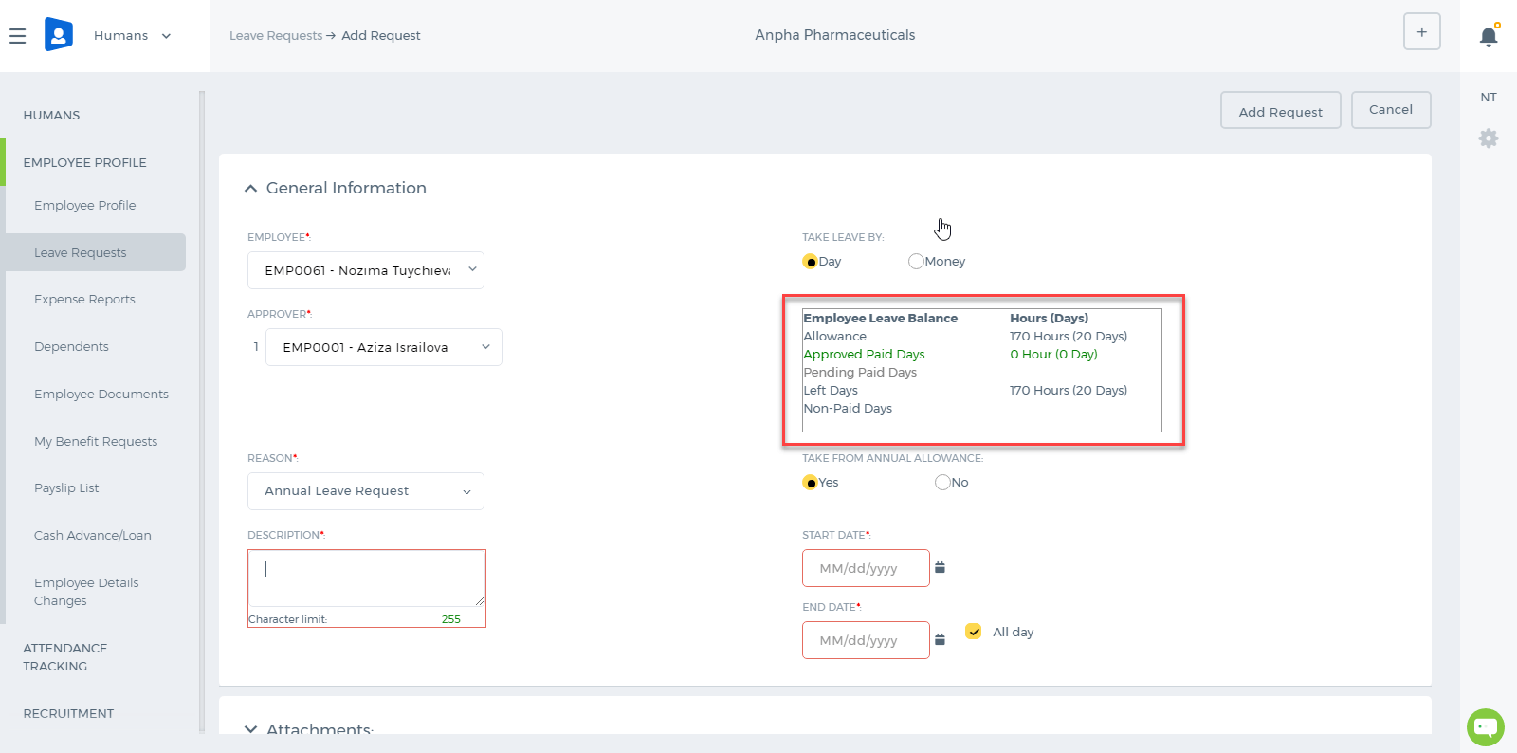 For example, the company employees are allowed to take 7 days as a Sick Leave in a year. Sick Leave days totaling to 7 have Paid type. If the employee takes more than 7 days, the Sick Leave type becomes Non-Paid automatically, meaning that he/she is taking more than allowed. Leave Requests can be taken by Day or Money. If it is a Day type Leave Request, it will be deducted in employees monthly payrun, if it is a Money type Leave Request, it will not be deducted from employees monthly payrun. Money type assumes that employee is still working for those allowed days and therefore, the payrun will not show the deduction for the period.

Setting Barcode for a Product
Setting Barcode for a Product In order to generate a Barcode for the particular product, go to Add / Edit Product form through Accounts >> Inventory Items >> Choose particular product. You should check for Show more options button. Once you click on it, additional fields such as SKU Number, UPC Number, Unit Measurement, Manufacturer, Part Number, Customer, Barcode will appear. Here, you can fill the Barcode field by entering your Barcode Number: 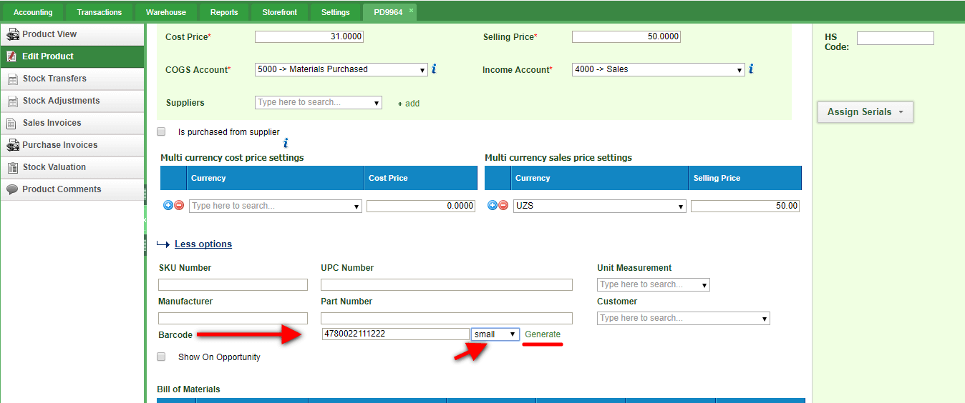 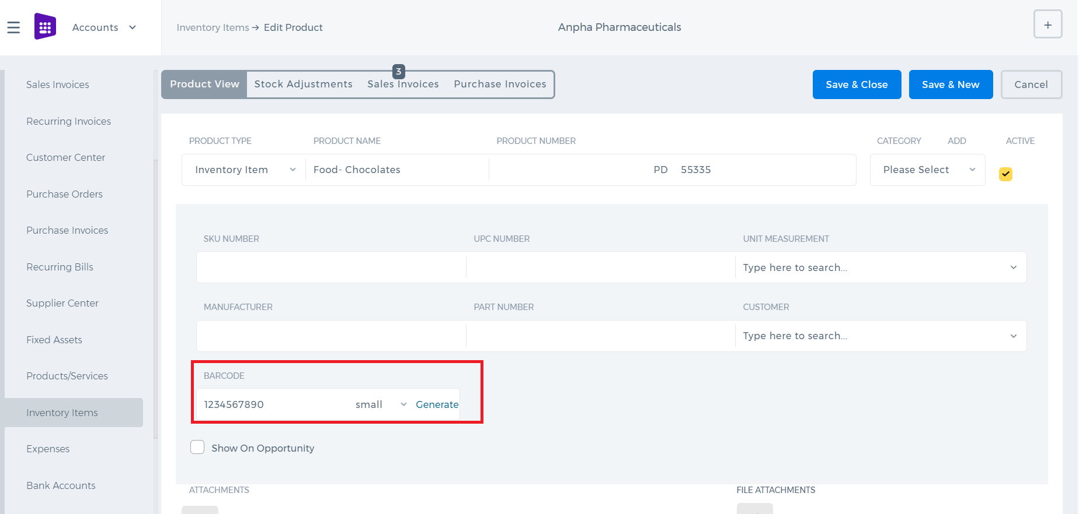 Then, choose the type of Barcode (small, medium, large) and click on Generate button and Save changes. Once you finish, you can download the generated barcode. 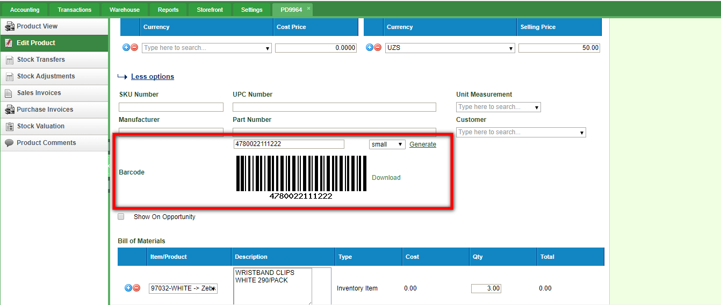 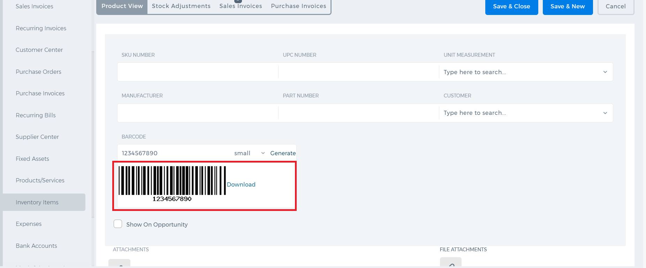

End of Service Gratuity

End of Service Gratuity
End of Service Gratuity is a benefit payment for employees when they resign from their work or when their job contract ends. This payment is practiced in some countries like United Arab Emirates, Saudi Arabia, Qatar and so on. In this article, End of Service Gratuity calculation will be discussed according to the United Arab Emirates Labor Law. If your company is located in United Arab Emirates, the End of Service settings are already set up according to the UAE Labor Law. 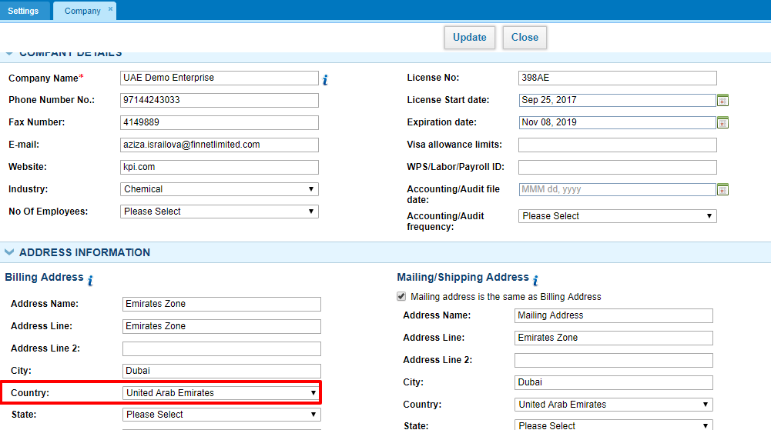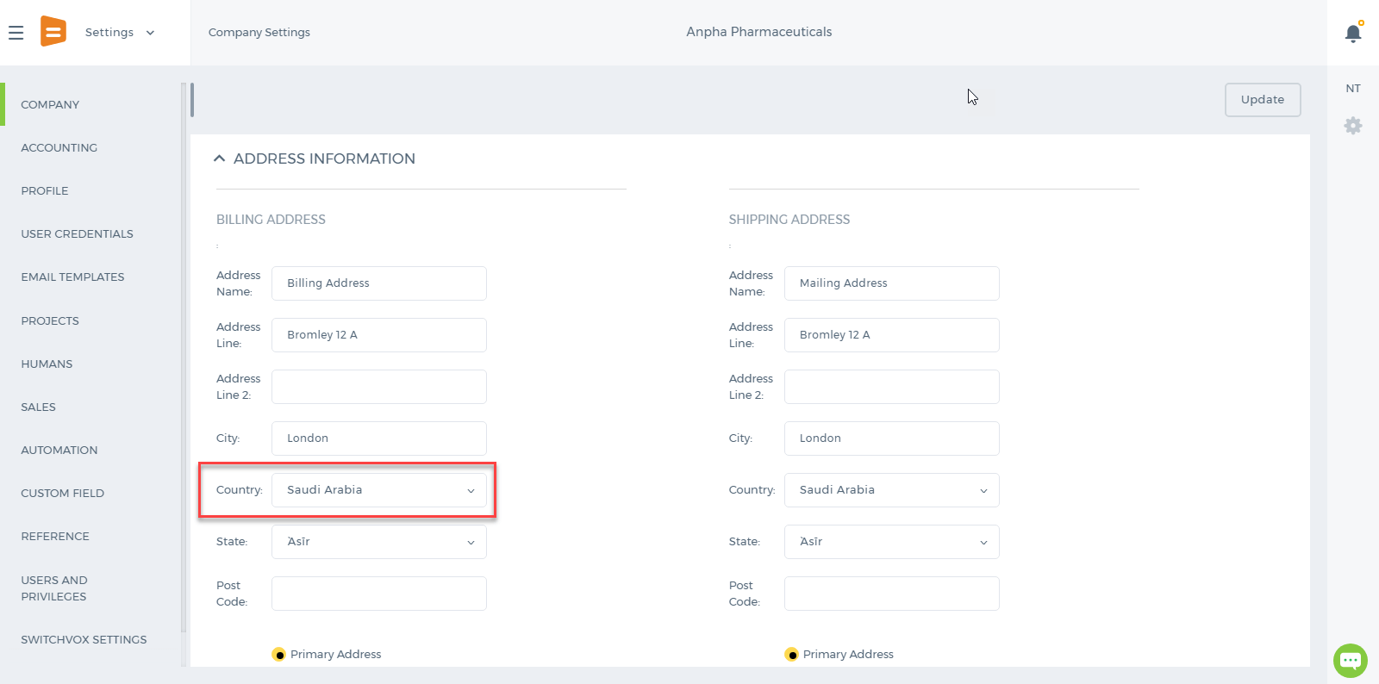 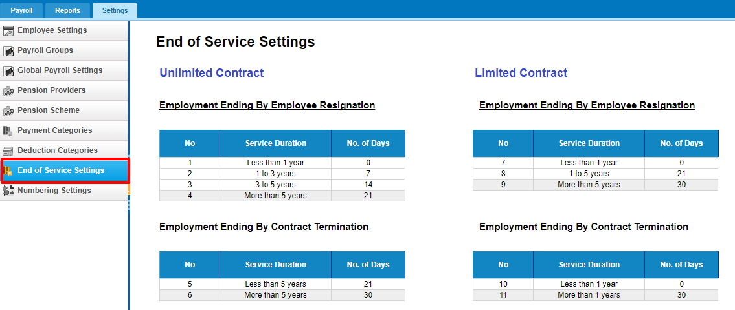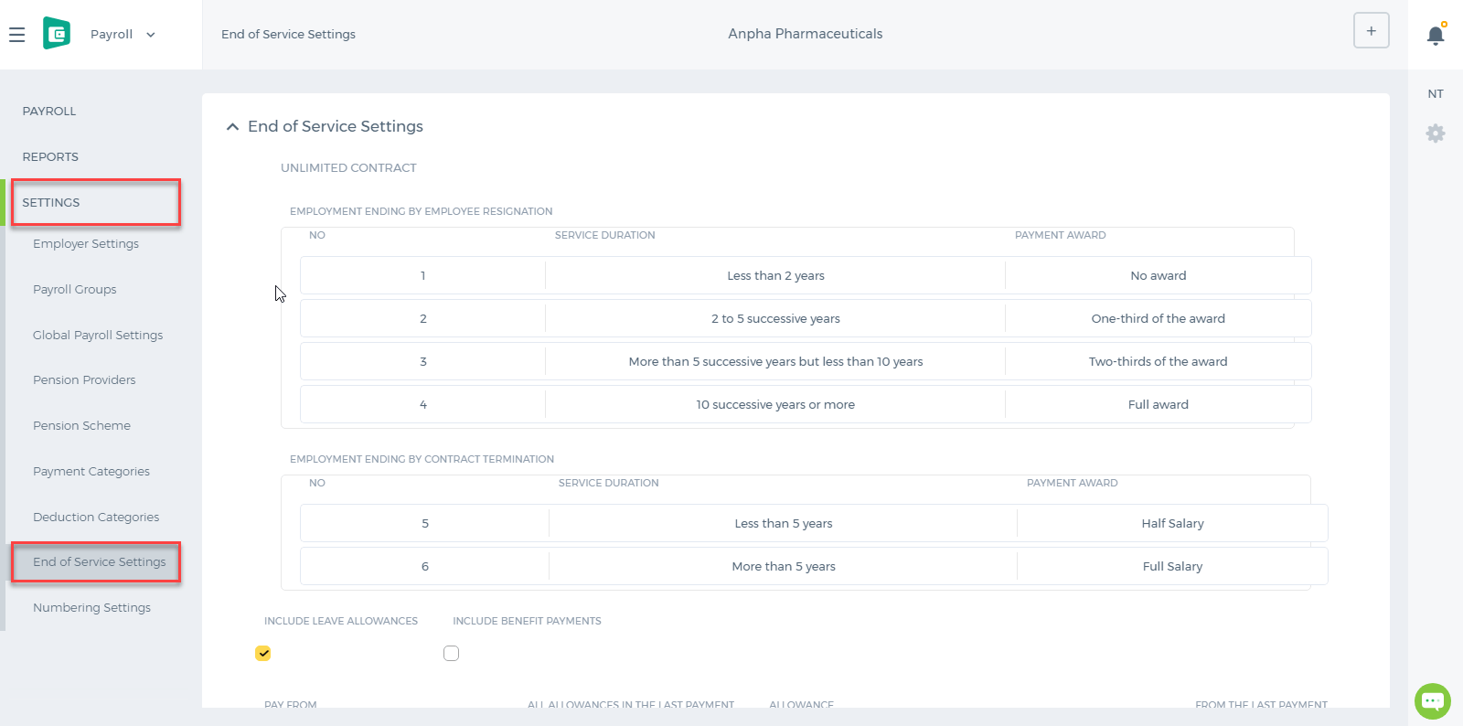 There are two types of Contracts: Limited and Unlimited Contract. If the employee has the Contract Start and End dates set in their profile, then the employee is said to get an end of service payment based on the limited contract calculations. If the employee doesn't have the Contract Start and End dates set in their profile, then the system will recognize them as Unlimited Contract employees. 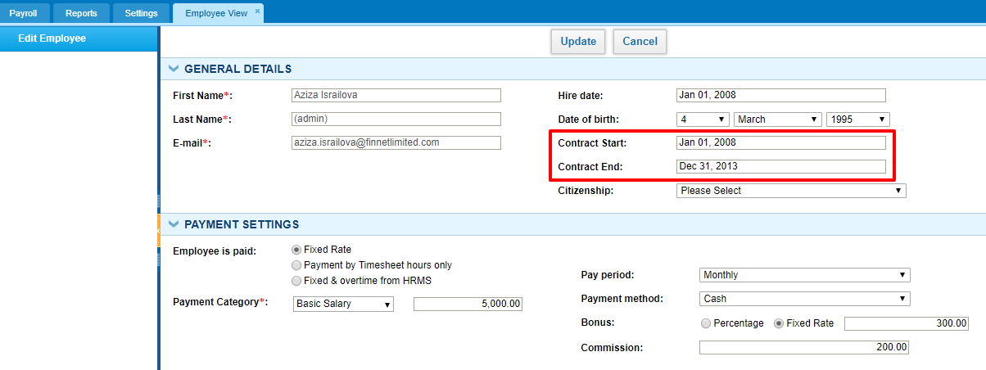 The system calculates end of service gratuity either by Resignation or by Termination. Let's calculate the end of service gratuity of an employee who has a limited contract. If the employee has completed more than 5 years of continuous service with your company and has resigned, then for the first 5 years he/she is eligible for 21 day’s basic salary and for service above 5 years, he/she is eligible for 30 day’s basic salary for every year of service. 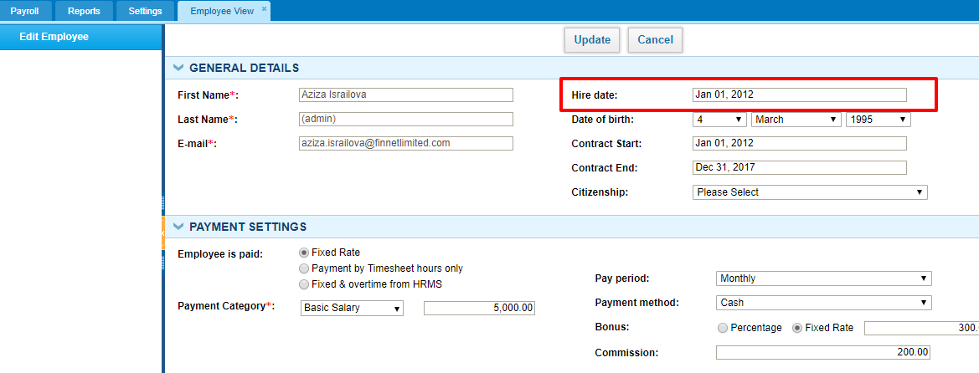 Calculation: Hire Date: Jan 01, 2012 As of Date: Dec 15, 2017 Basic Salary: 5000 per month Basic Salary per Day: 5000*12/365 = 164.3836 Total Number of Days Worked: Hire Date - As of Date = 2176 Total Number of Years Worked: 2176/365 = 5.96164 21 Days Basic Salary: 164.3836*21 = 3452.055 30 Days Basic Salary: 30*164.3836*(5.96164-5) = 4742.353 (for above 5 years). Total Gratuity: 5*3452.055 + 4742.353 = 22002.63 The end of service calculates the gratuity total according tot he reason you choose and date you choose. 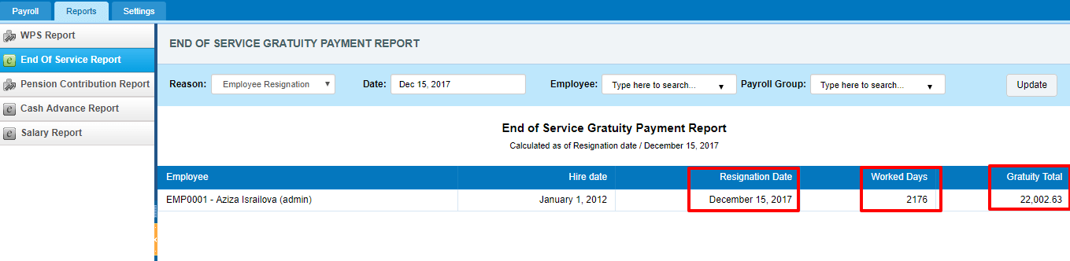 Other calculations are made according to the End of Service Settings in your account using the same formula. Resigned Employees If the employee is already resigned, the gratuity can be added from the End of Service Gratuity page. In order to add it, the employee should have the Resignation Date set in his/her profile. 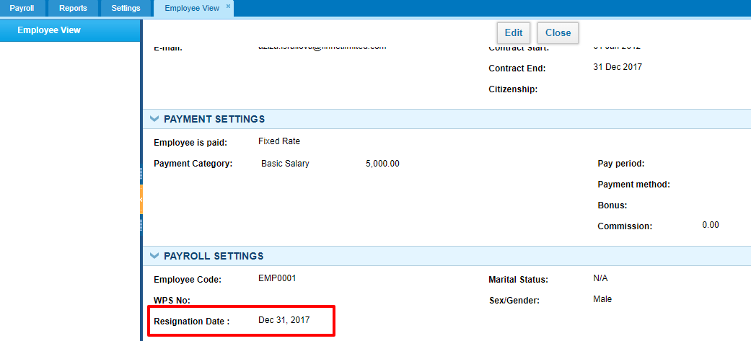 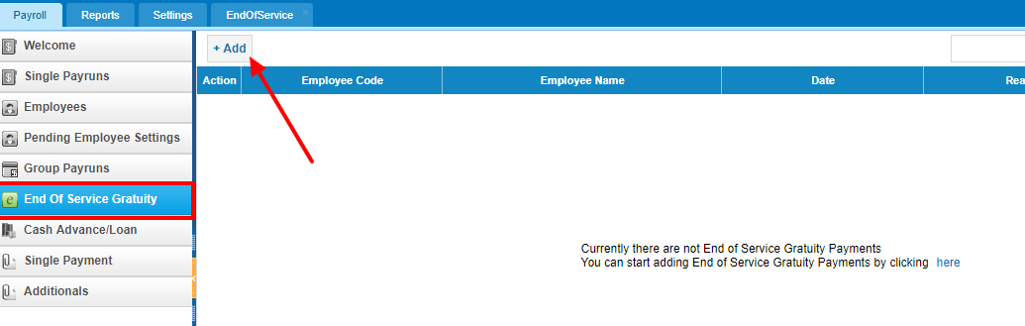 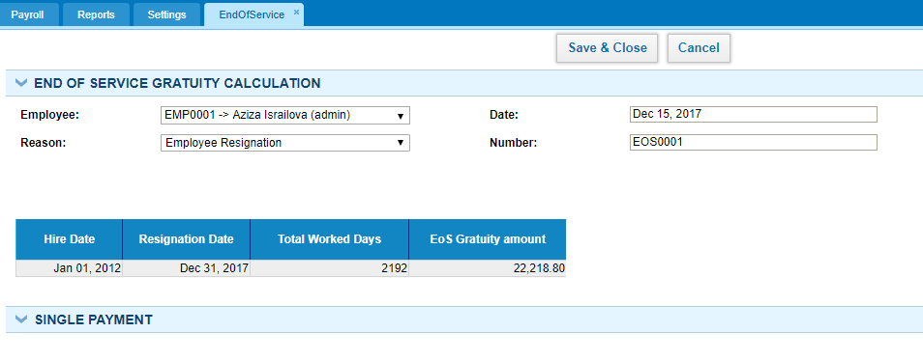 Once the End of Service Gratuity is added for the resigned employee, a single payrun will be automatically added in the Single Payrun list with a draft status.

