Key Performance Indicators: Intro [Infographic]
Published Date : February 3, 2016
Categories : Key Performance Indicators
Key Performance Indicators: Definition, Types, Search Criteria, Visualization
“Measurement is the first step that leads to
control and eventually to improvement.
If you can’t measure something, you can’t understand it.
If you can’t understand it, you can’t control it.
If you can’t control it, you can’t improve it.” ― H. James Harrington
A Key Performance Indicator (KPI) is a measurable value that demonstrates how effectively a company is achieving key business objectives. Companies use KPIs to evaluate their success at reaching their goals. Key Performance Indicators can be measured in different fields of your business from sales, marketing to financial and accounting departments. Each department has certain indicators that need to be measured and analyzed. 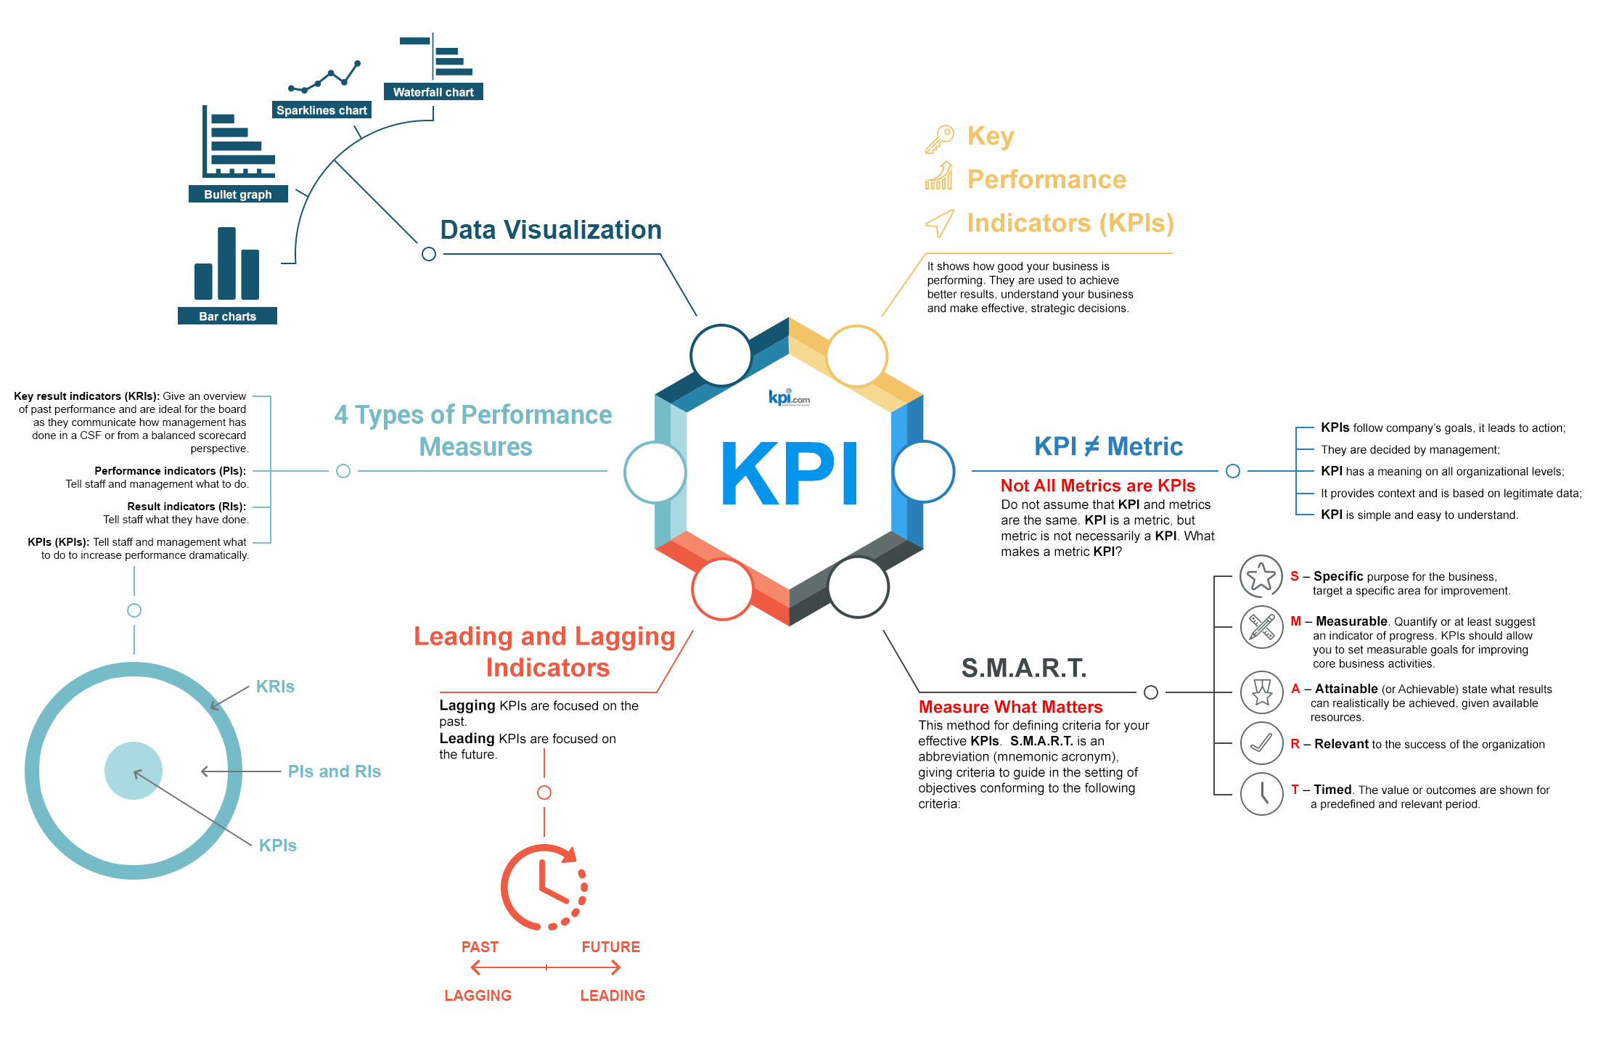Every area of business has specific metrics that should be monitored, measured and analyzed – marketers track campaign statistics, sales teams monitor new opportunities and leads, and HR managers control the turnover rate. Not all metrics are necessary Key Performance Indicators. And not all KPIs need to be measured and significant for the company. Various determination methods help us to define what Key Performance Indicators we need to take into account in our specific area of activity.

S.M.A.R.T. Key Performance Indicators criteria
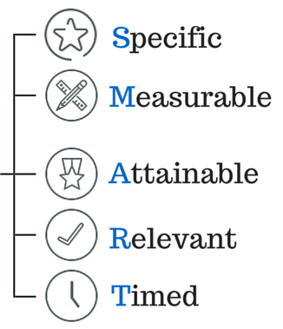 To evaluate the relevance of a KPI is to use the SMART method. The letters in the acronym stand for specific, measurable, attainable, relevant, timed. In other words, they should answer the following questions:
- Is your objective Specific, is it specified?
- Can you Measure the progress towards that goal?
- Is the goal real, is it Attainable?
- Is the goal Relevant to your organization?
- What is the Time limit for achieving this goal?
KPIs can be divided into Lagging and Leading. 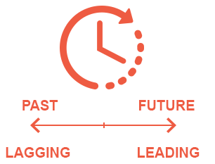Lagging KPIs are focused on the past. They measure the output. For example, in HR the “Turnover rate” is a lagging KPI. Lagging KPIs tell us story about the current state of your HR, but they don’t tell you how to change this state. While leading KPIs are focused on the future. Leading KPIs measure the input that should be introduced to achieve better results. KPIs are important for analysis and monitoring: they tell you different stories about your objectives. Different types of performance measure: KRIs, PIs, RIs, KPIs. The relationship between these four performance measures can be compared to the structure of an onion - multilayered. The outside layer describes the overall condition of the objective. The inner layers show the performance and result indicators, and the core is where the Key Performance Indicators are. 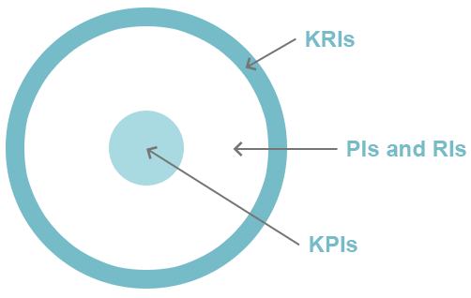When we have the Key Performance Indicators measured, the data itself can be difficult to percept and analyze. This is the reason we need to use data visualization which makes the process simple and understandable, increasing efficiency of the received data by focusing on important items, revealing trends, tendencies and allowing to trace over time changes. Waterfall Chart. A waterfall chart is a form of data visualization that helps in understanding the cumulative effect of sequentially introduced positive or negative values. The waterfall chart is also known as a flying bricks chart or Mario chart due to the apparent suspension of columns (bricks) in mid-air. 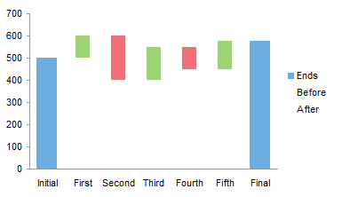Sparkline Chart. A sparkline is a very small line chart, typically drawn without axes or coordinates. It presents the general shape of the variation (typically over time) in some measurement. Sparklines are small enough to be embedded in text, or several sparklines may be grouped together as elements of a small multiple. 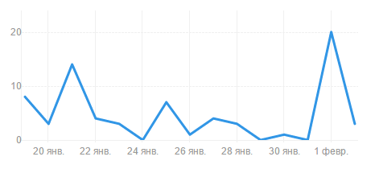Bar Chart or Bar Graph is a chart that presents grouped data with rectangular bars with lengths proportional to the values that they represent. The bars can be plotted vertically or horizontally. 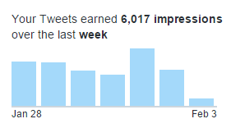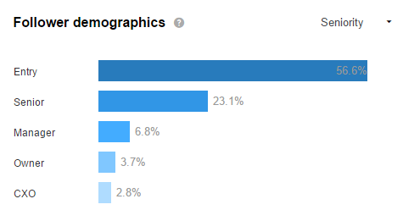Bullet Graph. A bullet graph is a variation of a bar graph.It serves as a replacement for dashboard gauges and meters. Bullet graphs were developed to overcome the fundamental issues of gauges and meters: they typically display too little information, require too much space, and are cluttered with useless and distracting decoration. 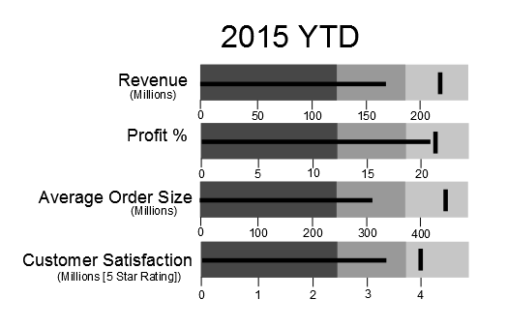Also, Pie Chart. A pie chart (or a circle chart) is a circular statistical graphic, which is divided into slices to illustrate numerical proportion. In a pie chart, the arc length of each slice (and consequently its central angle and area), is proportional to the quantity it represents. 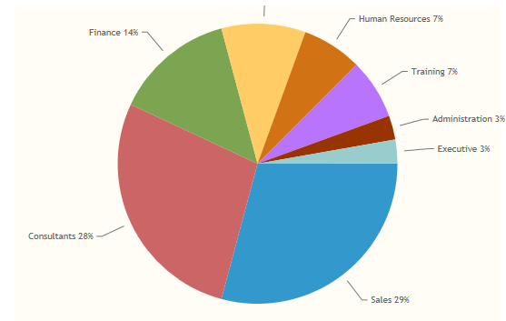Tips for KPI Data Visualization
- Avoid too many data points in a singular chart;
- Use effective color schemes;
- Avoid attempting to compare too many indicators in one chart;
- Don’t use dark backgrounds;
- Avoid overcrowding;
- Try to keep them simple, without 3D effects.
Embed This Image On Your Site (copy code below):
<br /><br /><br /><br /> <a href="https://www.kpi.com/wp-content/uploads/2017/08/59a6618d6f5b1.png"><img alt="" src="https://www.kpi.com/wp-content/uploads/2017/08/59a6618d6f5b1.png" /><br /><br /><br /><br /> </a><br /><br /><br /><br /> <a href="https://www.kpi.com/blog/2016/02/03/intro-to-key-performance-indicators-infographic/">Key Performance Indicators Infographic</a> by<br /><br /><br /><br /> <a href="http://kpi.com/">kpi.com</a><br /><br /><br /><br />

