February 2016 System Upgrades
Published Date : February 16, 2016
Categories : Updates
Dear kpi.com users, We are glad to announce thatkpi.com has launched its monthly upgrades for February 2016. Improvements are made in the Project Management, CRM, Accounting, HRMS, Payroll modules and the system’s overall performance. We put all our effort to improve existing features of the system and add new features according to our client’s feedback and requests. Thank you gratefully for your patience, understanding and goodwill, we do our best to add new features and resolve the appeared issues as soon as possible for your comfort and convenience. Workspace Meeting Minutes tool. Now you can send email notifications to Guests, set up email templates Project Management Contracts - added document attachments option. Now you can upload your documents and import them from Google to add them as attachments to your contracts. Contract list - added Notes and Start/End columns showing the contract start and end date. 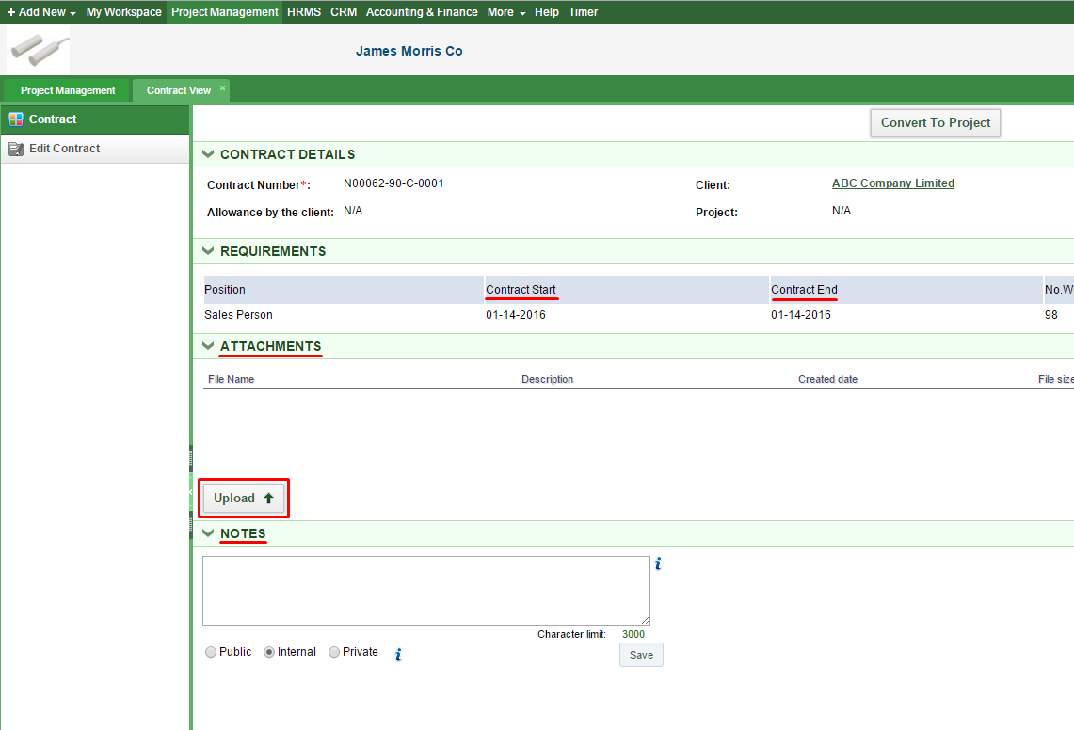CRM Import contact from CSV is optimized for speed and performance. 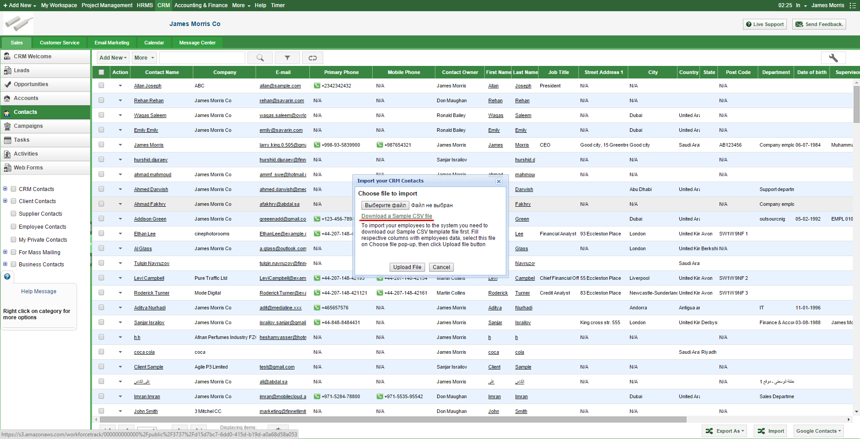Accounting Purchase order receive type field has been added. Now you can receive purchase order by quantity and by amount. Once you click on Receive button total quantity of the purchased item will be added to Receive field. In the Receive field you can change the quantity of received items that allow you receive partial amounts, or even more than ordered. 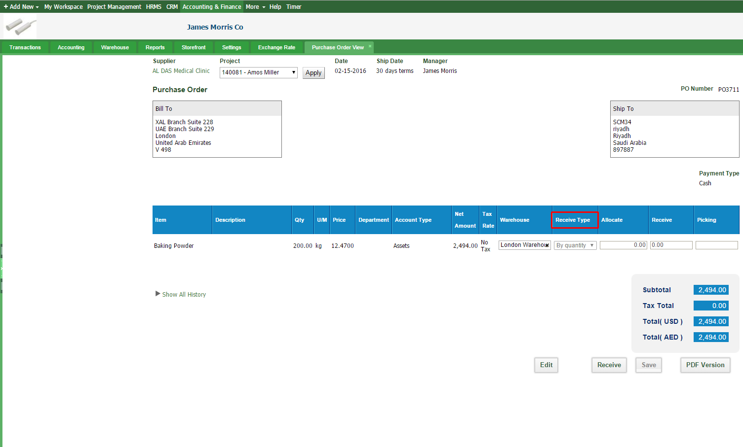Added discounts into add/edit product form - shows discounts list from Accounting settings, wich makes it easier to access the discounts page and set up discounts. 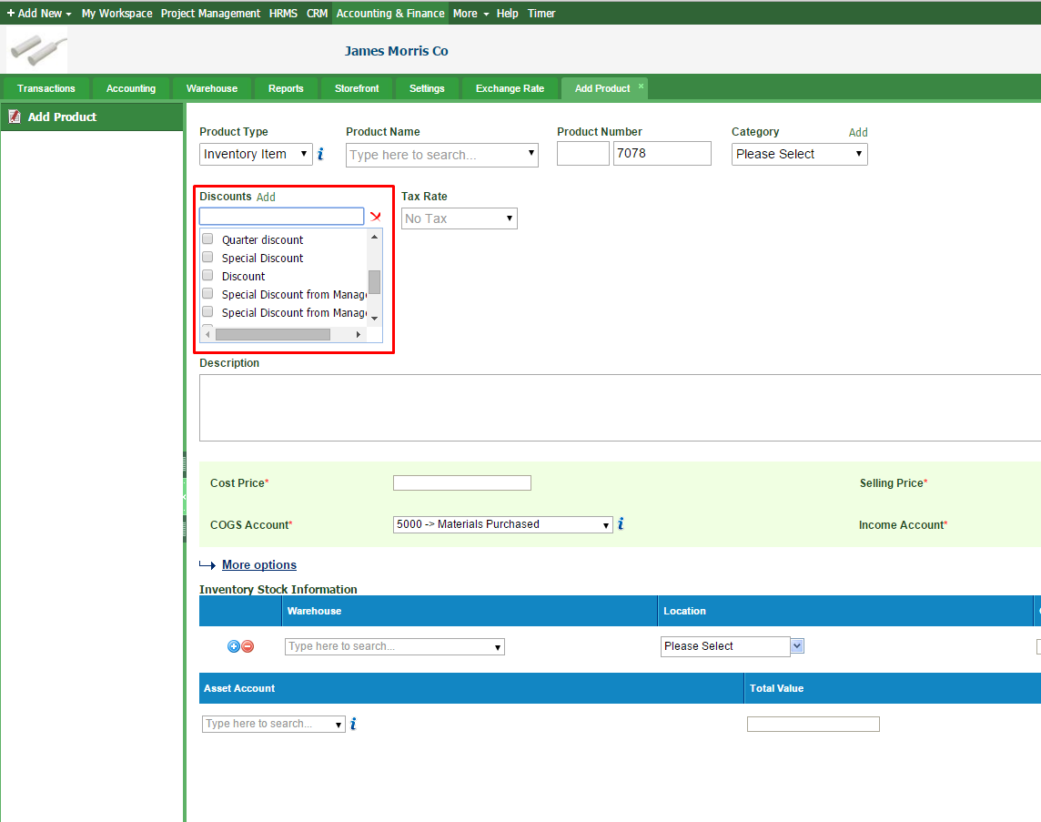Added new Currency Widget Added multi currency option into Balance Sheet report, now you can choose a currency from the dropdown menu. 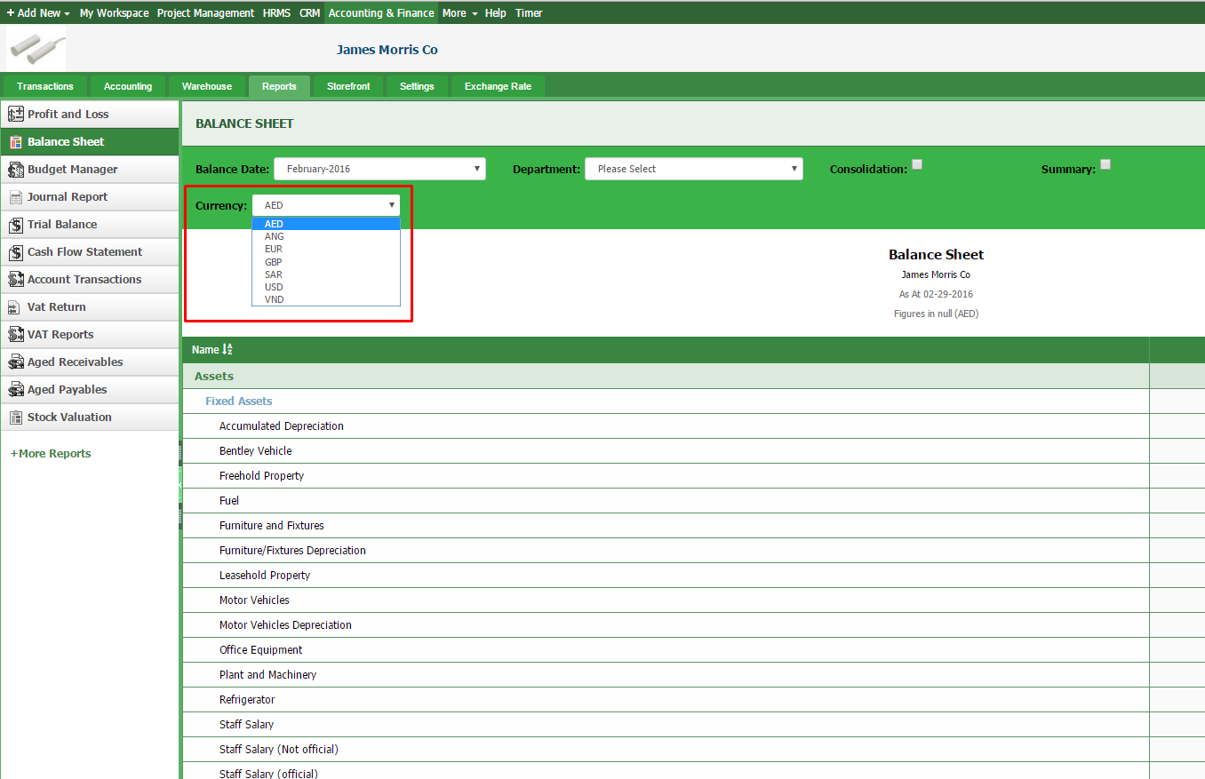Payroll Manage sending notification to employees HRMS Employee list - option to quickly change or add phone numbers. Double tap on the phone number to edit it. Click on the check mark to save. 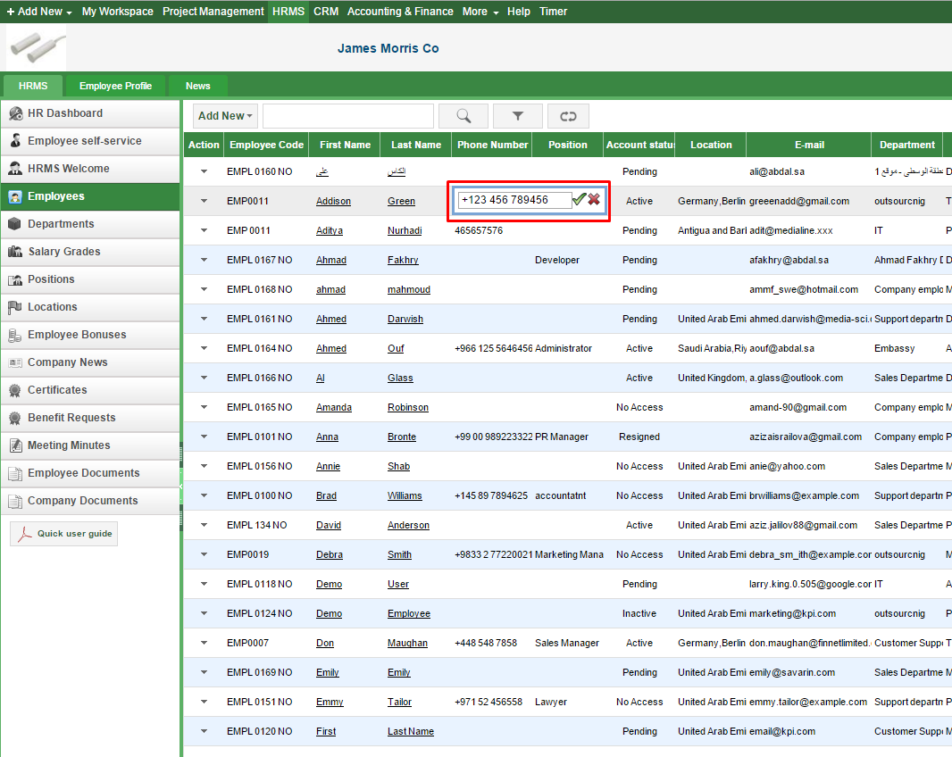Employee leave allowance - option to select previous years added. Certificates - option to attach employee image docs to certificates added. New certificate templates added:
- Employment certificate
- No objection certificate
- Job offer letter
- Salary certificate
- Salary transfer letter
- Contract termination letter
- Employee warning letter
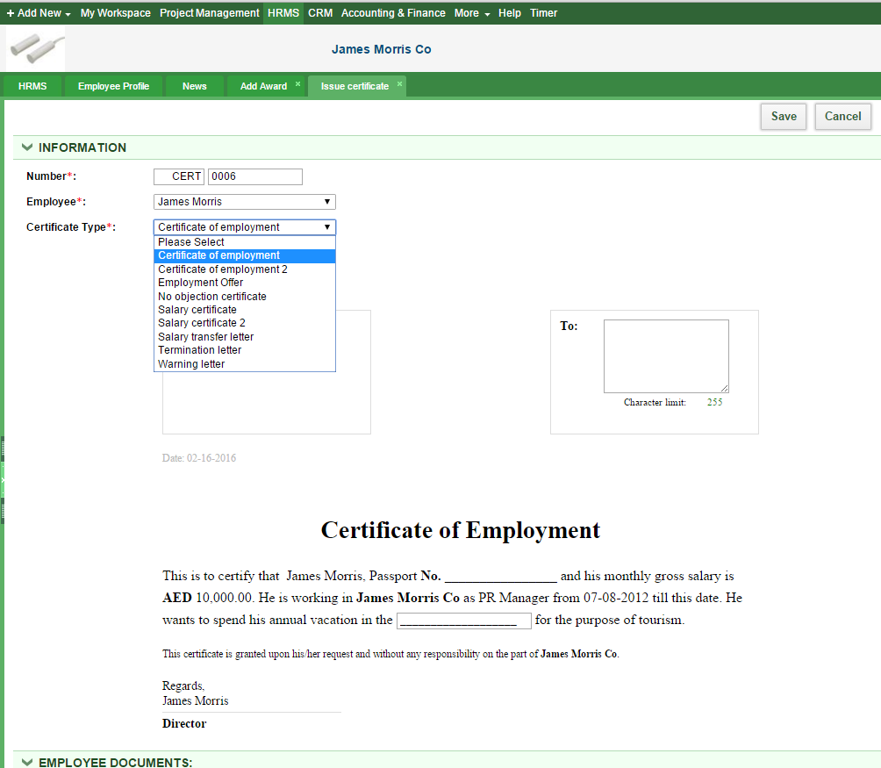 Existing position names can't be saved to avoid duplication. Attendance report - PDF export option added. Customize Recruitment Countries and Embassies option added. Vacancy form - country, embassy, gender, contract type etc. fields added If you have questions related to the upgrades, please contact our customer support team. E-mail: support@kpi.com Skype: kpi.com Phone: (UK) +44 (0) 207 096 1245 (UAE) +971 4 424 3033 (US) +1 646 844 33 30

