System Upgrades for April
Published Date : April 27, 2016
Categories : Updates
Dear kpi.com users, We are glad to inform that KPI.com has launched its monthly upgrades. Improvements are made in Project Management, Accounting, CRM, HRMS, Payroll, Reporting modules, as well as in the overall performance of the system. Our team puts the best effort to develop existing features of the system and add new features according to our customers’ feedback and requests. We greatly thank you for your patience, understanding and goodwill as we do our best to improve the system overall, implement new features, and resolve the appeared issues as soon as possible. Workspace
- Meeting Minutes - you can add CRM contacts to Recipients field.
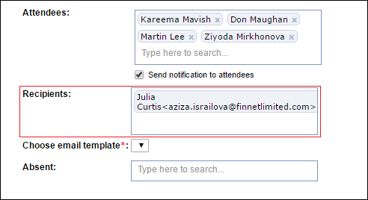 To add CRM contacts, tick the “Send notification to attendees” box and the “Recipients” field will appear. Project Management
- Timesheet Settings - “Validate Against Day Offs” option added
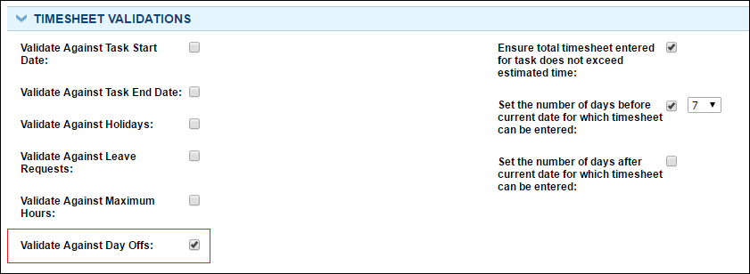 On order to avoid employees to fill in the timesheet beforehand or over time. To activate the feature, go to Settings >> Project Management Settings >> Timesheet Settings >> Timesheet validation block, tick the “Validate Against Day Offs:” box. CRM
- “Merge” contacts option added. Select a contact and click on “More” at the top of the contacts list.
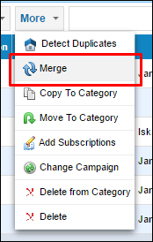
- Convert lead alias custom fields to account. When converting Custom field values in lead will be moved to the corresponding fields in Contact, Opportunity and CRM Account (only for unqualified) based on the Custom Field Settings.
- Multiple file attachment is now available on sending an email at once.
- “Opportunity” has been added to workflow automation engine. Go to Settings >> Automation settings >> Add new workflow and now pick “Opportunity” in dropdown of the Module field.
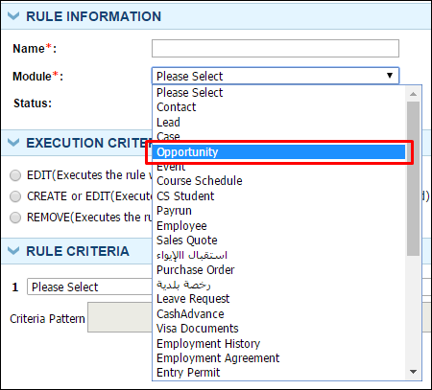
- SMS integration with “Our SMS” provider. From now on you can send SMS from this provider inside the system.
Accounting
- Import Journal Entries - a is new import feature for journal entries. To access it, go to Accounting & Finance >> Transactions >> Manual Entry listing page. Now users can import journal entries from an .csv file rather than entering them manually.
Payroll
- Multi approval for Cash Advance - users can set multiple approval levels for cash advance as they want.
- Added “Cash Advance” Report and “Salary Reports” in the Reports tab of the Payroll section. Fill in the fields and view the reports.
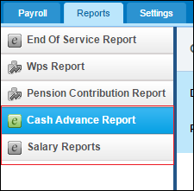
- Leave and benefit payment settings added to "End Of Service" Setting - this feature will allow users to add "Left Leave days" and left benefits to End of service gratuity payment
HRMS
- Organization chart renamed to "Supervisor structure". Supervisor chart shows people in the Company as a structure. When the Supervisors are set to employees, the Supervisor structure displays the hierarchy as a tree.
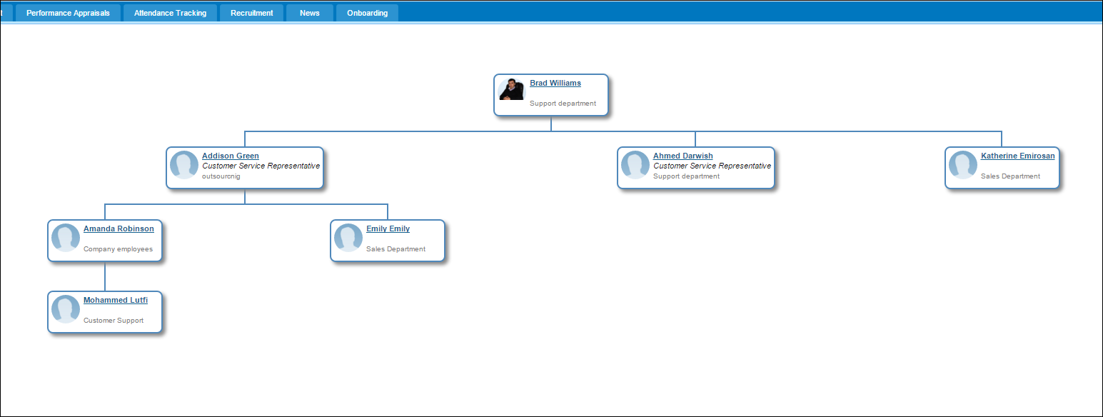 You can set a Supervisor for your Employee on the Profile edit page and from Employee listing by double clicking on "Supervisor" column. 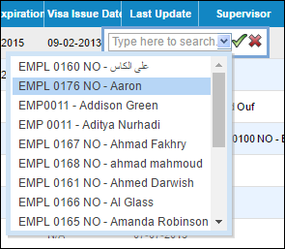
- New Organization chart is more specified for Department tree. When setting parent departments from Edit department page they will also be displayed on the page as a company tree. There is an option to show department employees in Organization chart view.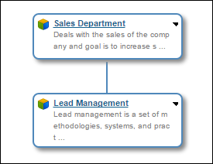
You can also quickly build department trees by clicking on little triangle in Department boxes, using "Set department" option. 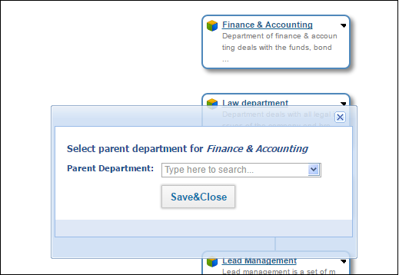
- Employee list - option to update Positions from the listing. Double-click on the position in the list and you will be able to open a dropdown to choose a position from the list
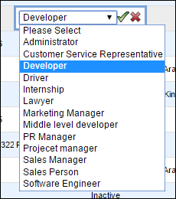
- Employee documents datepicker - years are now shown in cell editor
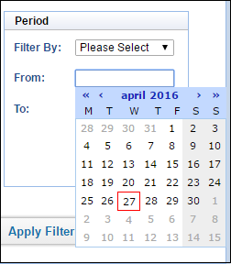
- Candidate list - added “Filter By Project” option
- Candidate - email and last name made optional,
You can now hire a candidate right from listing, by clicking on the “Action” option dropdown. 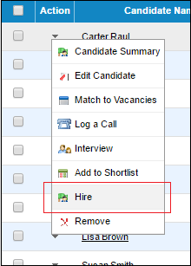Reporting
- PDF version orientation changed to Landscape
Overall system optimization changes. If you have questions related to the upgrades, please contact our customer support team. E-mail: support@kpi.com Skype: kpi.com Phone: (UK) +44 (0) 207 096 1245 (UAE) +971 4 424 3033 (US) +1 646 844 33 30

