Benefits Of An IVR System, And Why You Need One
Published Date : January 8, 2017
Categories : General
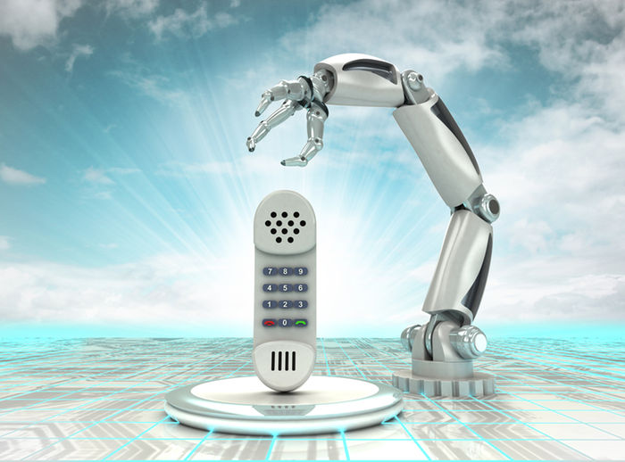 Most of you must be familiar with the IVR (Interactive Voice Response) because most of the times you hear this lovely voice telling you to “press 1 for sales”, and 2 for a different thing. The IVR system performs different functions like identification, segmentation, and routing. It transfers your call to the most appropriate agent in the company. The IVR system has many benefits as well: it is much more efficient and has very little costs. Many companies still don’t recognize the importance of the IVR system and they haven’t still installed proper IVR system in their customer care service. According to a research by JD Power & Associates, the IVR is a 27% of the total call experience. Here is a list of some benefits of IVR system, and some reasons why you need one.
- Increase in the First Time Call Retention
It is obvious if the customer care agent is taking too much time to answer the question or problem of the customer, the customer will lose interest. It happens because the customer care agent wasn’t qualified enough to answer that particular question. Had the call been transferred to the person who knew something about the particular question, the call wouldn’t have been dropped by the customer. IVR systems build up categories and transfer the customers’ call to the most appropriate customer care agent in order to provide the best help possible.
- IVR Provides Freedom to the Customers
You may have heard the notion that the customer is always right, and same is the case with customers who want to direct themselves as soon as possible to the live agent. According to a survey, 75% of the respondents said that the self-service is the most appropriate and convenient way to address the customer issues. An IVR system saves the callers from unlimited strings of call transfers and enables them to decide for themselves what they want.
- Increase in Employ and Organizational Efficiency
If the call is directed by the IVR system to the live agent, it is certain that the customer care representative will be qualified enough to answer that particular question. It will improve the efficiency of the agent because he knows how to answer that particular question, and hence the overall efficiency of the company will also increase. Apart from efficiency, The IVR systems also allow you to track certain metrics to ensure that the efficiency is really increasing. The IVR systems also record call abandonment rates, hold times and customer satisfaction score etc. By getting all this information, you can work specifically on the targeted areas making the efficiency of your company much higher than it previously was.
- Reduction of Operational Costs
You must agree with the notion that time is money, and so is the case in this scenario. If you are using manpower, it is obvious you will be paying a large amount of money to them. On the other hand, if you use an IVR system, the amount of manpower will reduce and you will have to pay very little. According to one research, it can cost $6 to $12 to a company who hires a man for chat interaction, and this is the price for one chat interaction. On the other hand, if you are using an IVR system, it will cost you25 cents per interaction. Initially, the installment of IVR systems cost you a lot of money, but nowadays these systems are becoming cheaper and cheaper.
- Greeting the Clients More Professionally
Now, by installing IVR systems, you can greet your clients more professionally than ever. Whenever a customer or any potential partner calls you, he will be influenced by the first impression and if you have installed IVR system, it might be good for further partnerships. With the help of IVR systems, the clients are provided with messages that are efficient and highly professional. This way, even if you have a small business, it will look very big and professional. The IVR systems can also help small and startup businesses prosper more quickly. These are all the benefits that you will get from installing an IVR system in your organization. This article is written by Lisa Myers who works at Coupon Goo. She is a software engineer by profession.

