Give your customers and suppliers access to kpi.com
Published Date : February 17, 2014
Categories : Updates
Trust of customers and suppliers plays crucial role in running business effectively. With kpi.com, users are able to increase transparency of projects work flow, tasks, documents as well as credence of financial operations for their customers and suppliers. The process is simple and requires just a few steps.
Customer access
In order to give access to customers, go to CRM>>Sales>>Accounts, then choose specific account and go to Contacts menu item.
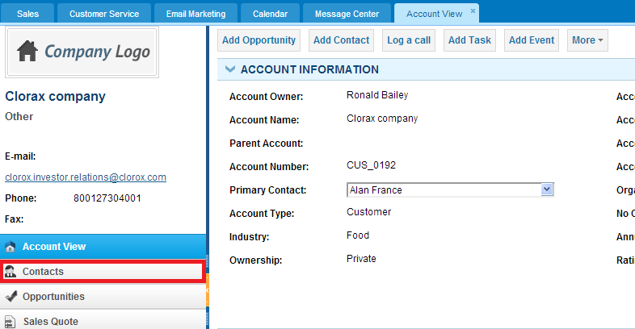
When you select Contact, you will see details of the primary contact of this customer. At the top of the page click More and choose Enable access.
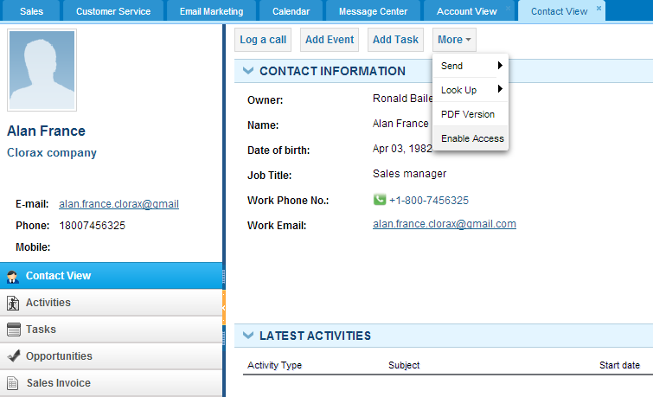
Customer’s primary contact will get an email with an activation link to the system. After successful activation, contact will be able to see projects, tasks, sales invoices, news and documents related to the customer.
- Supplier access
To enable supplier access to the system, go to Accounting & Finance>>Supplier Center
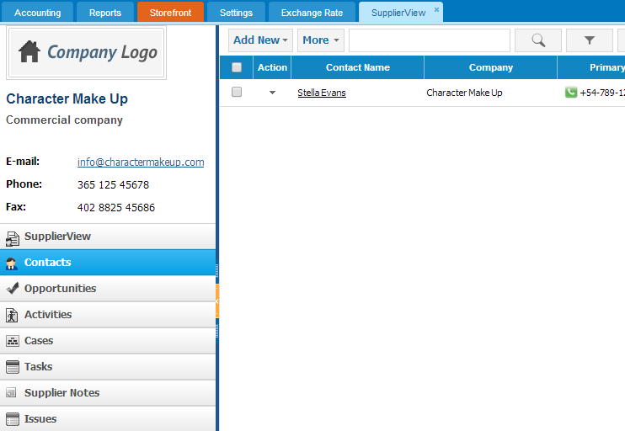
Choose particular account, and then enable access to the supplier’s primary contact the same way as we did for customer contact.
- Permission Settings
Moreover, users can give additional permissions with the Permission Management in Settings.
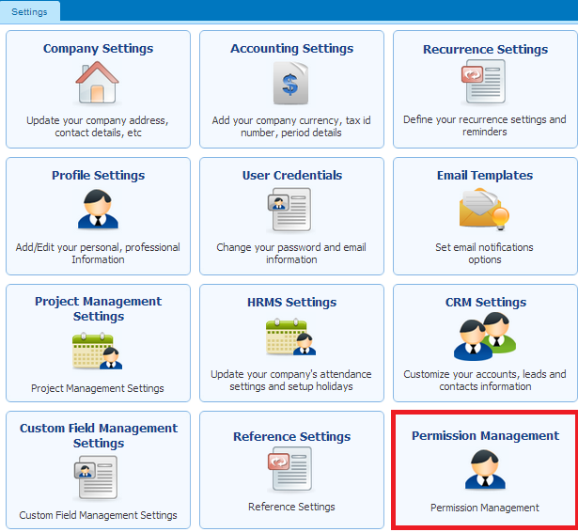

Users can give some additional permissions to clients and suppliers or vice versa – limit their access. In order to control permissions you just need tick or untick appropriate box under “Client” or “Supplier” role column.

For instance, in order to give permission to view sales quote list, you need to tick the box, located at the intersection of Sales Quote List row and Client column. Or in order to forbid sales quote deletion, you should untick the box located at the intersection of Sales Quote Delete row and Client column. Settings will be saved automatically, and your clients will be able to see sales quotes list but won’t be able to delete any sales quote.

Updates to kpi.com | February
Published Date : February 11, 2014
Categories : Updates
Dear kpi.com users,
We are pleased to announce that kpi.com has launched its February upgrades and enhancements for the modules such as CRM, HR management system and Accounting. Accordingly, we greatly appreciate your patience, understanding and goodwill, as we do our best in implementing new features and enhancing existing features of the system. Below you can familiarize yourselves with some of major updates released this month.

CRM
Google synchronization new API. We are keeping up with Google Accounts technical changes and this month we moved to new API. All users who are using our Google Synchronization should re-configure their settings within kpi.com accounts. For instructions on configuration, kindly visit:
Calendar synchronization
Contacts synchronization
Documents synchronization
Mailing list creation moved to background process – enhancement of this feature gives users opportunity to create large mailing lists. Moreover, process of mailing list creation will be running on the background, while users keep working with the system.
Good news for non-English users, kpi.com enabled importing non-English data into the system.

Accounting and Finance
In the Accounting section of kpi.com, three major features were implemented in the system.
Sales invoice import – with this new feature kpi.com users can import ready invoices into the system in a few minutes. Full information about sales invoice import can be read on Save your Time with New Sales Invoice Import Feature.
Elavon payment gateway – now kpi.com users can pay bills with the help of new payment gateway Elavon. You can read further on We Have Integrated with Elavon Payment Gateway.
Purchase order permission – Last but not least, kpi.com added new permission options for issuing and viewing Purchase orders.

HRMS
In/out hours import – this feature was in Beta version, now it is fully functional and users can import and override In/Out hours recorded in the system.
Apart from the mentioned above features and enhancements, we have also applied several small fixes around the system.

We Have Integrated with Elavon Payment Gateway
Published Date : February 10, 2014
Categories : Accounting
With the development of E-commerce the way of paying bills, services and purchasing products became easy. Instead of going to the stores or banks, people can buy bills or purchase goods and services by payment gateways. It is not a secret that businesses use different ways of payment to pay bills.
As a company, which cares about comfort and convenience of our customers, kpi.com launches new payment gateway. This payment provider has powerful solution for all payment types. Using it is simple, it takes only a few steps to pay.
Firstly, users should fill the credentials provided by Elavon in the Settings, Invoice Settings
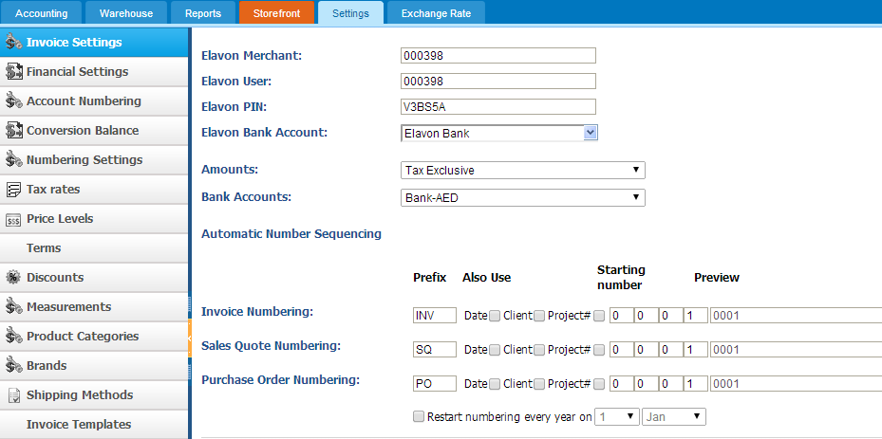
Then, your clients will get invoice payment on PDF file which will have Elavon link on it.
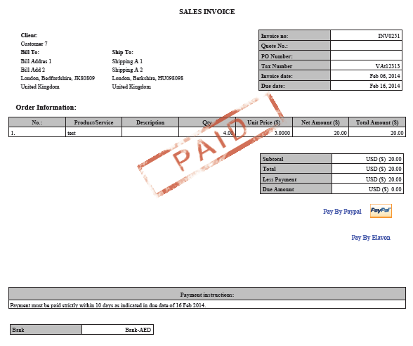
When it is clicked clients will be redirected Elavon’s web site. Note that client should fill the data in empty fields.
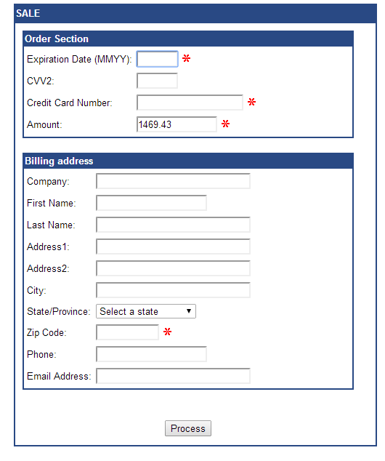
After client has filled data in and pressed Process, they will be redirected to the page, informing that they have paid certain amount of money.

Save Your Time with the New Sales Invoice Import Feature
Published Date : February 10, 2014
Categories : Accounting
Sales invoice has a crucial role in running business as it provides seller with a record what has been sold, when the transaction has taken place and how much money is involved. This information is useful for internal company records, also to follow up with buyers for billing purposes. The information it contains and the way it is written ultimately impact the company’s operations and financial statements. Thus, it is important to have properly written sales invoice in order to avoid confusions with the buyers and sellers.
We are introducing a new feature which makes invoicing even more convenient – invoice import. This function will give users opportunity to add Sales Invoices in a few minutes by importing file into the system, instead of typing manually. Moreover, the procedure of importing is not complex, you should complete only a few steps to import sales invoices.
Firstly, users should go to Accounting>> Sales invoice>> Import button.
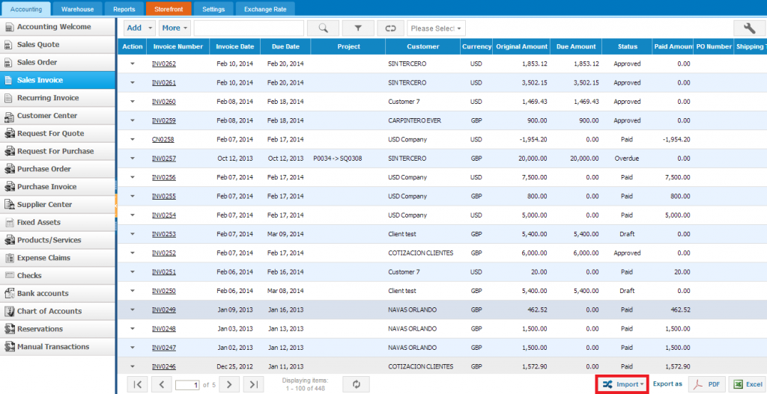
Before selecting file with the sales invoices, note that the file with data should be in .CSV format. After uploading the file, you are asked to match the columns of your file with the system columns.
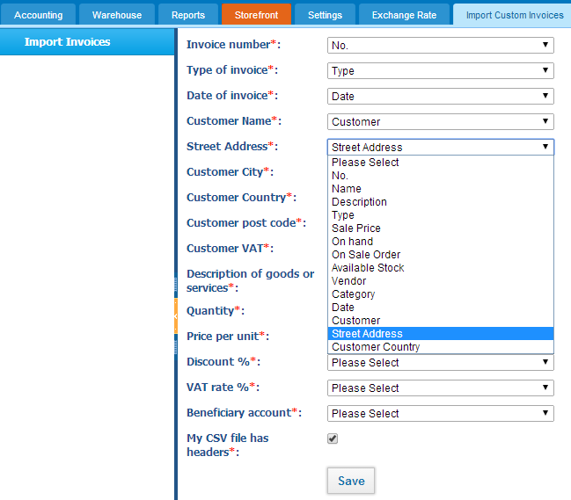
Once you have matched the columns and saved the result, your sales invoices will be successfully imported into the system.

Learn How the Reporting System Generates Reports being Integrated with Other Modules
Published Date : July 8, 2013
Categories : Accounting, CRM, General, Project Management
Corporate report is a valuable document that provides feedback supporting employees and executives for decision making. It also gives a basic supervision to the administration for solving problems faced by a company. However, report writing (the traditional method) is a time consuming, expensive and extensive activity since it involves compilation of facts, drawing conclusion and making recommendations.
Workflow of Reporting Tool
Kpi.com helps SMEs enhance their reporting processes offering a very useful tool for reporting. There are more than 4 modules such as Customer Relationship Management (CRM), Financials & Payroll, Project Management, HR Management System (HRMS) and others. All information created by employees i.e. in CRM section, the leads list created by your employee, goes to the first Database of kpi.com and in the same time, this information is saved in the second Database (also called as Secure Backup which is read only). The Reporting System takes all information (in our example, Leads list) and lets the user to create a report using the default templates.
Here’s the actual flow we want to track and understand:
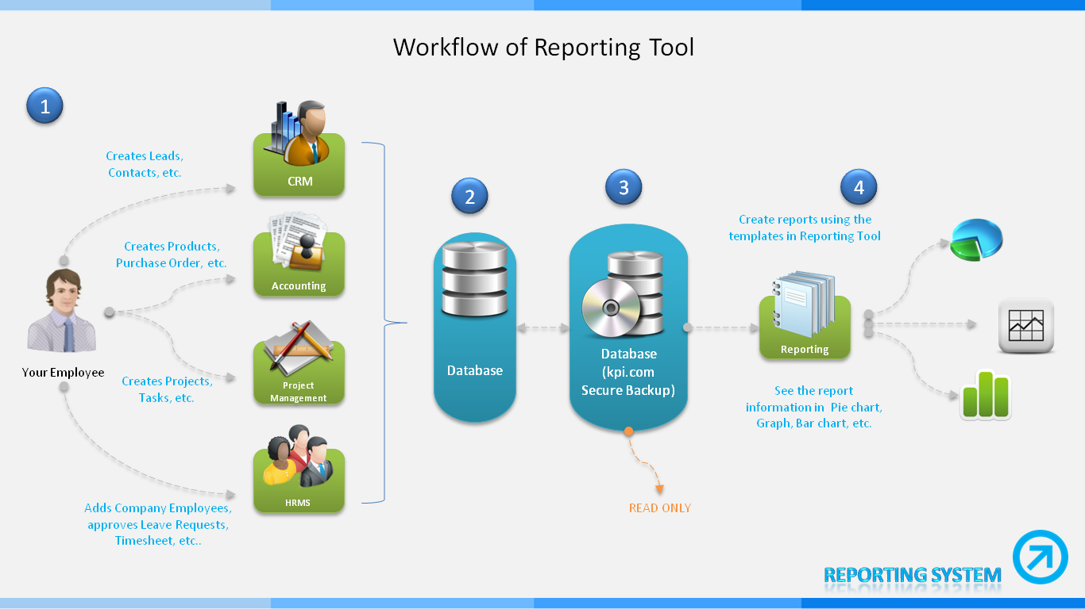
Generating Reports
You have three ways to generate reports:
- Customizing reports through the Advanced Search option
- Creating a new report manually
- Using the Templates that are located on the default page
Advanced Search
The Reporting System provides an advanced search where you need to choose a category from the dropdown then according to your choice, the system generates report types in the next dropdown option. You need to choose a report type and in a while two panels will be activated on your screen. Using the Filters panel, you can modify the information that you need to see in your report. Also, the columns appeared in your report can be customized manually on the Columns panel. Once you have completed the Advanced Search process, you will be able to View the results, Export the report in Excel or PDF formats.
Create New Report
This way is far detailed and accurate. To create a report, open a popup window that is appeared after clicking on the New Report button on the top of the default page of Reporting Tool. Select a data type from the list appeared on your screen and after choosing one of the data types by scrolling up/down, click on OK and go through the following reporting process:
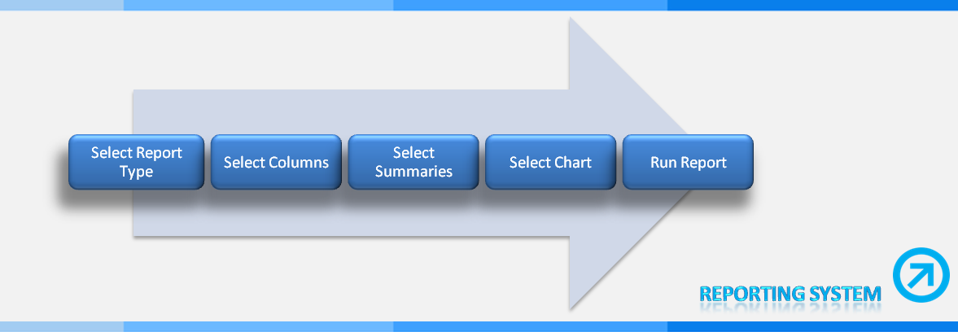
Default Templates by Source
There are five essential panels, Accounting & Finance, CRM, Project Management, My Library and My Favourites, that maintain the templates/reports associated with their sources. If you want to generate a report in a very easy way without any custom activities, you may click on one of the templates i.e. Leads by Source in CRM panel which collects all the relevant data on Run Report page. There you may view other kinds of reports, share the generated one, filter the information out and export it as CSV, XLS and PDF. Besides, you can return back to the previous processes to reset the columns and change the chart type. You may mark this report as your preferred which is found in My Favourites panel.
You can find the detailed guide on our Wiki section.

What Is SEO on a Next Level?
Published Date : June 24, 2013
Categories : General
People who have come to read this article already know what SEO (Search Engine Optimization) is, yet I still would like to point out that when somebody searches for queries in Google, they only see the web pages that are indexed by Google, so in other words, when you search for something on Google, you are only seeing what Google wants you to see. Sounds manipulative? Actually, Google is now doing its best to present you the most relative content.

We all know that in older era Google was bit naïve and used to fall for bunch of keywords instead of a meaningful content. Backlinks had also similar positive effect regardless they are from great quality web sites or the scam ones. Google introduced “Farmer Update”- Penguin and Panda and you cannot fool the Google anymore like you used to. For those who do not know what above two mean I will briefly summarize below:
Penguin is a complicated algorithm that is aimed at fighting against spam links- those from low quality sites or simply containing keywords as anchor text.
Panda is another algorithm with slightly different purpose- to watch out and penalize sites which has duplicate or thin content. If you are copying content from other web sites or creating pages that contain way too few sentences then you are running the risk of being hit by Panda.
What conclusions can be drawn from above? Well, Google has evolved over the past years and now it sees your pages like any other human does and they try to find the most relevant page for the queries searched for.
Below are Dos and Don’ts that help you move higher in the SERP (Search Engine Results Page)
DO
- Know your audience– make a unique and appealing content and keep it updated
- Be active in social networking – Promote your blogs, articles actively in social sites
- Become a guest blogger – If you are new blogger and not have a large audience, you should really think of becoming a guest blogger for popular and high-quality sites
DON’T
- Fall for SEO scam– You must be getting a lot of emails from self-claimed SEO Experts. You may wish to contact if you think you really need their help but beware that Google recently admitted to have received similar claims from them- that “google.com is not on top of the search list and there are couple of fixes that need to be applied”
- Agree to exchange links with everyone– Since Penguin is now checking for your backlinks place them in a quality sites. Agreeing to exchange links with sites you do not have enough information about may harm your reputation. There is also a concept called “Unnatural links” penalty which is monitored by a Google employee manually.
To sum up, links still being a primary area to monitor, you need to low quality web sites. The most effective way to improve your place in SERPs is putting out a unique content for your audience and do not forget to keep an eye on your Webmaster Alert Messages.
I would be happy to read your thoughts and suggestions.
*Image Source: http://www.seogeezer.com/google-penguin-panda-not-about-links-reversed-engineered-and-outs-penguin-negative-seo

15 Tips to Improve the Efficiency of Small Business
Published Date : June 20, 2013
Categories : General, Managing Business

Participating in various kinds of business forums, I found LinkedIn the most practical. People who are involved in business activities post and discuss a variety of matters. One of the members brought up a topic for discussion, “If you were given an opportunity to give one bit of advice for a small business owner that applies to the business efficiency, what would you suggest?”
The group members turned to be eager for the opportunity to speak, and they have posted over 60 counsels to this discussion. I sorted the comments out and thought these tips are worth reading and putting into operation.
1. Know where you are today in all the details of each process, from sales to delivery and payment. Make a map and describe each step, including where and when something goes wrong. If this is done with complete honesty, accuracy, directness and in sufficient detail, many improvement opportunities will be self evident.
The entire team should be engaged in the mapping of the region of responsibilities. They are required to be deeply involved in scheming and applying the prospect position.
2. Small business owners attempt to carry the whole business on their shoulders, including the employees. And in the beginning it is absolutely right to act as a pioneer. But very soon, this pioneer mentality becomes an obstacle for further growth, as the world is too complex to cope alone. The owner begins to overlook the opportunities. Then, it is time to delegate. Employees need not only to do what the owner said but they need to develop, and the owner must guide them and help them in their development. So, begin to delegate the responsibilities for the daily activities of your employees and start to allocate some time to create a long-term vision.
3. Take the time to plan properly. For small business owners the desire to create income and maintain cash flow often leads to violent tactical operations. Set aside time for planning. It may perhaps be difficult but eventually you will get more consistent results.
4. Determine and talk to your customers and observe what they expect from you.
5. Whatever you decide to do, make sure that it is connected with the needs of your customers and not the needs of products or services. Get rid of the procedures that conflict with the customer-oriented approach. It is worth to remember that the customers are the ones who give you their money. Provide your employees with the right training, tools, rights and opportunities for customer service.
6. Assure your customers that you perceive their interests at heart and prove it by becoming the safest and most efficient contractor who takes care of the quality.
7. Make sure that you have the right people in the right positions… then go ahead.
8. Keep your employees in problem solving and visibly track the results so that your employees can see the advancement.
9. Do not relax and do not be disheartened. You are lucky that the business you are leading is completely under your control. Many managers do not have such a chance, so do what you want!
10. Leave your ego at the office door, so that you can really “hear” what your employees tell you about where the waste might be and act on it.
11. Take a part in the transformation fully. Spend 85% of your time on the floor and ask everyone what they need to do a better job, and then give it to them. If you are not sure how to do it, do not be afraid to ask for help.
12. Start by eliminating the fear. Support and approval from the owner of the business will allow the staff to determine the problems with the processes.
13. Organize public recognition for employees who achieve exceptional results in certain projects by simply ordering a pizza; inviting them and recognizing the outstanding performer.
14. Be in touch, get regulation, authorize, assess and acknowledge… and start all over from the beginning!
15. Identify where you spend the most money and time (in this case, on human resources) and make sure you know exactly what your customers needs are. Then, involve employees in a root cause analysis, identify things you can directly impact and make the changes. This approach is most effectively achieved when employees are actively contributing as a part of the success.
Hopefully, these tips will bring goodwill to your business.

System Enhancements for June
Published Date : June 14, 2013
Categories : Updates
Dear kpi.com Customers,


We are pleased to announce that kpi.com has launched its June upgrades for the modules such as Workspace, Project Management, CRM, HR Management System, Financials and Payroll. Accordingly, we greatly appreciate your patience, understanding and goodwill as we do our best to implement new features and resolve the appeared issues as soon as practical.

Workspace
The Beta Workspace has been available for almost two months now for our users to compare its functions with the older version of Workspace. At the moment, the Beta Workspace can be set as default. For those who want to activate this option please, contact your kpi.com Support Manager.

Project Management
There have been two foremost and three accessory upgrades within the Project Management module requested by users as well as kpi.com QA professionals.


Gantt Chart, a very handful tool, is used for planning projects and ensuring efficient project delivery. Kpi.com has designed the Beta Gantt Chart with some enhancements and new options that are slightly different to the prior one. Users of this feature are now able to import MS Project files not changing the order of the file content. They can also export the kpi.com Gantt Chart in Excel format that is located on the top panel.
In Tasks section, most users need to remove the unnecessary and redundant information from an information stream using the Task Filter option. Since this is one of the key functions, kpi.com decided to apply some improvements to it. You can filter two kinds of options on Task Status such as the Assignee status and Overall status.
The accessory upgrades include:
- As a project manager, you can manage the project status through kpi.com Permission Management.
- All project related tasks can be assigned to a recently created employee preventing you from doing it manually.
- All users in the system are able to create public, internal and private notes in Tasks section.
- The Client Contacts list is now visible on the Task View page. Project associated employees are now able to send notifications to their clients. To manage this option, refer to the Permission Management.

CRM
In CRM Module, you can observe two changes in Note and Case Management sections. A special widget has been designed for CRM Note Management and user can leave three kinds of notes: private, for company employees only, and public. The department panel has been added in Filter option in Case Management section. The CRM Upgrade release also contains several other improvements.

Accounting


We upgraded Financials module with a few new features and enhancements.
Our new features:
- Add Product Images – Now you can upload product images and see them in Product Summary form.
Enhancements:
- Assembly Item improvements
You can add Other Charges and Service Items into Assembly Items section as well. Built Assembly Item can be broken back into stock easily.
- Bank Transfer between Multi currency bank
Exchange rate feature is added to Bank Transfers between bank accounts with different currency. You can receive/spend money form from/to other bank accounts by converting the amounts.
- PayPal Link added to Sales Invoice
- Convert into Invoice partial received items
Now, the purchase order for partial received items can be converted into invoice and not received amounts of the remaining can be closed.

HR Management System
In this upgrade month, no major change has been implemented to HR Management Module. Yet, one small enhancement has been done for employee Leave Request (LR) Approval Manager. Once the project manager has approved the LR that an employee submitted, he/she is now able to review the summary page for the Approved LRs.

Documents Management


The Documents Management module has been enhanced envisioning much clear database of several kinds of document folders. There is a Public Folder that contains all kinds of files uploaded by company employees, clients and contacts. Users are now able to create new folders in Public folder.

Plugins
Google Gadget is recognized as a “Have it your way” tool that assists you to add a case, task, sales quote and others directly on your Google Inbox. After the system upgrade, you are able to link a specific mail to the existing case, task, quote, opportunity etc. which prevents from redundancy.

Faceted Filter
Published Date : June 10, 2013
Categories : Project Management
This past weekend we ran a monthly system upgrade for June and it contained some major changes for task filtering. To avoid any possible malfunctioning we recommend you to reset your existing saved filters.
Major changes made:
1. We separated Task Managers from Task Assignees. Previously, when you filter by Task Assignee, the system automatically included Task Managers as well. But to advance the filtering options, we separated the Manager from the Assignee allowing you to filter purely by either Assignees or Managers
2. Also, we have introduced Assignee Status within the faceted filtering for tasks. Until you select a unique assignee, this box will not display any data. For those who wish to filter by overall task status we have added Overall Status
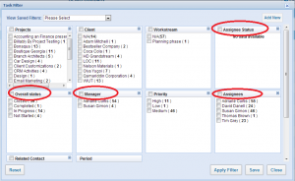
If you are not familiar with the faceted filtering option within kpi.com below find the in-detailed guide of the usage.
Faceted filtering is one of the unique features that kpi.com offers. Users can filter the tasks, contacts, cases etc to efficiently use the listing pages.
See the following screen shot to locate the button.
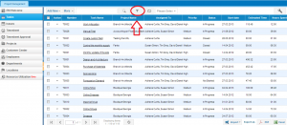
Once you click on the highlighted button, the new window pops up allowing you set various filters then choose either Apply filter or Save
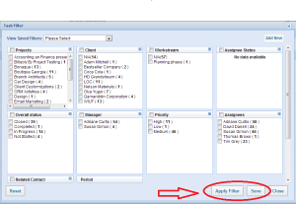
As the name suggests when Apply filter is chosen, the set filters will be applied for the temporary use- once you switch between the pages, filter will be gone. If you wish to save the filter for the future use, then you should click on Save and enter the name. Clicking on Close will cancel everything.
You can always retrieve the saved filters from the drop-down menu (see below)

7 Steps for Successful CRM Start
Published Date : May 30, 2013
Categories : Updates
Customer Relationship Management (CRM) is now a widely used term by business people. Different sources suggest different definitions but I assume the reader is already familiar with CRM system therefore I will avoid adding another definition to the World Wide Web. However, I have news for those who think CRM is just an online solution; well, it partially may be true. Modern CRM is a process that sets the stage for communication between a business and its customers. The more transparent this communication is, the more bonding the relationship becomes. Business owners should align their goals and mission statements such that sales and customer service employees make the best use of CRM to deliver the core value to the customers.
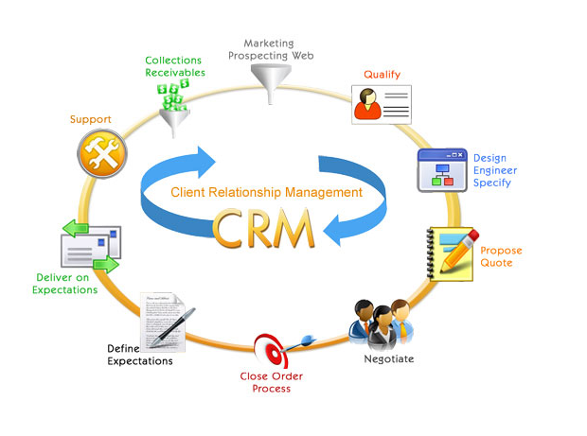
Apart from being a great communication tool, CRM can help you understand unique customer needs, decide which products and/or services are profitable. Nowadays, everyone is familiar with 20/80 rule which is 20% customers/products make up for 80% of your net profit. There are number of reports you can run within CRM which helps you make clear decisions about whether to implement a new feature or a product or vice verse, cease or decrease the particular types.
In the following lines I will try to list the steps that are necessary to choose and make the best use of CRM:
Before you choose
1. Familiarise yourself with CRM system. Basically, it consists of four main parts:
Marketing– Run campaigns, Generate leads, Form a Database
Sales– Assign, Qualify, Convert Leads and Track Opportunities
Orders– Deliver Products, Produce Invoices
Support– Manage Cases, Conduct Trainings, Provide Service, Develop Knowledge base
2. Most of the CRM solutions provide flexibility depending on your organisational workflow. Play with the system and contact the potential vendors inquiring about possible customisations that befit your workflow
3. Before selecting a particular CRM system the top management needs to conduct a research so that the new system will easily integrate with other sections of your business such as Accounting, Project management, Payroll, etc. Kpi.com offers an ‘all in one package’ ERP system
During Implementation
4. Once a particular CRM solution is employed you need to ensure your staff is comfortable with it. Especially, sales and support teams should be trained exclusively to deliver the best customer experience. Usually, ERP providers offer free trainings during the first month or two so do not forget to contact them directly and ask
5. Like I mentioned above, when using CRM system one needs to learn how to efficiently use reports. You can pull out the most valuable data on:
- Customer Profile- it is more cost-effective to keep the existing customer than attracting the new one. To maintain the current customer base you need to distinguish your loyal customers from the walk-ins and treat them the way they deserve
- Case Management- various reports can be pulled out of case management itself. The most important one is bug reports- it helps business owners to clearly see where they lack quality. If similar complaints are piled up in your case management, then it is time to roll the sleeves up and sort them out
- Leads- one can generate CRM reports on lead conversion, leads by industry, leads by status etc. Each of these reports serves different purposes. For example, you can evaluate sales performance with the help of lead conversion report
6. Almost all the CRM systems now support mail integration by which you can integrate your email address to the system and take advantage of built-in Message Center and Case Management. If you are new kpi.com user you can read a well-described wiki article to get started with mail integration in kpi.com
7. Run marketing campaigns using the mass-mailing tool. It is a great way to communicate with all of your customers as well as the leads. Inform them of the new updates, discounts and new line of products/services. But do not overwhelm your customers/leads since you might run the risk of getting labelled as spammer. Stay tuned for the next blog post on how to effectively use Email Marketing tool to win customers!

Leads vs. Opportunities (Part I)
Published Date : May 6, 2013
Categories : CRM

Hello all,
I hope you are enjoying your experience with kpi.com! As many wonder about the difference between Leads and Opportunities, today I will attempt to show you the fine line between the two and mostly focus on how to make the best use of Leads within the scope of kpi.com.
In business terms, individuals that might be interested in the products or services you offer are defined as Leads or Prospects. Although some can argue these two terms do not always coincide in terms of phases, we have only used the former as potential client contacts.
LEAD GENERATION
There are four different ways for certain contacts ending up as Leads in your CRM:
- Lead capture forms– One of the web form types that is used in landing pages to convert web site visitors into Leads
- Message Center– If the sender is not already registered as CRM contact, the system automatically adds them as new leads
- Add New button– New leads can be manually added to the system using the Add New button on the CRM Lead management page. With the drop-down menu, you can add a single lead, multiple leads or add your existing leads to mailing lists
- Lead import– To batch add your lead contacts, save your excel file as .csv and click on import button on the Lead management page. Instructions on how to import CSV format files into kpi can be found on our wiki page
Once you have all your Leads gathered in the CRM section you can:
- Assign to the sales people
- Manage the status (contacted, junk lead, lost lead, etc)
- Add different activities (logging a call, scheduling an event, adding a task, etc)
- Look up on Google Search or Hoovers Profile
- Convert*
- Send Sales Quote/Invoice
- Add to mailing lists
- Download the summary as pdf file
- Edit/Delete

*- Eventually, if you are lucky, your Leads will be pre-qualified thus can be converted to Contacts and while doing so you can choose to create an Opportunity for that Lead. Dealing with the Opportunities is a whole different story and I will discuss it in more details in my next posts. So stay tuned!

Have you tried recently released New Workspace?
Published Date : May 1, 2013
Categories : General
It is now available in beta version. A New Workspace is more flexible, easily customizable with draggable widgets. You can access it by copy pasting the following link https://app.kpi.com/BetaWorkspace.html or by clicking on “Try New Workspace” tab on the landing page.
There are various widgets currently available to design your own workspace; you will find them by clicking on “ADD WIDGET” button. You can also add new tasks, invoices, quotes, opportunities right from the beta workspace page using the “Create New” button.
The new workspace is in beta stage so expect more and stay tuned!

Did you know that you can upload your bank statement into kpi.com and track your transactions?
Published Date : April 26, 2013
Categories : Accounting
It is very easy to import your bank statement into kpi.com. Go to Bank Accounts section from the Accounting and Finance module. Add a bank account and import transaction from the actions dropdown.
Note that the bank statement should be in a .CSV or .OFX form. Once you have uploaded, you are asked to match the columns of your file with the system columns.
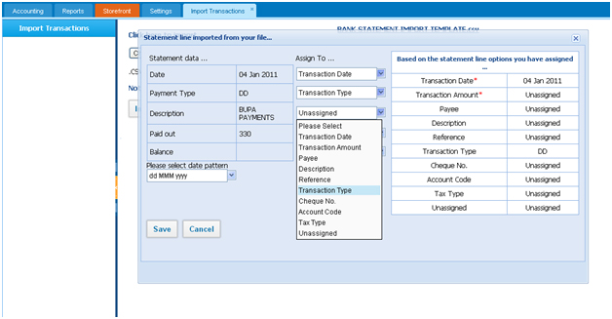
After successfully uploading the bank statement, you can match transactions in the system with the transactions in your file. If you don’t find matching transaction, you can create new by clicking on the link “Create New Transaction”.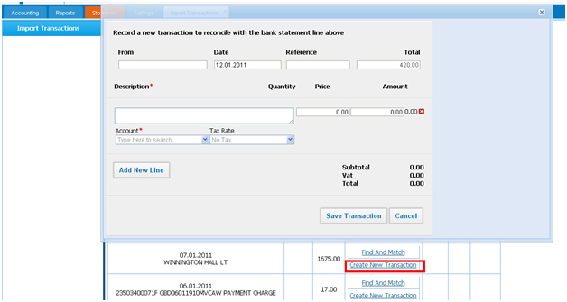
After that you can find and match the transaction and reconcile it. These transaction are reflected in the Reporting>>Account Transactions section of Accounting and Finance module.

kpi.com April System Enhancements
Published Date : April 15, 2013
Categories : Updates
We perform System Upgrade to enhance the level of service for our customers; below are the most notable new features and updates from the April Upgrade:

Project Management
There have not been major changes within this section but we have introduced minor features requested by some users.
Timesheet- when submitting or reviewing the hours for approval you can not only group by project, employee and client, but also can you now group by dates. This allows the user to clearly see timesheet entries by separate dates.
We have optimized project related email notifications- now your custom fields will also appear. Besides, task status and completion status columns have been added to Project Work-Break Down structure. Last but not least, Zip Code field has been included in Location.

Accounting
Accounting team has spared no effort to introduce new features and enhance the existing ones, below you can familiarize:
New Features
- A standard set of Terms & Conditions for all Purchase Order/Invoices
Now you can set a standard Terms & Conditions for all Purchase Orders and Invoices
- Fixed Asset & Purchase order relation
Fixed Asset now can easily be related to a Purchase Order
Enhancements
- Advanced Journal Entries
Manual journal entries are upgraded and as a result, Customer and Supplier balances can easily be manipulated
- Linkable Transaction Data
Trial Balance, P&L, and Balance Sheet transaction data are now linkable and guide to the Account Transaction list
- Trial Balance Upgrade
To enhance the usability, beginning and ending balance have been included
- Quickbooks Integration Upgrade
Major User Interface changes and printable logs have been introduced

CRM
No major changes here either, but we want to ensure you that there have been major optimizations related to Message Center. Email fetching spell is shortened- now the messages are fetched within pre-defined intervals specific to each account.
Also, some email addresses undesirably ended up in black list, where users do not receive emails from the system, due to certain automatic criteria. To solve the problem, we have removed auto-black listing, now email addresses can only be added manually.
Finally, when sending a text message via Clickatell, messages can be sent from your name if defined.

HRMS
Mini calendar in “My Attendance” now displays week-ends, public holidays and approved Leave Requests.
By requests received from our Middle East based customers, a new field for Visa Expiration Date has been added in Employee Profile. Users can also set email reminders right below it.

Overall in the System
There is good news when it comes to overall changes!
Warning Message- Now you do not have to worry about your account being inactive due to license expiration- warning message will appear on top of the screen when you log in and moreover, you will receive periodical email notices starting from a month in advance.
Live Help- If you face a problem or you have a quick question while using the application you are a click away from directly speaking to one of our supportive agents. Just click “Live Chat” button next to “Send Feedback” and have your questions answered right away!

Have you tried recently released New Workspace?
Published Date : March 22, 2013
Categories : Updates
It is now available in beta version. A New Workspace is more flexible, easily customizable with draggable widgets. You can access it by copy pasting the following link https://app.kpi.com/BetaWorkspace.html or by clicking on “Try New Workspace” tab on the landing page.
There are various widgets currently available to design your own workspace; you will find them by clicking on “ADD WIDGET” button. You can also add new tasks, invoices, quotes, opportunities right from the beta workspace page using the “Create New” button.
The new workspace is in beta stage so expect more and stay tuned!

kpi.com March system updates
Published Date : March 11, 2013
Categories : Updates

We perform System Upgrade to enhance the level of service for our customers; below are the most notable new features and updates from the March Upgrade:
Project Management
Multiple Timer function has been introduced. Just select Tasks you have been assigned to and run timer for each task. For your comfort we have added Auto Save function, so whenever you tap the Stop button it automatically saves under your Tasks field and always can be retrieved with Timesheet Report tab → Workstream
In Email Templates sections we added Project/Task Number personalization attributes, so now you can accurately put respective Project/Task Numbers in email notifications without hassle.
Customizable Date Format introduced to all sections of the Project Management tool. Select the format you want to use, whether it’s dd/mm/yyyy or mm/dd/yyyy, 1:15 a.m. or 13:15 or other, and build effective progress checking.
Accounting
Manual Foreign Exchange Rate configuration has been unveiled. kpi.com imports real-time Foreign Exchange Rates data automatically from European Central Bank and uses it as basis for running clients businesses. Now clients can choose from both options and customise their business as needed.
Serial Number Expiration Period added. Add Expiration Date to the products and be able to monitor subsequently whether they have expired or not by searching with the product serial number.
Paypal payment integration enhanced. Send invoices, receive payments via Paypal account and do not worry about account balances, the system automatically downloads all necessary data and makes respective amending to the general ledger.
Customer Balance emailing feature launched. See Receivables/Prepayments from the customer on the right-hand sidebar and email it to the client just by clicking the button.
General Custom Field has been added to the Product and Services page. If you want to add description to the group of products or highlight the feature which has multiple offerings, this feature will be handy.
Stock Adjustments Log started. Now you can see the history of who has added/edited the products and listings and run proper tracking.
CRM
The Leads list Time Zones further divided into States/Regions. So now, instead of just indicating country of the Lead/Contact you can define from which state he or she is, so you can schedule your follow-up phone calls without worrying about disturbance at non-office hours.
Calendar in both CRM and Workspace sections has been made customizable. If your business week begins on any other day than Monday, then you can amend it in the Settings tab, so that the set day (the first day of your business week) appears first on the calendar matrix grid.
HRMS
We have introduced Chinese characters support to the system. Now users from China can enjoy generating Performance Appraisals and other business correspondence using traditional and simplified Chinese characters.
For those who are planning to work on Sundays or pre-determined public holidays (you can define holidays on settings tab) and need to schedule it on timeslot, we have added Custom field down below Weekdays Timeslot, so you can add it up easily.
We have customized so you can select now who will be approving leave requests or leave it blank to reset it to defaults: HR Manager and Director.

kpi.com February system updates
Published Date : February 11, 2013
Categories : Updates
We perform System Upgrade to enhance the level of service for our customers; below are the most notable new features and updates from the February Upgrade:
OVERALL
Beta Workspace – Experience the draggable widgets and enjoy the flexibility to design your custom Workspace page. You can not only change the positions of the widgets but also can turn them on or off according to your preferences. Stay tuned for more widgets to come very soon!
ACCOUNTING
Multi-company consolidation reports – If you run a multi-company with subsidiaries in different countries you can take advantage of our new feature! Have your all financial statements in consolidated Balance Sheet and Profit & Loss without worrying about the trade balances between subsidiaries and parent company because you can easily adjust your receivable and payable accounts.
Multi-warehouse filter – Have you been using Multi-warehouse add-on? If not, you can enable at a very reasonable price. With the recent enhancements, you can filter products and services by warehouses.
CRM
Web Forms – Now you can customize the layout of the web forms in your website, if you are not an advanced user then we can help you do it from our end.
Message Center – it is synced with Accounting & Finance section of kpi.com. When you are sending sales invoice, quote or any other accounting related item now you can add cc, bcc and most importantly the copy of the sent items will appear in Message Center of kpi.com
Project Management
Project budget is now recalculated real time as you update the estimated hours for related tasks. Therefore, we removed “recalculate’ button which was previously used to update the budget every time task hours are changed.
Email notification on projects and tasks include more detailed information allowing you to be abreast of the change without logging into the system.
HRMS
When approving leave requests submitted by your employees you can mass-approve it with a single click!

Updates to Kpi.com | January
Published Date : January 22, 2013
Categories : Updates
Dear kpi.com Users,
We are pleased to announce that kpi.com implemented new features and changes related to Project Management, Accounting, CRM, and the overall system. Below you can familiarize yourselves with some of the major ones.
SYSTEM:
Security– To make your data less prone to hacking and other security vulnerability issues, we have introduced number of changes to the password set-up. Now the system does not allow users to set passwords either weak and/or less than 8 characters. Moreover, we have also improved the password encryption from the security point of view.
Supplier Access– As you know, users can enable limited access for their Clients; after January system upgrade your Suppliers can also have limited access to kpi.com.
PROJECT MANAGEMENT:
In the Project Management Section of kpi.com most of the major changes focused reinforcing the recently added features from the previous system upgrade.
Project Filtering– Previously we enabled choosing multiple backup managers for a project, now you can easily filter projects by the back-up managers.
Task filtering– Speaking of filtering, if you noticed, in our previous upgrades, we introduced the functionality to add tasks without assigning employees. Now you can filter those unassigned tasks and delegate effectively.
Timesheet Reminder- Last but not least, you can send the timesheet reminders immediately with the “Send Now” button introduced in this Upgrade.
ACCOUNTING:
Progress Invoicing– Whilst some projects require single invoice, others might require that you submit monthly progress invoices (partial billing) over the course of months or even years. Users already had option to parially bill by percentage, and now you can send partially invoices by line items.
Attachments to products/services– Now you can attach documents such as product/service brochures and have them displayed neatly.
Commission split in Sales Quotes– kpi.com users can now assign commission rates to products & services, as well as track, and split commissions in sales quotes.

To find out more about above mentioned changes feel free to contact us!
Sincerely yours,
kpi.com

Strategic Partnership and White Labeling Packages - 2013 Updates
Published Date : January 2, 2013
Categories : Updates
Partnership with kpi.com may be developed in two directions:

White-label partnership packages
We bill white-label partners on yearly basis. Partners can sell limited licenses and support packages, if limit is exceeded, additional charges will be setup;
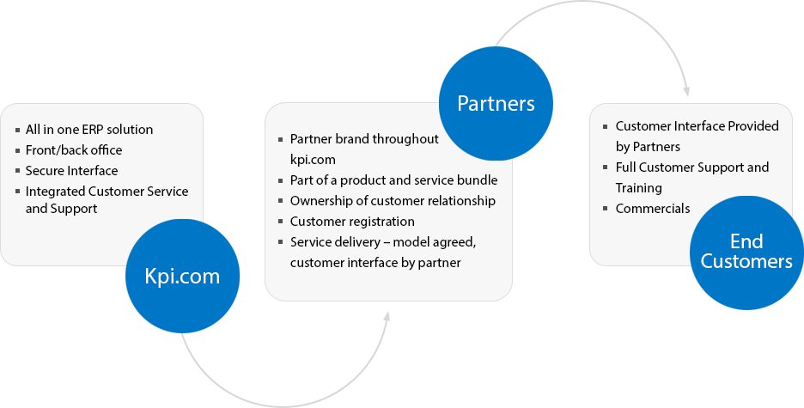

Reseller Partner Program
Participate in KPI.com’s Reseller Partner Program and be among the first to offer KPI.com’s ERP solution to your clients.
As a KPI.com Reseller Partner you will have a unique opportunity to introduce KPI.com’s Online Business Management solution to your clients and benefit from increased revenues from your referred accounts.
The referral procedure is very easy. You are only required to identify potential customers, direct them to the KPI.com web site and provide them a special Promotion code. All sales processes and billing will be handled by KPI.com.

Your Benefits:
– Increase your profit without having to deal with the entire sales process, service implementation or customer support.
– No need to change your current business processes.
– Participation in KPI.com™s Reseller Partners Program is totally free.

Strategic Partnership and White Labeling Packages – 2013 Updates
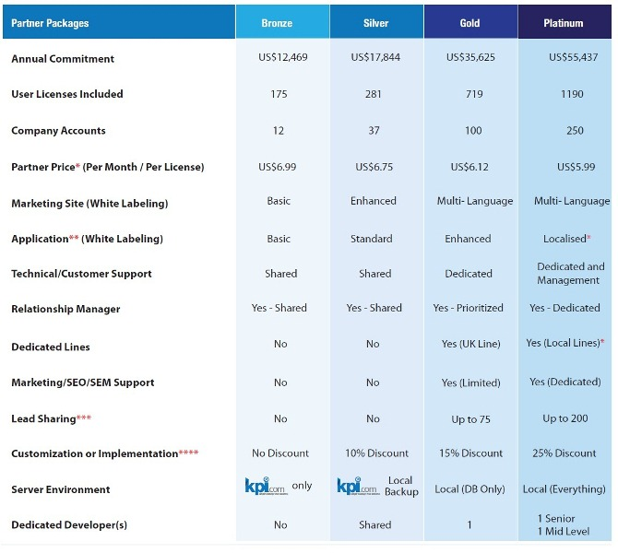
* End user prices must be disclosed to KPI – any pricing above $10 per user is shared on 50/50 basis with KPI.
For customers using with higher bandwith and/or storage (ie. Email and Data Storage, Massmailing. etc),
mutually agreed pay-as-you-go scheme will be applied.
** Lead time is required to set up relationship, priority is given to more premium partners
*** Subject to availability
**** Fees charged more than 100% on KPI side will be shared 50/50 with KPI and must be disclosed
Note: Customizations or extra service charges must be disclosed to kpi.com. Our minimum rate for partners is $25/hour
for new developments and $99 for activation services (such as mass mailing, custom pdf. etc.).

We wish You a Merry Christmas and Happy New Year!!!
Published Date : December 22, 2012
Categories : Updates

With Best Regards,
Kpi.com -Finnet Limited

